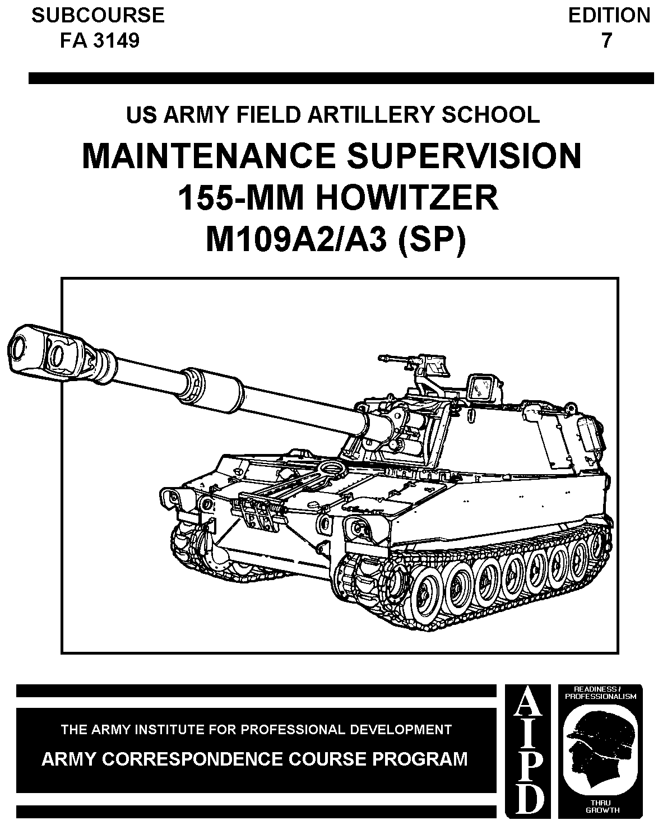
A

CANNON CREW MEMBER
MOS 13B SKILL LEVEL 3/4

MAINTENANCE SUPERVISION OF THE 155-MM HOWITZER
M109A2-A6 (SP)

SUBCOURSE FA3149

US Army Field Artillery School
Fort Sill, Oklahoma

EDITION A
3 CREDIT HOURS
REVIEWED: 06/2004

This subcourse is designed to train the skills necessary for performing tasks related to maintenance supervision on the 155-mm howitzer M109A2-A6 (SP). This subcourse is presented in five lessons, each lesson corresponding to elements of the concluding objective supporting the following soldier's manual tasks:

LESSON 1: Maintenance Responsibilities and the M109A2-A3 Howitzer (SP)

TASK NO: 061-270-3420

TASK: Verify preventive maintenance checks and services (PMCS) on the M109-series howitzer.

CONDITIONS: You will be given an M109-series howitzer in a maintenance location with section tools and equipment, section personnel, vehicle logbook, TM 9-2350-311-10, LO 9-2350-311-10, DA Pam 738-750, and a blank DA Form 2404 (Equipment Inspection and Maintenance Worksheet).

STANDARDS: Verify performance of all checks and services listed in the preventive maintenance checks and services table IAW TM 9-2350-311-10.

LESSON 2: Prefire Checks and Alignments

TASK NO: 061-270-3430

TASK: Perform prefire checks (M109-series).

CONDITIONS: You will be given an M109-series howitzer with a section and section tools.

STANDARDS: Perform prefire checks before firing IAW TM 9-2350-311-10.

W4605

TASK NO: 061-270-4554

TASK: Perform fire control alignment tests (M109-series).

CONDITIONS: You will be given an M109-series howitzer with a complete section, fire control equipment, section tools and equipment, three jacks, a plumb line, 5-gallon can of water/waste oil, a level hardstand, and the operator's manual.

STANDARDS: Perform the fire control alignment tests IAW the operator's manual.

TASK NO: 061-270-3429

TASK: Adjust the equilibrators (M109-series).

CONDITIONS: You will be given an M109 howitzer with the equilibrators out of adjustment and a container to catch fluid.

STANDARDS: Adjust the equilibrators IAW TM 9-2350-311-10.

LESSON 3: The M109A2-A3 in Operations

TASK NO: 061-266-3301

TASK: Prepare a howitzer for firing.

CONDITIONS: You will be given a howitzer, a crew, and all section personnel.

STANDARDS: Establish priorities and properly prepare the howitzer for firing.

TASK NO: 061-270-1507

TASK: Load and fire a prepared round (M109-series).

CONDITIONS: You will be given an M109-series howitzer, a prepared round, a swab, a bucket of water, and a fire command.

STANDARDS: Upon command, load and fire the howitzer IAW the performance measures.

LESSON 4: After-Operation Maintenance

TASK NO: 061-270-1410

TASK: Disassemble/assemble breech and firing mechanism (M109-series).

CONDITIONS: You will be given an M109-series howitzer, section tools, and one assistant.

STANDARDS: Disassemble the breech and firing mechanism within 8 minutes and assemble the breech and firing mechanism within 12 minutes.

TASK NO: 061-270-3433

TASK: Perform a zero pressure check (M109-series).

CONDITIONS: You will be given an M109-series howitzer.

STANDARDS: Perform a zero pressure check on the howitzer IAW TM 9-2350-311-10.

LESSON 5: M109A6 (Paladin) MAINTENANCE

TASK NO: 061-307-3433

TASK: Perform a Zero Pressure Check (M109A6)

CONDITIONS: Given a M109A6 howitzer in a garrison or field environment with section equipment, section personnel and Technical Manual (TM) 9-2350-314-10;

STANDARDS: Perform a zero pressure check to indicate the amount of hydraulic pressure in the pulse accumulator assembly. After completion of check, state if the howitzer can use hydraulic power or if manual operation must be used.

TASK NO: 061-307-1601

TASK: Perform a zero pressure check (M109-series).

CONDITIONS: Given an M109A6 Howitzer, a M42 series protective mask, microclimate conditioning system vest, and TM 9-2350-314-10;

STANDARDS: Operate the Microclimate Conditioning System and NBC equipment . Soldiers must follow the procedural steps without error. Soldiers must: (1) Perform MCS Lamp test; (2) Operate NBC equipment; (3) Remove NBC filter; and (4) Install NBC filter.
.
TASK NO: 061-307-3558

TASK: Operate the Automatic Fire Control System in the Maintenance Mode (M109A6).

CONDITIONS: Given an M109A6 Howitzer in a garrison or field environment, an assistant, section equipment, and (TM 9-2350-314-10);

STANDARDS: Operate the M109A6 in Maintenance Mode. Soldier must (1) conduct the BIT Test, (2) view AFCS Status, (3) identify any degraded or out subsystems, (4) conduct all Maint Mode Tests, (5) view software version/configuration display and CPU Environment display, (6) report any errors to unit maintenance and (7) return to setup and information screen.

TABLE OF CONTENTS

Section Page

Subcourse overview i

Lesson 1: Maintenance Responsibilities and the M109A2-A3 Howitzer

Introduction 1

Inspections 4

155-MM Self-Propelled M109A2/M109A3 Howitzer 8

Summary 12

Lesson 2: Prefire Checks and Alignments

Introduction 13

Prefire Checks M109A2/A3 Howitzer 14

Fire Control Alignments Tests 18

Gunner's Quadrant 21

Trunnions 28

Tube Leveling 36

Deflection Reliability 41

Elevation Quadrant M15 46

Care and Maintenance of Fire Control Equipment 55

Rammer Reliability Checks and Adjustments 60

Equilibrator Adjustment 62

Operating Cam Adjustments 65

The Torque Key 70

Summary 73

Lesson 3: The M109A2/A3 in Operation

Introduction 75

Hydraulic System 78

Cab Traversing Mechanism 85

Rammer 94

Emplace and Recover the Recoil Spades 105

Preparing To Operate Under Unusual Conditions 110

Summary 118

Lesson 4: After-Operation Maintenance

Introduction 119

Lubrication 133

Summary 144

Lesson 5: M109A6 (Paladin) MAINTENANCE

Differences ………………………………………………………………………………………..148

Microclimate Conditioning System (MCS) ………...………………………………………………..153

Replenisher System …………..……………………………………………………………………..155

Zero Pressure Check …….…………………………………………………………………………156

Travel Lock System …………………………………………………………………………………..157

AFCS Maintenance Mode ….………………………………………………………………………..160

Engine ………..……………………...……………………………………………………..166

Lesson 1
MAINTENANCE RESPONSIBILITIES AND THE M109A2/A3 HOWITZER

OBJECTIVE

After completing this lesson, you will recognize and be able to apply the principal responsibilities of a maintenance effort at unit level; identify various types of inspections and their relative value toward a sound maintenance program; and be familiar with general characteristics of the M109A1 product improvements applied to the M109A2/A3, and the difference between these models.

REFERENCES

This lesson is based on TM 9-2350-311-10, TM 9-2350-311-20-1, TM 9-2350-311-20-2, and LO 9-2350-311-12, and other materials approved for US Army field artillery instruction; however, development and progress render the text continually subject to change. Therefore, base your examination answers on material presented in this text rather than on individual or unit experience.

1. INTRODUCTION. Increasingly complex equipment and weapon systems in the field artillery operated by young and inexperienced soldiers, present the commander and supervisor with a real challenge regarding the inherent responsibility to maintain weapons and equipment.

a. Command responsibility. Each commander, (battery, battalion, division) has an inherent command responsibility to ensure that all equipment in his care is kept in serviceable, combat-ready condition. This responsibility extends to ensuring that the equipment is properly handled and correctly operated according to the technical manuals published for each item of equipment issued to the using unit. The commander/supervisor is responsible for allocating time and resources for performing maintenance and for training individuals in maintenance operating procedures. He must achieve a proper balance between operations, training, and maintenance to attain the highest possible readiness condition. The full impact of command responsibility penetrates to every level of command. Command responsibility is an eminently sound principle because it includes the authority and responsibility for effective use of available resources and for planning and employing, organizing, directing, and controlling all efforts of the command toward mission accomplishment. Thus, within the context of maintenance, the commander is responsible for:

- Ensuring that all equipment issued to elements of his command is in serviceable and combat-ready condition, and that the equipment is properly operated, maintained, and serviced.

- Advising superiors of equipment replacement needs and maintenance support requirements.

- Complying with instructions and procedures for maintenance operations; for training operators, crews and supervisors in proper maintenance procedures; and for allowing sufficient time for performing required maintenance.

- Assigning maintenance tasks for all organizational equipment to specific individuals.

- Preventing abuse of military material.

- Maintaining records on the use, maintenance, and modification of equipment as directed by regulations, directives and technical manuals.

- Ensuring prompt evacuation of unserviceable equipment.

He must, in sum, demonstrate an awareness that the most critical single element of effective unit maintenance is the personal interest and involvement of the unit commander.

b. Supervisory accountability. Supervisory accountability for maintenance extends to each person to whom equipment has been entrusted for use by his subordinates. The executive officer of a firing battery, chief of firing battery, or gunnery sergeant is accountable for required maintenance of weapons and all other vehicles and equipment that supports the combat mission of the firing battery. Each howitzer section chief is accountable for the proper operation and necessary maintenance of his howitzer. Similarly, a motor sergeant is accountable for the care and use of tools by the mechanics under his supervision.

c. Individual accountability. Individual accountability is charged to the person who uses and cares for equipment. In this sense, accountability for proper use and care of Government materiel and equipment is borne by all military and civilian personnel of the Army. Thus, the driver of a vehicle has individual accountability for doing the operator daily services and for reporting needed maintenance that he is not authorized to perform. Similarly, a mechanic has individual accountability for providing the services that he is authorized to perform and for the care of his assigned tools and test equipment.

d. Factors affecting maintenance. As indicated in Figure 1, the Army's approach to equipment maintenance is systematic and includes a number of factors, each of them indispensable to sound training and combat-ready equipment. In this, as in most other endeavors related to combat readiness, the commander is the single most important factor--the key to effectiveness. He must manage personnel and facilities, allocate time, and provide repair parts, publications, tools, and equipment. But most important of all may be his personal attitude toward maintenance--his enthusiasm, commitment, and personal involvement--in short, the example he sets for his subordinates. All this will, in turn, lead the commander to acquire technical proficiency and a thorough understanding of each item of equipment assigned to his unit, including the primary weapon system.

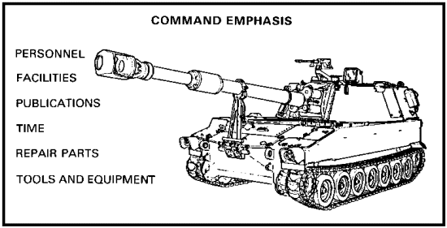

Figure 1. Factors affecting maintenance.

PRACTICE EXERCISES:

Complete the following exercises by circling T for true or F for false, circling the letter preceding the correct answer, or filling in the blanks, as appropriate. Be sure to complete the practice exercises as they appear. They are "building blocks" and will help you complete the rest of the subcourse successfully. The answers follow the last exercise and are separated by rows of slashes (/////). If any of your answers are incorrect, restudy the appropriate part of the subcourse before you continue.

1. Command maintenance responsibility is based on a sound principle, because it includes ________________ and responsibility.

2. What is the most critical single element of effective maintenance?

3. The person who uses equipment is charged with _____________________ accountability for maintenance.

4. The gunnery sergeant in your battery has _____________________ accountability for proper care and maintenance of equipment.

5. The Army's approach to equipment maintenance is ____________________ and includes a number of factors. List three of those factors:

a. command emphasis.
b. _____________________________.
c. _____________________________.
d. _____________________________.

//////////////////////////////////////////////////////////////////////////////////////////////////////////////////////////////////////////////////////////////////

ANSWERS:

1. authority
2. the personal interest and involvement of the unit commander
3. individual
4. supervisory
5. systematic
a. command emphasis e. publications
b. personnel f. facilities
c. time g. tools
d. repair parts

//////////////////////////////////////////////////////////////////////////////////////////////////////////////////////////////////////////////////////////////////

2. INSPECTIONS.

a. Purpose. Maintenance inspections are one method of supervising maintenance. Inspections allow commanders and supervisors at all levels to determine the adequacy of maintenance and maintenance support, to detect faults, and to direct corrective action. They also reveal whether equipment is being properly operated. Technical inspections may be made by technicians and specialists under the direction of the commander or his appointed representative. Since the validity of the inspection findings increases in proportion to the number of items inspected, all equipment should be inspected on a uniform, systematic basis. Additionally, equipment inspections made in preparation for oversea movement or of equipment transferred from storage configuration to the deployment force (e.g., REFORGER) must include all items to meet the inspection objective. If organizational equipment faults and failures are reduced, the work requirements at support levels will be reduced. This work reduction can be achieved if the commander follows proper inspection procedures and has a planned program of follow up action. Each officer, NCO, or person in a supervisory position should be able to inspect the equipment of his unit rapidly and thoroughly.

b. Standards. Technical standards of function, operation, and serviceability are established in appropriate technical manuals (TMs). Additionally, the commander must establish the standards by which the equipment in his unit is inspected. The word "standard" is defined as that which is set up and established by authority as a rule for the measure of quality. The quality of maintenance may vary with the amount of training received by operator and maintenance personnel and the conditions under which the materiel is operated. The commander must establish standards of maintenance that will ensure a satisfactory materiel readiness posture at all times. The commander should keep in mind that these maintenance standards must be specific and attainable. An unrealistic standard can adversely affect morale and consequently lower the maintenance level of the equipment. Individuals usually respond to a standard that is within reach. As the quality of maintenance improves, the standard can be revised upward to a more ideal limit. Standards may be published in the form of a standing operating procedure (SOP), a maintenance directive, a training directive, or a statement of policy. It is the commander' s prerogative to choose the method of publishing maintenance standards, but these standards must be clearly understood by all. The factors that should be considered in establishing standards of maintenance are as follows:

(1) Serviceability. Materiel should be kept at a standard of serviceability that will ensure its operational readiness and its capability to perform its intended mission at all times.

(2) Adequate maintenance. Maintenance should be performed according to applicable TMs.

(3) Condition. Vehicle parts that are twisted, bent, chafed, burned, cracked, dented, or collapsed should be repaired or replaced.

(4) Security. Components should be checked by touch or with a wrench, as appropriate, to ensure that the components are secure.

(5) Excessive wear of parts. Parts or components worn near or beyond serviceable limits should be replaced.

(6) Cleanliness. Cleanliness of equipment, proper marking, and freedom from rust are part of the maintenance program, as well as indications of morale and discipline. However, the commander should be aware of overemphasis on what is termed "maintenance camouflage" that may be used to hide or disguise equipment faults.

(7) Lubrication. Each vehicle should be lubricated according to the correct lubrication order.

(8) Leaks. All components, such as gear cases and radiators, should be checked for leakage of fluids.

c. Techniques. Close and continuous supervision of maintenance operations by technically competent supervisors at the operator or user level has proven to be the most important link in maintaining equipment in a high state of combat readiness. Nevertheless, inspections related to preventive maintenance continue to be the primary tools of the commander in his position as maintenance manager. All inspections of equipment and maintenance operations are conducted under command authority. These inspections may vary from those that do not interfere with normal unit activities to those that require extensive preparation--such as complete layout of equipment. Inspections may be conducted periodically, as requirements develop, or as an operational routine. Inspections are generally classified as:

- Formal.

- Technical.

- Spot checks.

- Informal.

(1) Formal inspections are time consuming, interfere with normal unit activities, produce questionable results of actual conditions, and should be conducted as infrequently as possible. They require thorough planning, advance notification, organization of inspection parties or teams, and recording/reporting of findings.

(2) Technical inspections are normally conducted at maintenance support facilities by technically qualified personnel to determine whether equipment should be continued in service, withdrawn for overhaul, or reclaimed for salvage of parts. If this inspection reveals that organizational maintenance is substandard or that operator maintenance deficiencies exist, the deficiencies will be reported to the commander of the using unit.

(3) Spot-cheek inspections are often used by commanders to verify the adequacy and effectiveness of organizational maintenance and to detect incipient failures in equipment before such failures occur. As the name suggests, spot-cheek inspections are performed on randomly selected items of equipment. The form of spot-cheek inspection most commonly used is the roadside vehicle inspection. At random times and in unannounced places, technically qualified maintenance personnel, with military police to handle traffic, set up a roadside checkpoint. Randomly selected vehicles traveling on the road are diverted into a vehicle turnout. The inspectors check the vehicle for evidence of inadequate operator or organizational maintenance. Unsatisfactory conditions are reported through channels to the unit to which the vehicle is assigned.

(4) Informal inspections are unannounced and unscheduled. They may be performed by the commander at any time. Other personnel in supervisory positions, down to and including crew/section chiefs, perform informal inspections on a continuous basis and as part of their daily, routine supervision of all operations. The informal inspection provides a true indication of the conditions in the unit, because the commander/supervisor observes vehicle/equipment maintenance operations as they occur. The crew member soon learns to closely observe proper procedures for operation and maintenance of the equipment. The commander/supervisor observes the technique actually applied during the normal operation and care of equipment. Informal inspections do not require an inspection team, should result in on-the-spot corrections and eliminate a great waste of time and effort by doing away with "eyewash" preparations, and save money when parts are replaced because they are defective--not because they look bad. Informal inspection/supervision is an ongoing process. For example, when a unit is scheduled to go to the field, the performance and supervision of before-operation checks can be observed in the motor park. The column can be observed on the march, and the general state of driver training and march control can be noted. During halts or after the unit has reached its field position, the vehicles can be checked for general conditions such as leaks, evidence of abuse, or improper maintenance. Operator performance of after-operation checks and evidence of continuing maintenance supervision can be noted. Many of the faults noted during an informal inspection will never be disclosed during a formal inspection. These areas should be informally inspected on a continuous basis:

- Shop facilities. The shop, shop equipment, parking area, wash racks, and petroleum, oils, and lubricants (POL) facilities should be inspected for cleanliness, fire and safety hazards, and efficient organization.

- Forms and records. Forms and records should be inspected for accuracy and completeness.

- Operating and maintenance personnel. Operating and maintenance personnel should be observed for neatness and efficiency. They should be questioned to determine their knowledge, aptitude, and attitude, in addition to their qualifications.

- Automotive. Informal inspection of vehicles and weapon carriages should include checking for the following:

- Manner of operation.

- Presence and security of components.

- Correct tire pressure.

- Serviceability of springs.

- Leakage of fluids.

- Properly locked pintle hook.

- Condition of towed load.

- Unusual noises in the power train, wheel bearings, or engine.

NOTE: In this context, continuous supervision should not be carried to the extreme of oversupervision. Inspections and supervision should be viewed as an additional teaching vehicle to instruct users/crew members on correct procedures as required, but not as a means to harass the troops.

PRACTICE EXERCISES:

6. T F The validity of the inspection findings increases in proportion to the number of inspections conducted.

7. T F When equipment is taken out of storage or prepared for oversea movement, it must be inspected down to the last item.

8. T F The commander must establish standards of maintenance that will ensure perfect materiel readiness at all times.

9. T F Inspections that focus on the prevention of maintenance problems are a primary tool for maintenance management.

10. T F Roadside vehicle inspections are categorized as spot checks.

11. T F Informal inspections provide a true indication of unit maintenance effectiveness.

12. T F Formal inspections should be conducted every 30 days.

//////////////////////////////////////////////////////////////////////////////////////////////////////////////////////////////////////////////////////////////////

ANSWERS.

6. F
7. T
8. F
9. T
10. T
11. T
12. F

//////////////////////////////////////////////////////////////////////////////////////////////////////////////////////////////////////////////////////////////////

3. 155-MM SELF-PROPELLED M109A2/A3 HOWITZER.

a. General characteristics. The 155-mm M109A2/A3, an armored, self-propelled, medium howitzer, is a highly mobile combat support weapon. It is air transportable in phase III of airborne operations. It has a cruising range of 220 miles at speeds up to 35 miles per hour (mph). Combat loaded, the M109A2/A3 weighs 55,000 pounds. The M109A2 has a number of product improvements applied to an off-the-assembly line M109A1. The M109A3 has the same product improvements as the M109A2, except that they have been applied to an M109A1 which has been in the field and used for quite some time. The M109A2/A3 is equipped with the longer M185 tube and achieves a range of 23,500 meters with the 98-pound (lb) rocket-assisted projectile. The maximum rate of fire is 4 rounds per minute for the first 3 minutes. The sustained rate of fire is 1 round per minute (charge 7), or 1 round per minute for the first 60 minutes, then 1 round per 3 minutes (charge 8). The weapon is equipped with a 24-volt electrical system with four 12-volt batteries connected in series-parallel. A hydraulic system provides power for traversing and elevating the howitzer and for ramming the projectile. Two recoil spades, located on the rear of the vehicle (one behind each track), are provided to improve the stability of the howitzer in the firing position.

b. Product improvement program (PIP). Improvements of the M109A1 have followed two separate tracks with the same end result. The M109A2 originally began as the M109A1B, which was manufactured specifically for foreign sales and was nothing more than a new M109A1 with all recent modifications. Afterwards, the decision was made to keep some of the M109A1B models and apply the mid-life PIP items with the result being the M109A2. The M109A3 is an application of the same mid-life PIP items to the M109A1, which has been in the field for quite some time and recalled for modifications.

(1) Ammunition storage. Ammunition capacity has been increased from 28 complete rounds to 36 by the addition of a projectile storage rack. The rack is installed in the rear opening of the turret. It has been designed with three doors, two large doors which protect the projectiles and a small door which allows servicing of the howitzer with ammunition from the M548. The original projectile rack inside the howitzer has been removed and replaced with a bracket that allows storage of 13 propellant containers. The rear door on the inside has been modified to allow storage of four metal fuze containers. In the past, servicing of air filters has been a problem because of the right front storage racks. Now, the racks are fitted with quick disconnects to provide easy removal when servicing the air filters.

(2) Safety improvements. Handholds have been provided on the cab roof and side walls to reduce possibility of injury to the crew during movement. The handhold over the operating cam also provides a point to secure the cam during maintenance. Latches on the cab side doors have been improved to prevent accidental closing of the doors during firing. The equilibrator hand pump has been moved to a location behind the panoramic telescope (pantel), providing a horizontal push-pull stroke without injury to crew members. The older stainless steel hydraulic lines have been replaced with flexible hoses where possible. This should reduce the frequency of hydraulic line breaks. To reduce entry of rain water into the howitzer cab via the rotor assembly, a window shade type of cover has been installed on the exterior. Initially, however, the weather cover did not prevent entry of water at all elevations, which caused further improvement to be necessary.

(3) Ballistic cover. For some time, many have believed that we could increase responsiveness if tactical movement could be done with the pantel mounted. A ballistic cover with plexiglass over the front has been installed to allow travel with the pantel mounted. Initially, the interior of the cover was painted the same color as the pantel, making sighting of the pantel with aiming circle very difficult. To alleviate this problem, the interior of the cover will be painted a different color. White has been considered, but it results in a significant signature that could be a tactical mistake.

(4) Loader-rammer. The time delay sequencing of the loader-rammer has been removed, and a simple push (ram)-pull (retract) control has been installed to replace the older system. Ramming is now a positive crew member action. The chief advantage, however, is that ramming time has been reduced by about 50 percent.

(5) Travel lock. The travel lock has been installed with a set of springs at the pivot point to make it easier to raise and lower the travel lock. The springs also prevent the travel lock from falling and injuring the operator during engagement and disengagement.
(6) Recoil mechanism. The counterrecoil buffer has been redesigned to provide a more reliable system that reduces more of the shock of firing. The bleeder T on the front of the recoil mechanism is being designed so that tools are no longer necessary for servicing.

(7) Driver's hatch and instrument panel. The driver's hatch on the M109A1 provides access only after being opened from the inside. The new hatch allows the operator to open the hatch from the outside. The driver's instrument panel has been modified to provide mounting in the crew compartment of the howitzer for easier monitoring during firing. A shutdown alerting device, in the form of a color-coded temperature gage to indicate to the driver when the engine temperature is low enough to shut the engine down, has been added to the instrument panel. Another alerting device to help in proper maintenance of the engine is the aeration detector. This will provide the operator with a positive indication when the coolant level is too low in the radiator.

(8) Fuel pump. To increase the automotive life of the weapon, an electric fuel pump has been installed. Loss of injector assemblies and injector pumps has been attributed to air in the fuel filter system. With the new electric pump, however, any air in the fuel lines will be removed before the fuel goes to the injector pump.

c. Differences. Specific differences between the M109A1 and the M109A2/A3 models of this weapon will be addressed in this text when a particular operation or maintenance procedure is affected by these differences. In general, the 155-mm M109A2/A3 howitzer (Figures 2 and 3) is the result of tests conducted to increase the maximum range capability of the 155-mm M109-series howitzer to 18,000 meters. Initially, increasing the range of the M109 series with the standard M126E1 tube was tried by use of a new 8-zone propelling charge. This proved infeasible because of damage to vehicle components and crew discomfort due to the effects of shock, blast, and overpressure created by the new propelling charge. Additional study and tests resulted in the development of the M185 tube to replace the M126E1 tube, plus other modifications to the M109-series weapon and vehicle components needed to compensate for the length and weight of the M185 tube (Figure 4).

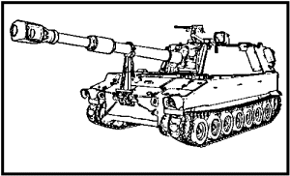

Figure 2. 155-mm self-propelled M109A2 howitzer.

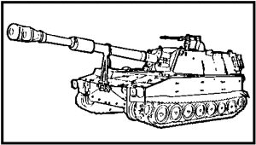

Figure 3. 155-mm self-propelled M109A3 howitzer.

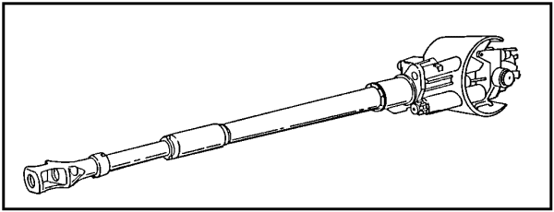

Figure 4. The 155-mm long tube M185.

PRACTICE EXERCISES:

13. The 155-mm M109A2/A3, traveling at 35 miles per hour, has a cruising range of--

a. 120 miles.
b. 180 miles.
c. 220 miles.
d. 250 miles.

14. The difference between the M109A2 and the M109A3 is that the--

a. M109A2 has a number of product improvements applied to an off the assembly line M109A1.
b. M109A3 has a number of product improvements applied to an off the assembly line M109A2.
c. M109A2 has a number of product improvements applied to an M109A1 that has been in the field and in use.
d. M109A3 has a number of product improvements applied to an M109A2 that has been in the field and in use.

15. Considering the mission capability of this howitzer, the most important change to the M109A2/A3 is the--

a. increased ammunition capacity of the storage rack.
b. improved loader-rammer system.
c. electric fuel pump.
d. increased range to 23,500 meters.

//////////////////////////////////////////////////////////////////////////////////////////////////////////////////////////////////////////////////////////////////

ANSWERS.

13. c.
14. a.
15. d.

//////////////////////////////////////////////////////////////////////////////////////////////////////////////////////////////////////////////////////////////////

4. SUMMARY. Command responsibility penetrates the chain of command down to and including the last man having another man under his authority. Maintenance is a part of every soldier's job; it differs only in degree and type of function. Effective maintenance is the result of the combined effort of every member from commander to crew member. It requires a thorough knowledge of the weapon or equipment in use and a clear understanding of maintenance procedures. The purpose of maintenance is to assure that Army materiel is sustained in combat-ready condition. It is achieved by the systematic care, servicing, and inspection of equipment, weapons, and facilities to detect and correct incipient failures before they occur.

Lesson 2
PREFIRE CHECKS AND ALIGNMENTS

OBJECTIVE

After completing this lesson, you will be able to list and apply the various prefire checks required before placing the M109A2/A3 in operation. These checks include specific procedures for the adjustment of the equilibrator, operating the cam and torque key, the rammer reliability test, and the alignment of various fire control instruments. This knowledge will prepare you to properly supervise your howitzer crews in performance of these tasks.

REFERENCES

This lesson is based on TM 9-2350-311-10, TM 9-2350-311-20-1, TM 9-2350-311-20-2, and LO 9-2350-311-12, and other materials approved for US Army field artillery instruction; however, development and progress render the text continually subject to change. Therefore, base your examination answers on material presented in this text rather than on individual or unit experience.

5. INTRODUCTION.

a. Readiness for combat demands total commitment and effort on the part of the entire organization in both training and maintenance. While training sharpens individual and team skills, maintenance prepares and maintains weapons and equipment in a high state of materiel readiness for mission accomplishment. These two factors cannot be separated. Training is clearly recognized as an essential ingredient for success in combat, and the vital importance of maintenance to combat effectiveness is amply documented in the history of modern, mechanized warfare. It follows then that training to maintain--learning to keep weapons and equipment in a high state of preparedness to help do the job they were designed to do--must be given a high priority by commanders and maintenance supervisors.

b. The prefire checks, tests, alignments, and adjustments presented in this lesson form an important part of the total knowledge and proficiency that the M109A2/A3 maintenance supervisor must have. These checks, tests, alignments, and adjustments, if performed properly, will permit the howitzer to fire accurately and all components to function properly without damaging equipment or causing injury to personnel. Checks, tests, alignments, and adjustments should be performed routinely before firing, as prescribed by TM 9-2350-311-10, and when conditions make additional checks necessary or prudent. Physical checks and tests and related alignments and adjustments to correct these deficiencies are a series of steps taken to examine critical components of the weapon that cannot, or should not, be made visually.

c. The prescribed manuals list preventive maintenance checks and services (PMCS) into before-, during-, and after-operation checks and by the crew member responsible for conducting the check. The chief of section has overall responsibility for PMCS. The chief of section must verify that the PMCS has been completed and all repairs finished or noted on DA Form 2404 (Equipment Inspection and Maintenance Worksheet) and turned into maintenance for completion.

6. PREFIRE CHECKS M109A2/A3 HOWITZER. Prefire checks of the breech, firing mechanism, and recoil mechanism ensure reliable function of these components when the weapon is fired. A malfunction or misalignment in these components may prevent the weapon from firing, or result in damage to equipment and injury to personnel. Perform these checks before firing the weapon.

a. Recoil system. The recoil system provides four functions in the safe firing of the howitzer:

- Stops the recoiling parts.

- Returns the recoiling parts to the in-battery position.

- Keeps the recoiling parts from slamming out of or into the in-battery position.

- Keeps the tube in the in-battery position at all angles of elevation.

(1) Check the index guide pins (Figure 5) and the locking nut at the outside (front) end of the recuperator cylinder. The guide pins must stick out at least 1/8 inch, but not more than 3/4 inch. The locking nut must be secure, and the cotter pin must be in place.

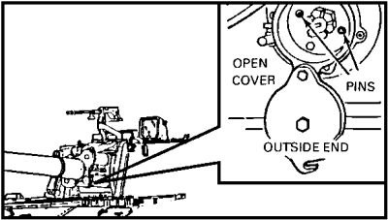

Figure 5. Recuperator cylinder, front view, outside end.

(2) Check the index guide pins (Figure 6) and the locking nut at the inside end of the recuperator cylinder. The guide pins must stick out at least 1/8 inch, but not more than 3/4 inch. The locking nut must be secure and the cotter pin must be in place.

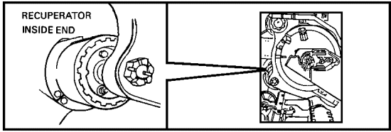

Figure 6. Recuperator cylinder, rear view, inside.

(3) Check the two recoil rod locking nuts (Figure 7) to make sure they are secure.

(4) Check the level of hydraulic oil in the replenisher by reading the replenisher pressure gage (Figure 8). It must read between 17 and 50 pounds per square inch (psi). Also check this gage frequently during firing.

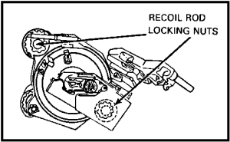

Figure 7. Recoil rod locking nuts.

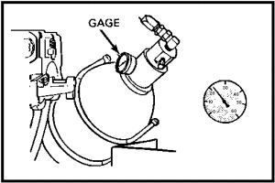

Figure 8. Replenisher pressure gage.

b. Tube, breech, and firing mechanism. In addition to the four checks shown, six more are required for the tube, breech, and firing mechanism.

(1) Open the breech block. Then check the breech operating handle (Figure 9) to ensure that it is securely latched to prevent injury to personnel.

(2) Check the bore and chamber of the cannon (Figure 9) to see that it is not blocked, dirty, or visibly damaged. A bore check is also required after each round is fired and the chamber has been swabbed to ensure no smoldering powder or propellant residue remains.

(3) Check the primer vent hole and chamber (Figure 9) to ensure that the primer vent (Figure 9) is clear.

(4) Close the breech block, and check the alignment of the witness marks (Figure 11). If the witness marks do not align, the breechblock is not closing completely.

(5) Check the firing pin (Figure 11) for a mushroomed or broken point.

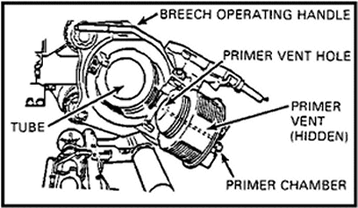

Figure 9. Tube and primer vent hole.

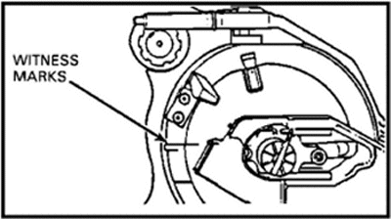

Figure 10. Firing mechanism.

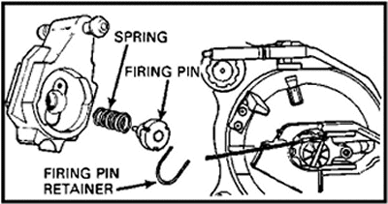

Figure 11. Breech mechanism.

(6) Check the operation of the firing mechanism (Figure 11) with a steady pull on the lanyard.

NOTE: To prevent mushrooming firing pins, always ensure the firing mechanism follower group is fully closed before pulling the lanyard.



FOR A NEWLY ISSUED OR RETUBED CANNON, MAKE THE FOLLOWING CHECKS BEFORE INITIAL FIRING TO MAKE SURE THE TUBE HAS BEEN ASSEMBLED PROPERLY.

- The rear face of the gun tube (Figure 12 ) must be flush with the forward shoulder of the breech ring .

- Measure the distance from the rear face of the howitzer tube to the rear of the breech ring. This must measure 5 inches.

- If either of these checks are incorrect, do not fire the gun. The howitzer is unsafe and may blow up when fired.

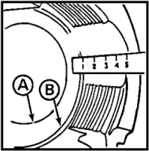

Figure 12. Gun tube.

- Even if you obtain these measurements, fire the first round using a 50-foot lanyard after major work has been done by direct support (DS) or general support (GS) maintenance.

PRACTICE EXERCISES:

16. Prefire checks, tests, and alignments serve these three purposes:

a. Ensures that the howitzer fires _____________.
b. Ensures that all components function ________________.
c. Prevents ______________ to equipment or _______________ to personnel.

17. There are four ___________ and four ______ ______ for the recoil system.

18. The guide pins on the recuperator cylinder must stick out between __________ and _____________ inch when the system is properly charged with hydraulic fluid.

19. The correct pressure for the replenisher is _____ _____ _____ _____.

20. Correct alignment of witness marks on the breech mechanism indicate _____________ _____________ of the breechblock.

21. Correct mating of the breech to the cannon tube can be checked by measuring _______ ________ from the face of the cannon tube to the rear of the breech ring.

//////////////////////////////////////////////////////////////////////////////////////////////////////////////////////////////////////////////////////////////////

ANSWERS:

16. a. accurately.
b. properly.
c. damage, injury
17. functions, prefire checks.
18. 1/8, 3/4
19. 17 to 50 psi.
20. complete closing
21. 5 inches.

//////////////////////////////////////////////////////////////////////////////////////////////////////////////////////////////////////////////////////////////////

7. FIRE CONTROL ALIGNMENT TESTS. One of the many factors contributing to accurate field artillery fire is the accurate setting of firing data (deflection and quadrant elevation) on the fire control equipment used with the weapon. Great care is taken during firing to ensure fire commands are set accurately on fire control instruments. But, regardless of the accuracy of the weapon crew in making settings, the settings will not be true unless the fire control equipment is accurately aligned. The accuracy of artillery weapons depends to a great extent on both accurate firing data on the fire control instruments and the proper alignment of sighting and laying equipment and the relationship of that equipment to the axis of the bore of the weapon. Misalignment is normally caused by:

- Extensive use of the equipment (excessive wear).

- Stress (shock) from repeated firing of the weapon.

- Travel of the weapon over rough terrain.

Fire control alignment tests will show whether the fire control equipment is correctly aligned. Tests are performed to ensure the proper relationship between the sighting and laying equipment and the axis of the bore of the weapon. These tests and adjustments are performed by the section crew members under the supervision of the battery executive officer, chief of firing battery, and artillery mechanic, at the discretion of the unit commander. Suggested times (intervals) for these tests are:

- Once each year if the weapon is used for nonfiring training.

- Every 3 months if the weapon is fired.

- As soon as possible after extensive use, an accident, or travel over extremely rough terrain.

- After fire control mounts have been replaced.

- When fire is inaccurate for no apparent reason.

a. Equipment and tools. The following tools and equipment are required for fire control alignment tests:

- Three 10-ton jacks.

- Plumb line--a cord at least 22 feet long with an object (plumb bob) that weighs at least 1/2 pound tied to the end.

- Muzzle cross hairs.

- Breech boresight disk.

- Gunner's quadrant.

- Test target.

- A 5-gallon container (bucket) of water or used oil.

- Gun tube leveling fixture (bar) when available.

b. Pretest activities. Before undertaking the fire control alignment tests, ensure that all routine maintenance of the weapon and its associated fire control equipment has been performed and any deficiencies that would prevent successful completion of the test have been corrected. Additional preparations necessary before the actual fire control alignment tests can begin are:

(1) Site selection. Select a site for the test that is as firm and level as possible, preferably a hardstand if one is available. In addition, if the plumb line method of leveling the trunnions is to be used, select a site near an object from which a plumb line can be suspended. The site must allow emplacement of the weapon so that the muzzle of the tube is within 12 inches of the plumb line and the alignment of the axis of the tube on the plumb line is near the center of traverse (less than 100 mils from the center of traverse).

(2) Equipment. Ensure that all equipment for performing the test is on hand.

(3) Emplacement. Emplace the weapon at the selected site.

(4) Fire control equipment and mounts. Check the M15 elevation quadrant, the M117 pantel, and the M145 telescope mount for looseness or other obvious defects. Install the M117 pantel securely, using both latches.

(5) Gunner's quadrant. Inspect the gunner's quadrant shoes for dirt, nicks, or burrs. Clean the shoes with an oil rag. If nicks and burrs are present, do not use the gunner's quadrant; notify organizational maintenance. Perform the gunner's quadrant micrometer and end-for-end test (para 8).

(6) Prepare the weapon. Prepare the weapon for the tests by first--

- leveling the trunnions (paragraph 9).

- zeroing (leveling) the tube (paragraph 10).

(7) Tube drop. Stability of the cannon assembly (tube drop) should be checked as follows:

- Using the gunner's quadrant, place the tube at +266 mils of elevation.

- Turn off the cab power switch, and wait 1 hour.

- After the waiting period, check the tube elevation again with the gunner's quadrant. The tube should not have moved more than 3.0 mils.

- If the movement was greater than 3.0 mils, check the weapon equilibrator according to procedures at Lesson 2, paragraph 15, and/or notify organizational maintenance personnel.

Applicable fire control equipment alignment tests can be performed after the above preparations are done.

PRACTICE EXERCISES:

22. T F The accuracy of artillery fire depends totally on accurate settings of firing data by the crew.

23. T F A howitzer may fire a large number of missions without needing its fire control equipment realigned as long as it is not moved from the firing point.

24. T F Tube drop tests are performed with the tube at +266 mils of elevation over a 1-hour waiting period.

//////////////////////////////////////////////////////////////////////////////////////////////////////////////////////////////////////////////////////////////////

ANSWERS:

22. F
23. F
24. T

//////////////////////////////////////////////////////////////////////////////////////////////////////////////////////////////////////////////////////////////////

8. GUNNER'S QUADRANT. The gunner's quadrant has a frame with a graduated arc, an index arm, a micrometer knob and scale, a bubble, and machined reference surfaces. The arc is graduated in 10-mil increments from 0 to 800 mils on the left side and from 800 to 1,600 mils on the right side. The teeth on the arc position the index plunger at the 10-mil graduations. The index micrometer scale is graduated in 0.2-mil increments from 0 to 10 mils. One complete revolution of the index micrometer knob raises or lowers the index arm 10 mils. The index micrometer scale is numbered with black figures. The line-of-fire (direction-of-fire) arrows indicate the manner in which the gunner's quadrant is placed on the quadrant seats of the weapon.

NOTE: The M1A1 gunner's quadrant differs from the M1 as follows: The M1A1 has a micrometer mask to ensure use of the correct micrometer scale, it has an indicator on the index arm, and the index mark on the micrometer is numbered 10 rather than 0. The M1A2 gunner's quadrant differs from the M1A1 in that the level vial is self-illuminated by a radioactive material, tritium gas (H3). The gunner's quadrant is used in laying any field artillery howitzer for elevation and when making sight tests and adjustments. It can also be used when the on-carriage range (elevation) quadrant is inoperative or, when necessary, to split a mil in elevation. However, the gunner's quadrant will not measure a true vertical angle (elevation) when the weapon is canted.

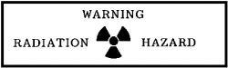

THE M1A2 GUNNER'S QUADRANT (FIGURE 13) IS RADIOACTIVELY ILLUMINATED AND SHOULD BE CHECKED BEFORE USING FOR ILLUMINATION IN A LOW LIGHT ENVIRONMENT. IF NOT ILLUMINATED, FOLLOW RADIATION HAZARD PROCEDURES LISTED IN THE -10 MANUAL.

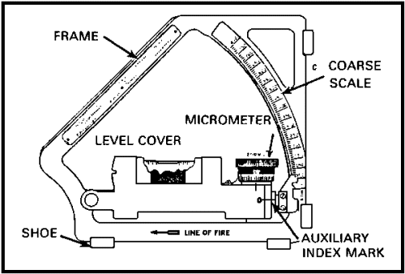

Figure 13. M1A2 gunner's quadrant.

NOTE: Before a quadrant is used for sight tests and adjustment of on-carriage fire control equipment, it must be checked for accuracy by an end-for-end test and a micrometer test.

a. Micrometer test. Ensure that the gunner's quadrant shoes and the quadrant seats of the M15 quadrant have been inspected and cleaned before performing this test. The micrometer test is performed in the following sequence (Figure 14):

Set the index to a reading of +10 mils.

Set the micrometer knob to 0 mils.

Place the gunner's quadrant on the M15 quadrant seats, with the line-of-fire arrow pointing toward the muzzle.

Elevate or depress the tube until the bubble in the gunner's quadrant levels.

Do not disturb the position of the tube. Set the index arm at 0.

Set the micrometer knob to a reading of +10 mils.

Place the quadrant with the line-of-fire arrow pointing toward the muzzle. The level vial bubble should center.

If the bubble centers, the test is complete. Proceed to the end-for-end test.

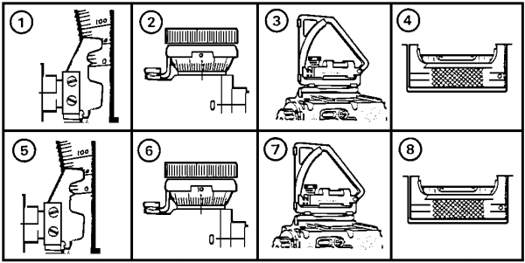

Figure 14. Steps for micrometer test.

NOTE: If the bubble does not recenter, the micrometer is out of adjustment and the gunner's quadrant should be turned in to DS maintenance for repair.

b. End-for-end test. Ensure that the gunner's quadrant shoes and the quadrant seats of the M15 quadrant have been inspected and cleaned before performing this test. Then proceed as follows (Figure 15):

Set the gunner's quadrant index arm and micrometer scale at 0 mils.

Place the gunner's quadrant on the M15 quadrant seats with the line-of-fire arrow toward the muzzle.

Elevate or depress the tube until the bubble in the gunner's quadrant level vial is centered.

Reverse the gunner' s quadrant, and check the bubble (line-of-fire arrow toward the breech).

NOTE: If the bubble recenters at step , the gunner's quadrant is in proper alignment, and the test is complete.

The bubble should recenter in the leveling vial of the gunner's quadrant. If not, go to step .

Center the bubble using the micrometer knob. If the bubble centers, go to step . If not, go to step .

Read the black figures. Divide the micrometer reading by 2 to determine a positive correction factor.

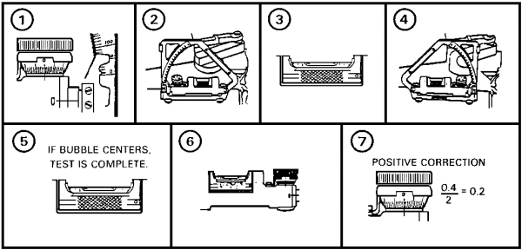

Figure 15. Steps 1 through 7 of the end-for-end test.

NOTE: If you can center the bubble by turning the micrometer knob in step , the gunner's quadrant error is positive. Read the black figures on the micrometer scale, and divide this reading by 2 to determine the correction factor for this gunner's quadrant. Using a grease pencil, record the correction factor on the gunner's quadrant case. Now double-check (steps through Figure 16).

Place the correction factor from step on the micrometer scale of the gunner's quadrant.

Place the gunner's quadrant on the quadrant seats of the M15 quadrant with the line-of-fire arrow pointing toward the muzzle.

Elevate or depress the tube to center the bubble in the gunner's quadrant leveling vial.

Reverse the direction of the gunner's quadrant.

The bubble should center. The end-for-end test is completed.

Record the correction factor of the end-for-end test on the gunner's quadrant carrying case.

NOTE: If the bubble does not recenter when the micrometer knob is turned in step (6) above, the correction factor is negative. Move the gunner's quadrant index arm down one graduation (-10 mils), and turn the micrometer knob until the bubble centers.

Set the quadrant index arm at -10 mils.

Center the bubble in the leveling vial using the micrometer knob.

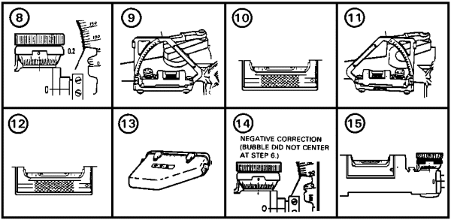

Figure 16. Steps 8 through 15 of the end-for-end test.

Read the black numbers on the micrometer scale (example: 9.8), add 10 mils to that reading, and divide the sum by 2. 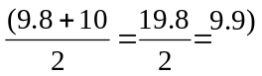 This is your trial correction. Place the result on the micrometer scale. (See Figure 17.)

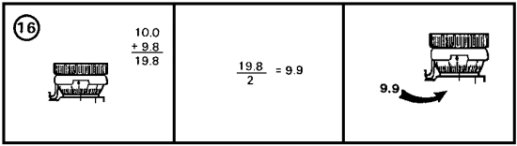

Figure 17. Step 16 of the end-for-end test.

With the gunner's quadrant index arm at -10 mils and the results obtained in step set on the micrometer scale, place the quadrant back on the quadrant seats with the line-of-fire arrow pointing toward the muzzle. Elevate or depress the tube until the bubble in the gunner's quadrant level vial centers. (See Figure 18.)

- Place the gunner's quadrant on the M15 quadrant seats with the line-of-fire arrow pointing toward the muzzle.

- Elevate or depress the tube to center the bubble in the leveling vial of the gunner's quadrant.

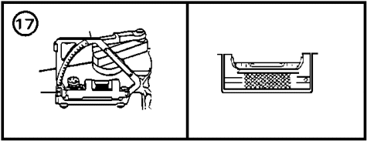

Figure 18. Step 17 of the end-for-end test.

When the bubble is centered in the vial, reverse the quadrant. The bubble should recenter. (See Figure 19.)

- Reverse the direction of the gunner's quadrant.

- The bubble should center in the leveling vial. The end-for-end test is completed.

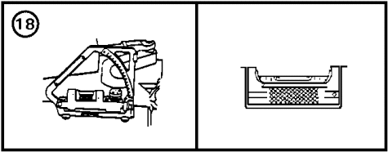

Figure 19. Step 18 of the end-for-end test.

The final step determines the correction factor. Subtract the micrometer reading from 10. Since this is a negative correction, a minus sign must be placed in front of the correction factor (Figure 20).

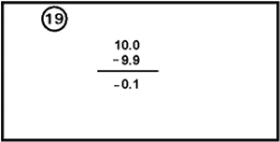

Figure 20. Step 19 for end-for-end test.

Using a grease pencil, record the correction factor (negative end-for-end correction) on the gunner's quadrant case (Figure 21).

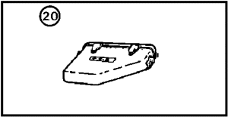

Figure 21. Step 20 for end-for-end test.

c. Application. If a correction (+ or - ) for the error is determined during the end-for-end test of the gunner's quadrant, it will be carried only during fire control equipment tests and adjustments. Do not apply this correction factor for elevation during fire missions. However, if the correction for the error is more than 0.4 mils, the gunner's quadrant must be turned in to DS maintenance as early as possible for repair and adjustment.

PRACTICE EXERCISES:

25. Which elevation setting can be indicated on the right elevation arc of the gunner's quadrant?

a. 400 mils
b. 600 mils
c. 700 mils
d. 900 mils

26. What is the maximum permissible (+ or -) error for a serviceable gunner's quadrant?

a. 0.3
b. 0.4
c. 0.5
d. 0.6

27. What is the smallest graduation other than 0 that can be set on the gunner's quadrant for elevation readings?

a. 0.2 mils
b. 1/2 mil
c. 1 mil
d. 10 mils

28. The gunner's quadrant is checked for accuracy by performing the following tests:

(fill in the blank)

a. _____________________________________________.

b. _____________________________________________.

29. SITUATION: You have just completed the end-for-end test on your gunner's quadrant. The final reading on the micrometer scale was 8.6 with the index arm at -10.

PROBLEM:

a. What is your correction factor? ____________________.

b. Is this gunner's quadrant serviceable? _____________________.

//////////////////////////////////////////////////////////////////////////////////////////////////////////////////////////////////////////////////////////////////

ANSWERS:

25. d.
26. b.
27. a.
28. a. micrometer test.
b. end-for-end test.
29. SOLUTION:

a. Subtract the final micrometer reading from 10:

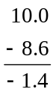 The correction factor is -1.4 mils.

b. No, the error is in excess of 0.4 mil.

//////////////////////////////////////////////////////////////////////////////////////////////////////////////////////////////////////////////////////////////////

9. TRUNNIONS.

a. Function of trunnions. The trunnions of the cradle (Figure 22) furnish an axis about which the tipping parts of the cannon rotate in elevation.

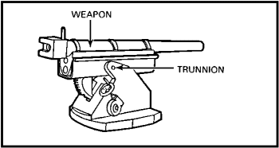

Figure 22. Location of trunnion on weapon mount.

On the M109A2/A3, the trunnions rest in trunnion bearings (Figure 23) on the M178 howitzer mount and cradle. The elevation mechanism is coupled to the cradle by means of the elevating arc fastened to the bottom of the cradle. The cradle supports the recoiling parts and moves in elevation with them.

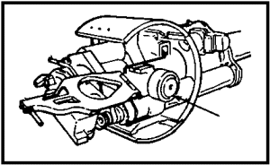

Figure 23. Howitzer mount M178--trunnion bearing.

Since the trunnions are an integral part of the weapon, leveling the trunnions requires leveling of the whole carriage. Trunnions must be leveled to eliminate cant and to ensure that the fire control equipment mounts are parallel with the tube. If trunnions are canted, the results of the fire control alignment tests will not be accurate. There are two methods to level the trunnions:

- Plumb line tracking method.

- Scribe mount method.

b. Level the trunnions--plumb line method. To level the trunnions using the plumb line method, follow these procedures:

(1) Position the weapon, and attach the muzzle boresight cross hairs (Figure 24).

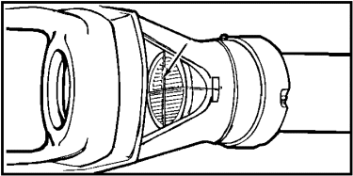

Figure 24. Boresight cross hairs.

(2) Open the breechblock, and install the breech boresight disk (Figure 25).

(3) Suspend the plumb line, with weight attached and placed in the bucket of water, at a location where there is little or no wind (Figure 26). The plumb line must be at least 22 feet high to allow elevating the tube to 600 mils.

(4) Position the weapon so that the muzzle end of the tube is within 12 inches of the plumb line (Figure 27).
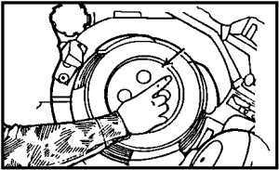

Figure 25. Breech boresight disk.

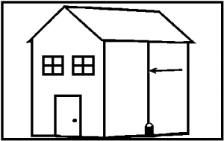

Figure 26. Suspend plumb line.

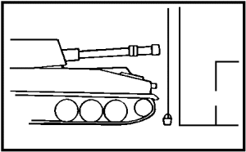

Figure 27. Muzzle within 12 inches.

(5) Position the jacks under the weapon; place one jack in center front of the vehicle (Figure 28). Raise the jack until it supports a part of the weight of the vehicle. This will allow the weapon to tilt when the rear jacks are raised.

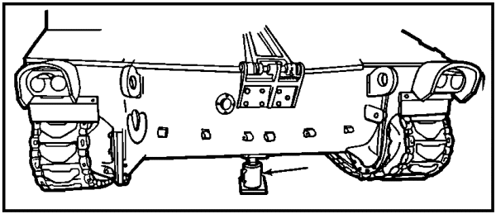

Figure 28. Jack in center front.

(6) Place the other jacks in the rear of the vehicle, one under the left and the other under the right side of the vehicle, to form three points of contact (Figure 29).

NOTE: Hydraulic jacks may leak and allow the weapon to lower. This will make the test invalid or inaccurate. Ensure the hydraulic jacks do not leak.

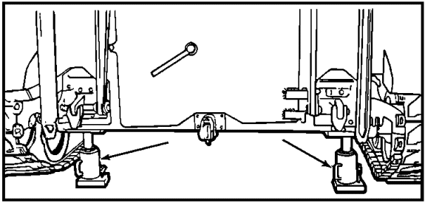

Figure 29. Jacks in rear of vehicle.

(7) Release the tube travel lock and the cab traverse lock.

(8) Turn on the lights of the M145 mount and the M15 quadrant.

(9) Manually elevate or depress the tube until the tube is at zero elevation.

(10) Now, look through the breech boresight (Figure 30) while an assistant manually traverses the tube until the vertical cross hair on the muzzle boresight is aligned next to the plumb line. The maximum allowable traverse from center position is 100 mils left or right. If you have to traverse more than 100 mils left or right, reposition the weapon or move the plumb line.

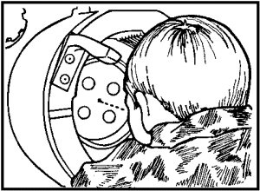

Figure 30. Breech boresight.

(11) Looking through the breech boresight disk "peephole," observe the relationship of the vertical cross hair to the plumb line until proper alignment is achieved as follows:

- If the top of the vertical cross hair moves to the right of the plumb line (Figure 31), the right side of the weapon must be jacked up and the tube traversed to realign the vertical cross hair with the plumb line.

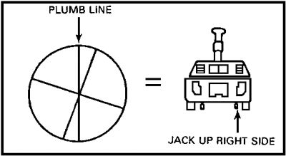

Figure 31. Cross hair right of plumb line.

- If the top of the vertical cross hair moves to the left of the plumb line (Figure 32), the left side of the weapon must be jacked up and the tube traversed to realign the vertical cross hair with the plumb line.

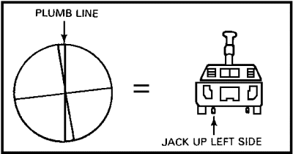

Figure 32. Cross hair to left of plumb line.

- Proper alignment is achieved when the vertical cross hair is parallel to the plumb line (Figure 33).



Figure 33. Cross hair parallel to plumb line.

(12) To verify that the trunnions are level, elevate the tube manually in 100-mil increments up to 600 mils while observing the plumb line through the breech boresight disk. Jack the weapon as required, and traverse the tube to keep the cross hair parallel to the plumb line.

(13) Reset the elevation mil counter on the elevation quadrant to 0 mils. Slowly depress the tube to 0 mils while observing the plumb line. The cross hair should track the plumb line at all elevations. When it does, the trunnions are level. Otherwise, repeat step 11.

c. Level the trunnions--scribed line method. To level the trunnions using the scribed lines, position the weapon on firm and level ground or on a hardstand, if one is available.

(1) Turn on the M15 quadrant lights, and carefully align the scribe lines as shown in Figure 34 and .

(2) Set 0 mils on the M15 quadrant, and level the elevation bubble by elevating or depressing the tube manually.

(3) Slowly traverse the tube (manually) in either direction while observing the cross-level bubble . Stop traversing when the cross-level bubble centers. Now manually elevate or depress the tube until the elevation bubble centers. Recheck the cross-level bubble.

(4) If the cross-level bubble remains exactly centered, the trunnions are level. If not, repeat the process until the cross-level bubble remains centered at the same time that the elevation bubble is centered. The trunnions are now level.

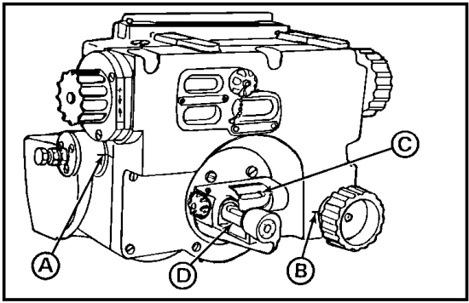

Figure 34. M15 elevation quadrant.

PRACTICE EXERCISES:

30. The tipping parts of the cannon rotate in elevation about an axis which is furnished by the--

a. cradle.
b. elevation arc.
c. trunnions.
d. traversing handwheel.

31. The trunnions must be leveled before making other tests and adjustments to eliminate--

a. cant.
b. parallax.
c. droop.
d. sway.

32. When leveling trunnions using the plumb line method, the plumb line must be at least--

a. 10 feet high.
b. 12 feet high.
c. 22 feet high.
d. 24 feet high.

33. Hydraulic jacks are placed under the vehicle to form--

a. 2 points of contact.
b. 3 points of contact.
c. 4 points of contact.
d. 6 points of contact.

34. When tracking the plumb line through the breech boresight disk, the tube must be elevated manually in--

a. 100-mil increments to 600 mils.
b. 50-mil increments to 600 mils.
c. 20-mil increments to 776 mils.
d. 10-mil increments to 100 mils.

35. The trunnions are level when the--

a. cross-level bubbles on the elevation quadrant are centered.
b. cross-hair tracks the plumb line at all elevations.
c. cross-level bubbles on the pantel mount are centered.
d. hydraulic jacks can be removed without disturbing the sight picture.

36. The scribed line method of leveling the trunnions is done by aligning the scribe lines on the M15 elevation quadrant and then--

a. elevating the tube to 600 mils in elevation.
b. hydraulically jacking up the vehicle until the trunnions are level.
c. traversing the tube at 0 mils elevation until the cross-level bubble centers.
d. elevating the tube in 100- to 600-mil increments or until the pantel mount bubbles center.

//////////////////////////////////////////////////////////////////////////////////////////////////////////////////////////////////////////////////////////////////

ANSWERS.

30. c.
31. a.
32. c.
33. b.
34. a.
35. b.
36. c.

//////////////////////////////////////////////////////////////////////////////////////////////////////////////////////////////////////////////////////////////////

10. TUBE LEVELING.

a. Leveling (zeroing) the tube using the gun tube leveling fixture (bar). The purpose of this test is to ensure that an absolute parallel relationship exists between the axis of the bore and the reading on your M15 elevation quadrant.

NOTE: Recheck the trunnions. They must be level for this test. The gun tube must be clean and dry.

(1) Set 0 on the M15 quadrant. Manually elevate or depress the tube until the bubble in the elevation level vial centers.

(2) Remove the gun tube leveling bar from its case and, using the following procedure, install the bar:

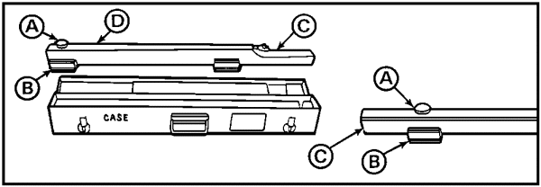

Figure 35. Installing the bar.

- Remove the screw (Figure 35 ) of the moveable shoe on the leveling bar , and move the shoe to the plainly marked 155-mm position .

- Replace the screw in the proper hole, and tighten the screw securely.

- Loosen the screw (Figure 36 ), and insert the cross-level vial under the holder on the leveling bar. Tighten the screw , then place the magnet base stop on this screw protruding through the leveling bar from the cross-level holder. Tighten the magnet base stop screw securely.

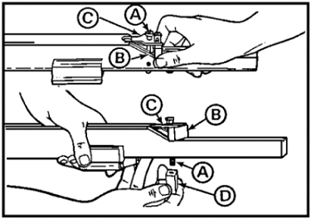

Figure 36. Installing the bar (continued).

- Insert the leveling bar into the muzzle end of the tube to the point at which the magnet base stop (Figure 37 ) contacts the face of the gun tube . Be sure the magnet is flush with the tube.

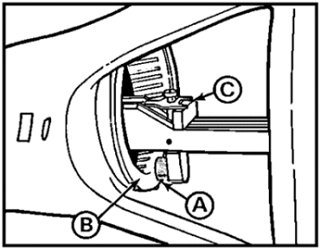

Figure 37. Insert bar into muzzle end.

- Rotate the leveling bar until the cross-level vial bubble is centered.

(3) Now place a pretested gunner's quadrant set at 0 mils (with correction factor applied) in the groove (Figure 38) of the leveling bar with the line-of-fire arrow pointing to the muzzle end of the gun.

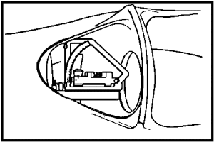

Figure 38. Place quadrant in groove.

(4) Manually elevate or depress the tube until the bubble in the gunner's quadrant leveling vial is centered.

(5) Reverse the position of the gunner's quadrant on the leveling bar groove. The level vial bubble should recenter.

(6) Now check the M15 elevation quadrant level bubble. It should still be centered. If not, notify support maintenance.

b. Leveling the tube--gunner's quadrant on the breech. If the gun tube leveling fixture (bar) is not available, zeroing (leveling) the tube can be done using the following procedure.

NOTE: Again ensure the vehicle is on level ground and the trunnions are level.

BECAUSE THE BREECHBLOCK MUST BE OPEN AND THE HANDLE LEFT UNLOCKED, KEEP ALL PERSONNEL CLEAR OF THE BREECH MECHANISM. DO NOT LIFT THE CRADLE CAM BEFORE SECURING THE OPERATING HANDLE.

c. The cannon has quadrant seats on the top muzzle end of the tube and on the top of the breech ring. The embedded correction (the difference between muzzle and breech elevation) is measured rather than stamped on the breech. (Breechblocks that have stamped embedded corrections should be disregarded during the tube leveling test.)

(1) Place a tested gunner's quadrant on the top surface of the muzzle quadrant seat (Figure 39). Apply only the gunner's quadrant correction, if any, and center the bubble by manually elevating or depressing the tube. The tube is now at 0 mils.

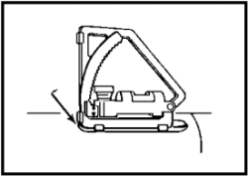

Figure 39. Gunner's quadrant on muzzle quadrant seat.

(2) Place the gunner's quadrant on the breech ring quadrant seat (Figure 40), and center the bubble.

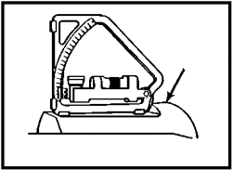

Figure 40. Gunner's quadrant on breech ring quadrant seat.

(3) The reading on the gunner's quadrant is the total of the gunner's quadrant correction and the measured correction. Subtract the gunner's quadrant correction (if any) from the total to find the measured correction. For example:

Total on gunner's quadrant | +2.3 |  | +1.8 |  | -2.0 |  | -1.6
Gunner's quadrant correction | +0.3 | or | -0.2 | or | +0.1 | or | -0.3
Measured correction | +2.0 |  | +2.0 |  | -2.1 |  | -1.3

NOTE: Failure to compensate for measured correction will result in misalignment on the weapon being checked. The measured correction shall be redetermined when a breech is retubed.

(4) Record the measured correction in the remarks column on DA Form 2408-4 (Weapon Record Data). Refer to the measured correction when making elevation settings with the gunner's quadrant.

(5) Secure the handle, and close the breechblock.

PRACTICE EXERCISES:

37. The gun tube leveling fixture is mounted in the __________ _________ of the howitzer tube.

38. Actual leveling (zeroing) of the tube is done with a ______ ______ ______, whether or not a leveling fixture is used.

39. The purpose of zeroing the tube is to ensure that an absolute ____________ relationship exists between the _________ of the bore and the reading on the ______________ ______________ quadrant.

40. Before leveling the tube with the gunner's quadrant on the breech, you must first determine and then apply the ______________ correction to a ____________ gunner's quadrant.

41. SITUATION: You are preparing to zero the tube using the gunner's quadrant on breech method. Your gunner's quadrant has a -0.2 correction factor. The measured correction for the breech of your howitzer is +0.8.

PROBLEM: a. Determine the total correction to be set on the gunner's quadrant.

b. For what other purpose will you use this total correction?

//////////////////////////////////////////////////////////////////////////////////////////////////////////////////////////////////////////////////////////////////

ANSWERS:

37. muzzle end
38. pretested gunner's quadrant
39. parallel, axis, M15 elevation
40. measured, pretested

41. SOLUTION:

a. Gunner's quadrant correction factor: -0.2
Embedded correction on breech: +0.8
Total correction placed on gunner's quadrant: +0.6

b. None.

//////////////////////////////////////////////////////////////////////////////////////////////////////////////////////////////////////////////////////////////////

11. DEFLECTION RELIABILITY. With the foregoing preliminary tests and adjustments completed and with the howitzer remaining at the selected test site and in testing configuration, you may now proceed to perform deflection reliability tests. First, you should review and refamiliarize yourself with the basic characteristics and the critical components and controls of the M117 pantel. The M117 pantel (Figure 41) is the basic instrument used in laying the weapon for direction. The M117 has an azimuth counter that permits readings from 0 to 6,400 mils. It is mounted directly on the M145 telescope mount. It is a 4-power, fixed-focus telescope with a 10° field of view. It is equipped with a mechanical counter device. Included also is a reset counter, which can be set to show a reading of 3,200 mils when the telescope is aligned with the aiming point. A gunner' s aid counter mechanism is an integral part of the counter mechanism and permits special corrections to be entered for factors peculiar to the individual weapon and its emplacement. The 90° head prism, objective lens, reticle, and erector lens are included in a single assembly. This design eliminates relative movement between the reticle and the 90° head prism as the cab rotates.

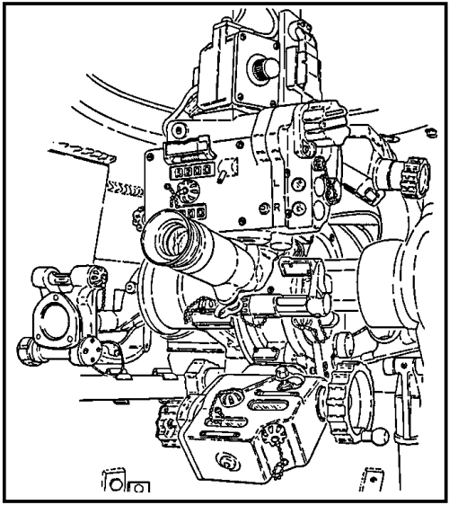

Figure 41. M117 Pantel.

a. Testing reliability of deflection. To perform deflection reliability tests, follow the procedural steps described below and note the critical points shown in Figure 42.

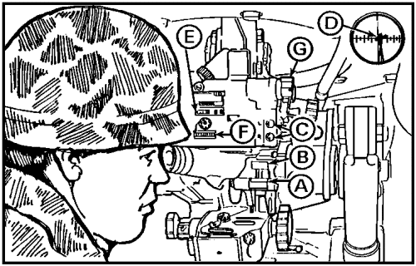

Figure 42. Deflection reliability checks.

(1) Install the M117 pantel in the M145 mount on the weapon.

(2) Center the bubbles in the cross-level (Figure 42 ) and pitch-level vials of the pantel, and set the gunner's aid counter to 0.

(3) Sight on a reference point by turning the azimuth knob. The reference point should be at least 50 meters away.

(4) Record the reading on the azimuth counter . Push in and turn the reset knob to obtain a reading of 3200 on the reset counter .

(5) Now turn the azimuth knob in a clockwise direction until you have rotated the telescope through two complete circles, and return to the reference point, taking care to stop at exactly the same point (sight picture).

NOTE: Rotation of the azimuth knob should be done smoothly for the two complete turns. If you pass the reference point on the second circle, turn back past the reference point at least 50 mils (counterclockwise) and reapproach the reference point clockwise from left to right.

(6) With a correct sight picture appearing in the pantel lens and with all bubbles level, instrument readings should be as follows:

- Azimuth counter -- the same as that recorded in step 4, ± 1 mil.

- Reset counter -- 6000 ± 1 mil.

- Gunner's aid counter -- at 0.

(7) If these readings do not appear as stated, the telescope is out of adjustment and should be referred to support maintenance.

c. Testing reliability of special corrections. With the howitzer maintained in testing configuration, follow the procedures described below and note the critical points shown in Figure 43.

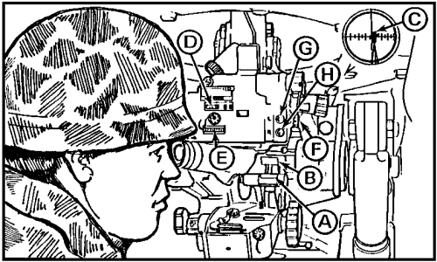

Figure 43. Special corrections reliability checks.

(1) Center the bubbles in the cross-level vial and the pitch-level vial of the pantel.

(2) Look through the eyepiece, and sight on a reference point at least 50 meters distant.

(3) Record the reading on the azimuth counter . Push in and turn the reset knob to obtain a reading of 3200 on the reset counter .

(4) Turn the gunner's aid knob to insert a 10-mil special correction into the left gunner's aid counter .

(5) Now check to verify the following instrument readings:

- The line of sight (sight picture) must be on the reference point.

- The azimuth counter reading should be unchanged (a 1/4-mil deviation is within tolerance).

- The reset counter should be changed by 10 mils.

(6) Repeat steps 4 and 5 above for 20, 30, and 40 mils.

(7) Repeat steps 4, 5, and 6 above using the right gunner's aid counter .

(8) If the prescribed readings are not obtained, the telescope is out of adjustment and should be referred to support maintenance.

d. Testing the M145 telescope mount (azimuth walk off). If this test is being performed independently, you must install the M117 pantel in the mount, recheck the trunnions to ensure they are perfectly level, and depress the tube to 0 mils before conducting this test. Then proceed as follows:

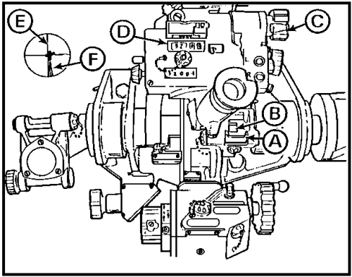

Figure 44. M145 telescope mount test.

(1) Center the bubbles in the cross-level vial (Figure 44 ) and pitch-level vial .

(2) Turn the azimuth knob to place the vertical reticle of the pantel on any stationary object, at any deflection. Be sure to approach the object from left to right. Record the reading on the azimuth counter to the nearest 1/4 mil.

NOTE: Be careful not to traverse the tube.

(3) Elevate the tube to 400 mils. Center bubbles and , and turn the azimuth knob to realign the vertical reticle on the same stationary object . Make sure you approach the object from left to right. The reading on the azimuth counter must be within ± 1 mil of the reading taken in step (2) above. If not, refer to support maintenance for repair and adjustment.

(4) Elevate the tube to 900 mils. Center bubbles and and realign the vertical reticle (as in 3 above) on the same stationary object. Approach the object from left to right. The reading on the azimuth counter must be within ± 2 mils of the reading taken in step (2) above. If not, refer to support maintenance for repair and adjustment.

PRACTICE EXERCISES:

42. The principal instrument used in laying the M109A2/A3 howitzer for direction is the ___________ pantel.

43. When performing deflection reliability checks, the reference point should be at least--

a. 50 meters away.
b. 500 meters away.
c. 1,000 meters away.
d. 6,400 mils away.

44. The pantel is out of adjustment and should be turned in to support maintenance for repair when the azimuth counter and/or the reset counter show an error of more than--

a. ± 0.2 mils.
b. ± 0.4 mils.
c. ± 1.0 mil.
d. 0 mils.

45. The reliability of special corrections is tested by applying 10-mil incremental readings to the--

a. gunner's aid.
b. azimuth scale.
c. reset counter.
d. azimuth counter.

46. Before testing the M145 telescope mount, you must take all except which of the following preliminary steps?

a. Mount the M117 pantel.
b. Mount the M118C elbow telescope.
c. Recheck the level of the trunnions.
d. Depress the tube to 0 mils.

47. The azimuth walk-off test is performed with the tube at 0 mils and at--

a. 200 and 400 mils of elevation.
b. 400 and 600 mils of elevation.
c. 400 and 900 mils of elevation.
d. 600 and 900 mils of elevation.

//////////////////////////////////////////////////////////////////////////////////////////////////////////////////////////////////////////////////////////////////

ANSWERS:

42. M117
43. a.
44. c.
45. a.
46. b.
47. c.

//////////////////////////////////////////////////////////////////////////////////////////////////////////////////////////////////////////////////////////////////

12. M15 ELEVATION QUADRANT. The M15 elevation quadrant (Figure 45), mounted directly on the right-hand trunnion, is used for adjustment of the weapon in elevation when two men are laying the weapon. The M15 elevation quadrant is equipped with a mechanical mil counter for elevation readings. Correction counters are built in to permit quick, accurate insertion of elevation correction factors peculiar to the individual howitzer and howitzer emplacement. Quadrant seats are provided on the instrument to allow the use of the M1A2 gunner's quadrant when fine elevation settings are required. A mounting bracket for the elevation quadrant is precisely machined and aligned so that when the instrument is installed complex adjustments are unnecessary and only an accuracy check is required. The controls on the elevation quadrant are identical with corresponding controls on the M145 pantel mount. The M15 quadrant is scribed so that the crew may accurately level the trunnions without using a plumb line. Once scribe lines have been applied, it will be necessary only to verify alignment when in a field location. Review the major components and location of controls on the M15 quadrant in Figure 45, then proceed to the step-by-step instructions for testing and scribing the quadrant.

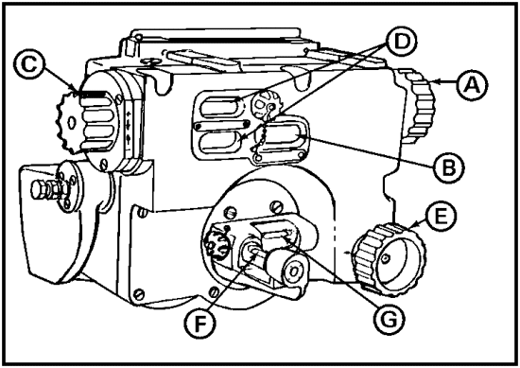

Figure 45. M15 elevation quadrant.

a. Testing and scribing the M15 elevation quadrant.

(1) Ensure that the trunnions are still level, with the vehicle resting on the jacks, as explained in paragraph 9b.

(2) Level all bubbles and zero all instrument readings as follows:

- Turn the elevation knob (Figure 45 ) to place the elevation mil counter on 0.

- Turn the correction knob to place the correction counter dials on 0.

- Turn the cross-level knob to center the cross-level vial bubble .

(3) Manually elevate or depress the tube until the bubble in the elevation vial centers and the tube is at zero elevation. The elevation counter and the correction counter should still read 0. Relevel the cross-level vial if necessary.

(4) Set the elevation mil counter to 600 while watching the crosslevel vial bubble and slowly elevate the tube to 600 mils. During elevation movement, the bubble must not move over 2 graduation marks from the center of the vial. If it does, the quadrant may be defective; notify support maintenance.

(5) Set the elevation mil counter to 0 mils, and depress the tube to 0 mils. Again observe the cross-level vial bubble . It must not move over 2 graduation marks on the vial.

(6) When the tube is at zero elevation, carefully recenter the crosslevel bubble , if necessary.

NOTE: Scribe lines provide a permanent reference point at which a level, or zero, relationship exists. Great care is required to ensure a fine line that can give an accurate zero reading at future checks and alignments is engraved. Therefore, use a sharp-bladed knife to cut the scribe lines on the prescribed locations. Also, use a steel straight edge to guide the knife and to ensure the lines are even with each other.

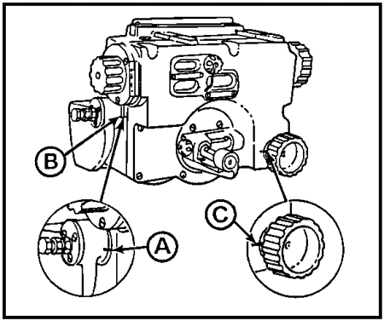

Figure 46. Scribe line locations, M15 quadrant.

(7) Cut one line (Figure 46 ) from the range quadrant mounting bracket pivot stud to the front side of the quadrant.

(8) Cut the second line from the cross-level knob to the side of the quadrant.

(9) Paint these scribe lines with a paint that contrasts with the color of the quadrant so that they can be seen easily. Wipe off excess paint, and let dry thoroughly.

(10) Verify the accuracy of the scribe lines as soon as possible, as described in the next paragraph.

b. Scribe verification using the M145 pantel mount. The accuracy of the scribe should be verified immediately while the howitzer is positioned on the jacks, the trunnions are level, and the tube is at zero elevation. Be sure also that the scribe lines are still matched and the cross-level vial bubble and the elevation vial bubble are still centered. Verify the accuracy of the scribe lines by performing the following checks using the M145 pantel mount.

(1) On the M145 mount (Figure 47), turn the cross-level knob and center the cross-level vial bubble . Turn the pitch-level knob , and center the pitch-level vial bubble .

(2) Look through the eyepiece on the pantel, and turn the azimuth knob to rotate the telescope. Choose a well-defined aiming point to sight on. Approach the aiming point with the vertical hairline going from left to right, and stop when a positive sight picture is obtained.

(3) Record the reading showing on the 6,400-mil azimuth counter .

(4) Set the M15 quadrant elevation counter on 900 mils, and elevate the tube to 900 mils.

(5) With the tube at 900 mils elevation, center the bubbles in the cross-level vial and the pitch-level vial on the M145 pantel mount.

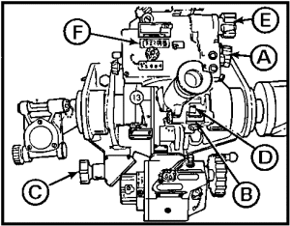

Figure 47. Verify scribe lines.

(6) Look through the eyepiece on the pantel again, and find the same aiming point. Be sure to move the head of the pantel from left to right. If the sight is off to the right of the aiming point, you will have to turn the head of the pantel all the way around to approach the aiming point from the left.

(7) Record the reading that is on the 6,400-mil azimuth counter .

(8) The difference in the readings on the 6,400-mil azimuth counter at 0 mils (step (3)) and 900 mils elevation (step (7)) is the amount of error in the pantel sight mount.

(9) Record the amount of error in the pantel sight mount. You will need it later.

NOTE: The difference between the two readings taken on the 6,400-mil azimuth counter (steps (3) and (7)) should not be over ± 1 mil. If it is, you should notify support maintenance to check the M145 pantel mount. However, for purposes of this test, the ± 1 mil tolerance is not critical.

(10) You have now verified the accuracy of the scribe lines on the M15 quadrant by performing this M145 pantel mount check.

c. Field verification of scribe lines. Field verification of scribe lines is an essential check on the alignment of fire control instruments to ensure their parallel relationship to the axis of the bore and, therefore, the accuracy of fire of the weapon. The test is performed with the howitzer emplaced in a firing position and the recoil spades emplaced.

(1) Place the elevation mil counter (Figure 48 ) on the M15 quadrant on 0, and then manually elevate or depress the tube until the elevation level vial bubble is centered.

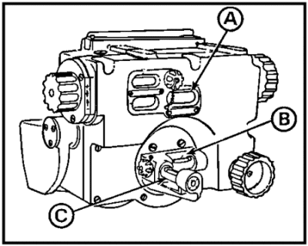

Figure 48. Field verification of scribe lines.

(2) Carefully align the scribe line on the M15 quadrant. You must align both the cross-level and the elevation knob scribe lines.

(3) Slowly traverse the tube manually as someone watches the elevation level vial bubble and the cross-level vial bubble . If the elevation level vial bubble goes off center, recenter it by elevating or depressing the tube. (As you continue to traverse, it may be necessary to repeat the raising or lowering of the tube to keep the elevation level vial bubble centered.)

(4) At some point in the 6,400-mil traverse, the cross-level vial bubble will center. It is very important that the bubble in the cross-level vial is centered exactly.

(5) When the elevation level vial bubble is centered and the cross-level vial bubble is centered, the trunnions are level.

(6) Repeat steps (1) through (5) of scribe verification using the M145 mount.

(7) When you have finished, compare the pantel sight mount error with the sight mount error you recorded while the howitzer was still on the jacks (step (8) of scribe verification using M145 mount). The difference between the two pantel sight mount error readings must not be over ± 1 mil. If the difference is greater than ± 1 mil, go through the entire procedure again to be sure there were no mistakes made and no steps overlooked. If the difference between pantel sight mount error readings in the two tests is still greater than ± 1 mil, notify support maintenance.

(8) If the readings are within the ± 1 mil tolerance, the trunnions can be leveled and the M145 mount check can be performed in the field by use of the scribe lines painted on the M15 quadrant.

e. Testing the M15 quadrant and auxiliary quadrant. This is a comprehensive test of your fire control equipment that involves both the M15 elevation quadrant and the auxiliary quadrant on the M145 pantel mount. It should be performed with the howitzer in test configuration. The trunnions must be level and the tube zeroed using the tube leveling fixture. The purpose of this test is to verify the accuracy of the M15 quadrant, the auxiliary quadrant, and the relationship between these two instruments and the axis of the bore. To perform this test, follow the 22 steps explained below.

(1) Turn the cross-level knob (Figure 49 ) until the bubble in the cross-level vial is centered.

(2) Turn the correction knob , and zero the correction counters .

(3) Turn the elevation knob , and center the bubble in the elevation level vial .

(4) Check the elevation mil counter reading. The reading should be no less than 9999 (-1 mil elevation) and no more than 0001 (+1 mil elevation). If readings are not within tolerance, notify support maintenance.

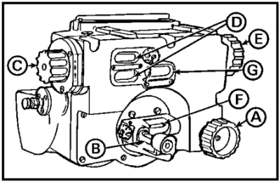

Figure 49. M15 elevation quadrant.

(5) Place the pretested gunner's quadrant on the M15 quadrant seats (Figure 50 ). Apply the gunner's quadrant correction factor, if any, but do not apply the embedded corrections.

(6) Turn the micrometer knob to center the bubble in the gunner's quadrant. The value of the gunner's quadrant should not change more than 0.5 mil. If the value changes more than 0.5 mil, notify support maintenance.

EXAMPLE: The gunner's quadrant correction is -0.4. The value on the gunner's quadrant should be between -0.9 and +0.1 mil when the bubble is leveled.

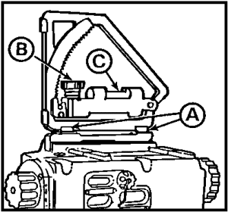

Figure 50. Gunner's quadrant.

Now turn your attention to the auxiliary quadrant (Figure 51).

(7) On the M145 mount, turn the cross-level knob , and center the bubble in the cross-level vial .

(8) Turn the correction knob , and zero the correction counter .

(9) Turn the elevation knob , and center the bubble on the auxiliary quadrant level vial .

(10) Check the reading on the elevation counter . It should read no less than 9999 (-1 mil elevation) and no more than 0001 (+1 mil elevation).

NOTE: The auxiliary quadrant elevation counter must also be subjected to sequential checks at two elevations, 400 mils and 800 mils. However, this test should be performed together with the M15 quadrant tests as described in step (22) below.
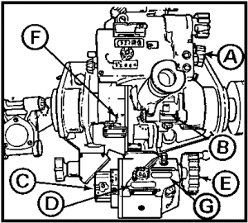

Figure 51. M145 mount.

(11) Return to the M15 elevation quadrant. Zero all counters, and center the cross-level bubble on the M15 quadrant.

(12) Manually elevate or depress the tube to 0 mils elevation (using the M15 quadrant).

(13) Place the gunner's quadrant on the quadrant seats (Figure 52 ) of the M15 elevation quadrant. Turn the micrometer knob , and center the bubble . Record the value now showing on the gunner's quadrant micrometer scale.

(14) On the auxiliary quadrant (M145 mount), turn the correction knob to set a +5 mils reading on the elevation correction counter. Now, check the reading on the M15 quadrant elevation counter. It should have changed by 5 mils.

(15) On the auxiliary quadrant, turn the elevation knob until the elevation counter reads 0.

(16) Elevate or depress the tube until the elevation vial bubble centers.

(17) Set +5 mils on the gunner's quadrant, and then add the value recorded in step (13).
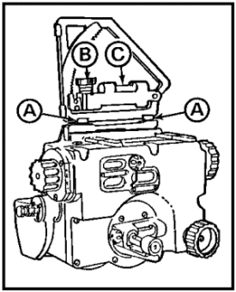
Figure 52. Gunner's quadrant.

EXAMPLE:

Test value | = | +5.0 | +5.0
Value recorded in step 13 | = | +0.6 | -0.4
Value to set on gunner's quadrant | = | +5.6 | +4.6

Place the gunner's quadrant back on the M15 quadrant seats. The gunner's quadrant bubble should center. If it does not, the correction counter is inaccurate and should be adjusted by support maintenance.

(18) Now, again zero all counters. Repeat steps (12) through (17), only this time use a value of -5 mils. If the gunner's quadrant bubble does not center, the correction counter is out of adjustment. Report this to support maintenance.

(19) Having completed both plus and minus tests on the auxiliary quadrant, zero all readings on the gunner's quadrant.

(20) Using the M15 elevation quadrant, zero the tube.

(21) Set the gunner's quadrant on the quadrant seats. Level the bubble on the gunner's quadrant using the micrometer knob, then record the value on the gunner's quadrant.

(22) Using the M15 quadrant, elevate the tube from 0 mils to 400 mils and then to 800 mils. At each elevation, place the elevation counter reading (400 then 800) plus the value recorded in (21) above on the gunner's quadrant and set the gunner's quadrant on the M15 quadrant seats.

EXAMPLE:

Elevations placed on elevation counter | 400.0 | 800.0
Value measured in (21) above at zero elevation | + 0.7 | + 0.7
Values placed on gunner's quadrant | 400.7 | 800.7

The bubble in the gunner's quadrant should center. If the bubble centers, the test is complete. If the bubble does not center, center it by turning the micrometer knob. After centering the gunner's quadrant, read the value now on the quadrant. It should not have changed more than ± 0.5 mil from the original reading. If it does, the M15 quadrant is in error and must be referred to support maintenance.

NOTE: Remember to also check the readings on the auxiliary quadrant (M145 mount) as explained in step 10.

PRACTICE EXERCISES:

48. T F The M15 elevation quadrant is equipped with a mechanical mil counter for elevation readings.

49. T F Complex adjustments on the M15 elevation quadrant are unnecessary and only an accuracy check is required.

50. T F To lay the M109A2/A3 howitzer for both elevation and direction requires two crew members at all times.

51. T F Scribe lines are permanent reference points at which a level, or zero, relationship exists.

52. T F When verifying the M15 elevating quadrant scribe lines with the M145 pantel mount, the difference in readings on the 6,400-mil azimuth counter at 0 mils and 900 mils elevation is the amount of error in the pantel sight mount.

53. T F Field verification of scribe lines must be done with the howitzer on a level hardstand.

54. T F Any difference in readings (error) between the pantel mount and the elevation quadrant discovered during scribe line verification procedures must be within ± 1 mil of each other, and of previously recorded errors.

55. List the tests and procedures applicable to the M15 elevation quadrant.

a. _________________________________________________________________.

b. _________________________________________________________________.

c. _________________________________________________________________.

d. _________________________________________________________________.

56. A comprehensive test of fire control equipment involves the M15 elevation quadrant and the ________________________ quadrant on the M145 pantel mount.

57. The final reading on the gunner's quadrant cannot exceed ___________ mil from the original reading recorded for the M15 quadrant when performing the comprehensive checks.

//////////////////////////////////////////////////////////////////////////////////////////////////////////////////////////////////////////////////////////////////

ANSWERS:

48. T
49. T
50. F
51. T
52. T
53. F
54. T
55. a. Testing and scribing
b. Scribe verification
c. Field verification
d. Comprehensive auxiliary quadrant tests
56. auxiliary
57. ± 0.5

//////////////////////////////////////////////////////////////////////////////////////////////////////////////////////////////////////////////////////////////////

13. CARE AND MAINTENANCE OF FIRE CONTROL EQUIPMENT. Tests and adjustments of fire control instruments, if properly performed, will ensure accuracy of fire. Normal care and cleaning, proper handling, and conscientious maintenance will keep the equipment ready for use when needed. The maintenance supervisor should know both the specific technique to test and adjust fire control equipment and the required maintenance procedures to keep the equipment functioning properly. He must also be able to recognize improper handling that tends to abuse these delicate instruments. The following paragraphs provide you with a few hints on what to look for and how to detect potential problems.

a. Care and handling.

- Avoid rough handling of the equipment.

- Limit disassembly to the extent authorized in the field manual or technical manual pertaining to a particular weapon.

- Keep the equipment dry; never put the equipment in carrying cases when it is damp or wet.

- Keep the equipment in the carrying cases when not in use.

- Send any instrument not performing properly to the DS maintenance unit for repair.

- Never paint any of the equipment.

- Depress fully all throw out levers, when used.

- Before assembly, remove all dust and grit from the contact surfaces.

- Wipe off all excess lubricant to prevent the accumulation of dust and grit.

b. Telescopes and sight mounts.

- Remove dust or grit with a clean camel-hair brush or lens tissue paper.

- Use oil, lubricating, light (PL-L), on sight mounts. Oil through the hole on top of the housing.

- Use oil, lubricating, preservative (PL-S), special, on the felt washers of the range quadrant and telescope mount and on exposed bearing surfaces of the sight and sight mount.

- Remove oil or grease immediately from the rubber eyeshield.

- Keep the level vials covered when not in use.

- Do not try to force a mechanism beyond its stop.

- Have the equipment lubricated periodically by DS maintenance.

c. Coated optical elements. The optics of some instruments are coated with a reflection-reducing film of magnesium fluoride. Rub coated optics as little as possible. If such a coating is partly removed, do not remove the remainder of the coating, since any remaining will help make the sight clearer.

d. M1A2 gunner's quadrant. Make the following checks on the M1A2 gunner's quadrant.

- Ensure the quadrant shoes are smooth and free of nicks and burrs.

- Ensure the figures can be easily read. (If necessary, gently clean the dirt out of the numbers with a small brush.)

- Ensure the micrometer knob turns freely without play.

- Ensure the level bubble can be centered--vial not broken or cracked.



DANGER EXISTS IF SEALS ARE BROKEN.

- Ensure the teeth on the coarse scale are not chipped or burred.

- Ensure the error not more than 0.4 mils on the end-for-end test.

- Ensure the M82 case is free of dents, all cork gaskets and protective strips are present and secure, and the latches on the case are not broken.

- Do not burr, dent, or nick reference surfaces or the notched portion of frame.

- Clean the arc frequently with a small brush or with a brush and dry-cleaning solvent.

- Never leave the gunner's quadrant on the weapon during firing.

e. M117 pantel. Ensure that the--

- Rubber eye shield is not hardened, cut, or torn.

- Eyepiece rotates within its arc of movement without binding.

- Nitrogen valve cap is in place.

- Reset knob moves freely and stops automatically when the reset counter reads 3200.

- Azimuth (deflection) counter latch and door works smoothly.

- Azimuth knob turns freely and moves the azimuth counter numbers without backlash or lost motion.

- Azimuth knob rotates the cap assembly as the numbers in the deflection counter change.

- Gunner's aid knob turns easily and moves the numbers in the gunner's aid counter windows through full range from 00 to 50 mils.

- Rheostat knob works through the entire range.

CAUTION

YOU CAN RUIN YOUR M117 TELESCOPE UNLESS YOU KNOW THE RIGHT WAY TO BORESIGHT IT. TO MAKE THE ADJUSTMENT, PUSH IN THE BORESIGHT ADJUSTING SHAFT ALL THE WAY WITH A SCREWDRIVER AND KEEP IT PUSHED IN AS YOU TURN THE SHAFT UNTIL YOU GET A 3,200-MIL READING IN YOUR AZIMUTH COUNTER. THEN LET IT OUT.

f. M145 telescope mount and auxiliary elevation quadrant. Ensure that the--

- Four leveling vials (quadrant cross-level, elevation level, pitch-level, and cross-level) light up when the toggle switch is turned on.

- Vials are not broken or cracked, covers turn easily, bubbles can be centered, and red graduation lines are easy to read.

- Knobs and wheels are all present--easy to turn.

- Glass over the elevation and correction counters is not cracked or dirty.

- Correction counter can be turned through its full range of ± 50 mils.

- Electrical wiring is all serviceable and free of cuts or frays. Illumination bulbs are working. (Replace burned out bulbs promptly.)

- Linkage is adjusted properly--not binding or sticking.

- Catch holds the M117 telescope securely in place.

- Nitrogen valve cap is present.

- Nameplate is not painted.

h. M15 elevation quadrant. Ensure the following checks are made to the M15 elevation quadrant.

- Ensure both leveling vials (cross-level and elevation) light up when the control button is turned on. (Replace burned out bulbs promptly.)

- Ensure the bubbles can be centered by moving the elevation and cross-level knobs.

- Ensure all knobs and wheels turn freely without binding.

- Ensure the hand light works; wire is not frayed or cracked.

- Ensure the quadrant seats are clean, smooth, and free of nicks and burrs.

- Ensure the numbers in the correction dials change smoothly as the correction knobs are rotated.

- Ensure the glass in all the counter windows is clean, not cracked or cloudy.

- Ensure the counter and vial lamp covers are complete, with chains secure at both ends.

PRACTICE EXERCISES:

58. At least as important as technical proficiency in supervising tests, adjustments and maintenance of fire control equipment is the supervisor's ability to recognize _____________ _____________ that tends to ___________ the instruments.

59. As a general rule, fire control instruments should be stored in ___________ _______ when not in use.

60. Chips, nicks, and burrs are especially harmful if not removed from the __________ __________ ______ _____ _____.

61. A good rule for checking knobs and dials is to make sure they ______ _______, __________ ___________.

62. Rubber eyeshields should be kept clean and free of _______, ______, or ______.

63. The check for cracked or broken glass is made on counter windows and all __________ _______.

64. Illuminating devices are checked for ________ _______ ________ and frayed or broken _______ ________.

//////////////////////////////////////////////////////////////////////////////////////////////////////////////////////////////////////////////////////////////////

ANSWERS:

58. improper handling, abuse
59. carrying cases
60. gunner's quadrant shoes and arc.
61. move freely, without binding.
62. oil, cuts, tears.
63. leveling vials.
64. burned out bulbs, wire leads.

//////////////////////////////////////////////////////////////////////////////////////////////////////////////////////////////////////////////////////////////////

14. RAMMER RELIABILITY CHECKS AND ADJUSTMENTS.

a. Adjustment. In addition to general cleaning and lubrication following firing of the weapon, the rammer may require adjustment. If an effort is required to move the weapon-mounted rammer to the rear stop or the forward stowed position, check to see if the storage bracket adjustment screw is properly adjusted. Adjustment is required if the rammer chute (Figure 53 ) contacts the stowage bracket during stowing of the weapon-mounted rammer.

(1) With the rammer in the stowed position, adjust two screws to provide a clearance of about 1/4 inch between the rammer chute and the stowage bracket.

(2) When this clearance has been obtained, securely lock the screws in position with the two locknuts and safety wires.

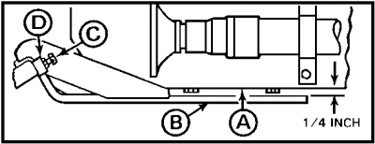

Figure 53. Rammer adjustments.

b. Reliability check. A reliability check is conducted on the rammer to ensure that the rammer will provide a safe and proper ramming of the projectile into the tube. The check is as follows:

(1) With the rammer in stowed position, check to see that rammer safety pointer is in the black position.

(2) Be sure that latch will latch.

(3) Place the rammer in ram position.

(4) Check to ensure the rammer locks in ram position and the plunger on the blocking valve is depressed by the cam.

(5) Slowly depress the ram control valve handle, and hold to extend the rammer a full stroke. Release the handle to bring the rammer back to original position.

(6) Return the rammer to stowed position.

CAUTION

NEVER EXTEND THE RAMMER FULL RAM WITHOUT A PROJECTILE.

NOTE: If the rammer fails to ram, notify organizational maintenance.

PRACTICE EXERCISES:

65. Adjustment of the rammer is required--

a. annually.
b. before boresighting.
c. when the rammer contacts the stowage bracket.
d. by organizational maintenance.

66. The clearance between the rammer chute and stowage bracket should be adjusted to about--

a. 2/3 inch.
b. 1/2 inch.
c. 3/8 inch.
d. 1/4 inch.

67. Rammer function, and therefore reliability checks, involves primarily--

a. the electrical system.
b. the hydraulic system.
c. three crew members.
d. a 9/16" socket wrench.

68. When checking the rammer for reliability, push the ram control valve handle--

a. quickly.
b. backwards.
c. three times.
d. slowly.

69. The rammer is rammed full stroke--

a. during maintenance.
b. only with a projectile.
c. to check the seals.
d. never.

//////////////////////////////////////////////////////////////////////////////////////////////////////////////////////////////////////////////////////////////////

ANSWERS:

65. c.
66. d.
67. b.
68. d.
69. b.

//////////////////////////////////////////////////////////////////////////////////////////////////////////////////////////////////////////////////////////////////

15. EQUILIBRATOR ADJUSTMENT. On artillery weapons, the horizontal axis (trunnions) about which the tube revolves is located well to the rear of the center of gravity of the tube to permit high angles of elevation. Thus, the tube is unbalanced. Most of the tube weight is toward the muzzle. An equilibrator is a mechanical/hydraulic device that overcomes the unbalanced weight and keeps the tube in balance at all angles of elevation so that it can be easily elevated or depressed (see Figure 54). All types of equilibrators are designed to reduce the effort required to elevate the tube. The equilibrator is in proper adjustment when the tube can be elevated and depressed with equal effort. To compensate for most of the weight of the tube being forward of the trunnions and to reduce the effort required to elevate the tube, the M109A2/A3 is equipped with a hydropneumatic-type equilibrator (hydro = hydraulic fluid; pneumatic = nitrogen gas).

a. Components.

(1) Equilibrated elevating cylinder. The rear part of the elevating cylinder is located on the roof of the cab near the gunner's station. It is composed of a piston, a piston rod, seals, and a cylinder housing. The piston rod is attached to the howitzer mount. Hydraulic fluid under constant pressure from the hydraulic accumulator assembly forces the piston to exert a constant pull on the howitzer mount. This pull helps with the elevation or depression of the tube.

(2) Accumulators. The accumulator is a cylinder containing hydraulic fluid and compressed nitrogen gas separated by a floating piston. Hydraulic fluid is forced through a tube from the accumulator to the equilibrated elevating cylinder by the compressed nitrogen gas acting against the floating piston. On the M109A2/A3, there are two accumulators located at the gunner's station. The primary one is located on the lower left cab wall. The secondary one, which is smaller, is located above the primary one on the cab wall.

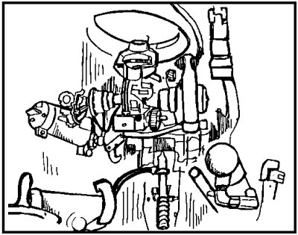

Figure 54. Equilibrator system M109A2/A3.

(3) Reservoir. On the M109A2/A3 howitzer, the main reservoir provides hydraulic fluid to the accumulators through a pressurized line or a free-flow line if there is no power.

(4) Hand pump. A hand pump is incorporated into the system to force the hydraulic fluid from the reservoir to a cross in the line leading from the accumulators to the equilibrator. This permits adjustment of the equilibrator system to compensate for variations in temperature. The hand pump is located at the gunner's station.

(5) Drain and fill valves. The equilibrator system has two valves. The first is the drain valve (painted red). The valve allows fluid to be drained from the system during adjustment. The second valve is the equilibrator valve knob, or filler valve, which allows fluid to be pumped into the system during adjustment.

b. Adjustment. The equilibrator is adjusted as follows:

(1) Using the gunner's quadrant or M15, elevate the tube to +266 mils.

(2) Using the manual elevation handle (Figure 55 ), elevate and depress the tube to determine whether it requires equal effort to elevate and depress.

NOTE: If no difference is detected, no adjustment is necessary.

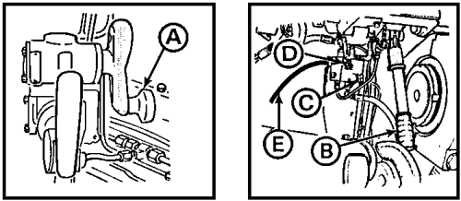

Figure 55. Equilibrator adjustment.

(3) If it is harder to elevate, use the power elevation and hand pump at the same time to elevate the tube to maximum elevation. With cab power on, open the equilibrator valve to allow the system to equalize (about 15 seconds). Close valve , and repeat steps 1 and 2.

(4) If harder to depress, slowly open the system drain valve . Place a clean container under the drain tube , and bleed off a small amount of hydraulic oil. Close the valve, and repeat step 2.

CAUTION

WITH THE MASTER SWITCH AND CAB POWER SWITCH ON AND THE EQUILIBRATOR VALVE OPEN AND THE DRAIN VALVE OPEN, THE HYDRAULIC POWER PACK WILL BE PUMPED DRY. DO NOT OPERATE THE HYDRAULIC SYSTEM WITH LOW FLUID LEVELS.

PRACTICE EXERCISES:

70. List the principal components of the equilibrator system:

a. _______________________________
b. _______________________________
c. _______________________________
d. _______________________________
e. _______________________________

71. The equilibrator compensates for most of the weight of the tube being forward of the trunnions, keeps the tube in ______________, and reduces the manual effort to ___________ the tube.

72. The equilibrator can be adjusted to compensate for differences in the amount of ________ required to __________ or __________ the tube.

73. Adjustments are made to the equilibrator system with the tube at _______ mils.

74. How is the adjustment made if it is harder to depress than to elevate the tube?

//////////////////////////////////////////////////////////////////////////////////////////////////////////////////////////////////////////////////////////////////

ANSWERS:

70. a. equilibrated elevating cylinder
b. accumulators
c. reservoir
d. hand pump
e. drain and fill valves
71. balance, elevate
72. effort, elevate, depress
73. +266
74. Slowly open the system drain valve, and blend off a small amount of hydraulic fluid

//////////////////////////////////////////////////////////////////////////////////////////////////////////////////////////////////////////////////////////////////

16. OPERATING CAM ADJUSTMENTS. The breech operating cam is an integral part of the semiautomatic breech mechanism (Figure 56) of the M109A2/A3 howitzer. The breech operating cam (Figure 57) is a heavy steel alloy plate that has two grooves (camways) cut into the down-facing side. The breech operating crank moves in these grooves. It is hinged above the breech block to the gun mount and pivots vertically when lifted by the handle. Lifting the cam causes the crank to disengage from the camway and allows the breech block to be closed. Since the operating cam is attached to the gun mount cradle (by the pivot pin), it does not move with the recoiling parts but remains stationary.

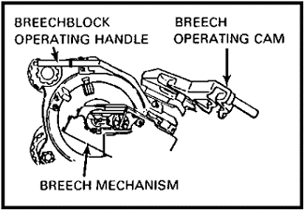

Figure 56. Semiautomatic breech mechanism.

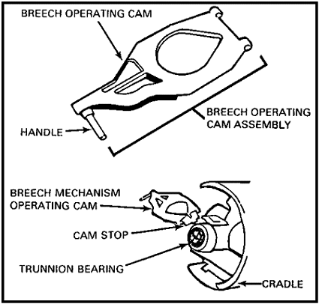

Figure 57. Operating cam is attached to gun mount.

a. Function. When the weapon is fired, the recoiling parts (tube and breechblock) move rearward during the recoil cycle. It is during the counterrecoil cycle when the recoiling parts are going back to the in-battery position that the semiautomatic breech mechanism functions. As the recoiling parts move back to the in-battery

position, the primary roller (Figure 58 ) on the operating crank assembly engages with the S-shaped camway on the operating cam. As the primary roller passes along this camway, the breech block is rotated about one-sixth of a turn counterclockwise to the unlocked position. At this time, the secondary roller engages the C-shaped camway on the operating cam. As the roller passes along the camway, it pulls the breechblock open. The operating cam opens the breech in counterrecoil and holds it open for the next swabbing and loading operation. Therefore, the operational adjustments are critical and must be performed frequently if the weapon is in heavy use. Otherwise, a quarterly adjustment is Additionally, the operating cam clearances must be checked and adjusted whenever the torque key is removed (see paragraph 17).

b. Adjustment. Heavy parts and high tension springs that make up the operating cam assembly are potentially dangerous if improperly handled. Close supervision by maintenance supervisors is essential to prevent damage to equipment or injury to personnel. To check and adjust operating cam clearances proceed as follows:

(1) With the breechblock closed, place the tube at zero elevation.

(2) Remove the cotter pin (Figure 59 ) and castle head nut from the recuperator piston rod . Hold the piston rod with a pipe wrench to keep it from turning.

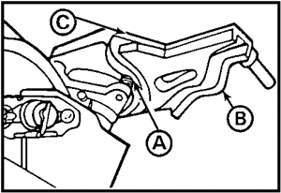

Figure 58. Breech operating cam.

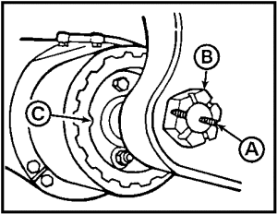

Figure 59. Recuperator inside end.

CAUTION

THE RECOILING PARTS ARE EXTREMELY HEAVY. EXERCISE GREAT CARE WHEN MOVING THE TUBE OUT OF BATTERY.

(3) Force the tube out of battery (follow instructions in TM 9-2350-311-20-2). Move the tube back into battery until the breechblock opening roller (Figure 60 ) is in position opposite the arrow on the bottom of the operating cam .

(4) Measure the vertical clearance between the top of the roller (Figure 61) and the top of the camway. This clearance must be at least 3/16 inch, but not more than 1/4 inch. If these measurements are not obtained, the vertical clearance of the operating cam must be adjusted (next step).

(5) Loosen the locknut (Figure 62 ), which is located below the operating cam hinge pin. (See also Figure 57, CAM STOP.) Rotate the operating cam stop clockwise to increase clearance or counterclockwise to decrease clearance. When the correct clearance (3/16 inch to 1/4 inch) has been obtained (measured), hold the cam stop with a wrench, and tighten the locknut. Now measure and adjust the horizontal clearance.

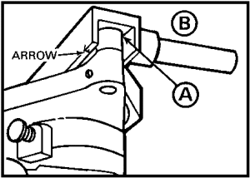

Figure 60. Opening roller.

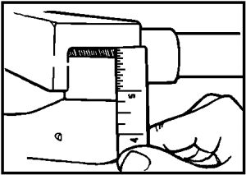

Figure 61. Vertical clearance.

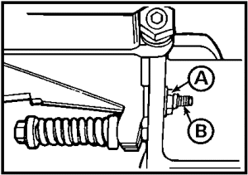

Figure 62. Locknut and operating cam stop.

(6) Using a thickness gage (Figure 63 ), measure the clearance between the breech opening roller and the camway at the arrow. This clearance should be at least 0.001 inch but not more than 0.002 inch. Adjustment is necessary if this clearance is incorrect.

(7) With a proper open-end wrench, loosen the locknut (Figure 64 ) and rotate the cam hinge pin clockwise to increase the clearance or counterclockwise to decrease the clearance. When the correct clearance (0.001 inch to 0.002 inch) has been obtained, hold the hinge pin and tighten the locknut.

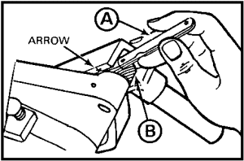

Figure 63. Thickness gage.

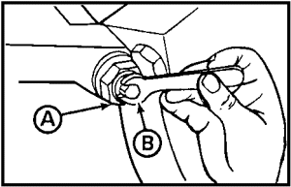

Figure 64. Locknut and cam hinge pin.

(8) With these adjustments completed, return the cannon to the in-battery position as follows:

- Depress the tube slowly while holding up on the operating cam.

- Allow the cannon to return to battery.

- Be sure to secure the castle head nut and the cotter pin on the end of the recuperator piston.

(9) One final adjustment is necessary. Adjust the distance between the spring cap ends on the cam damper group for correct tension. Correct tension is obtained when the distance between the outer edge of both the front and rear spring caps measures 4 inches. To adjust the distance, first loosen the jam nut (Figure 65 ) then turn the cam tension adjuster screw until you measure 4 inches as shown. When the correct clearance is obtained, hold the adjuster screw and tighten the jam nut.

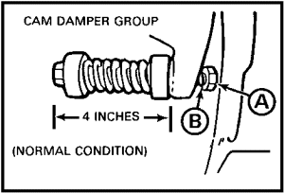

Figure 65. Tension adjustment.

PRACTICE EXERCISES:

75. T F The breech operating cam moves with the gun in recoil.

76. T F The semiautomatic breech mechanism functions in counterrecoil to open the breechblock.

77. T F Operating cam adjustment must be made quarterly or when the torque key is removed.

78. T F Operating cam adjustment procedures include the requirement to move the tube out of battery.

79. T F The tube must be elevated to +266 mils of elevation before adjusting the operating cam.

80. T F The vertical clearance between the top of the breech operating crank roller and the top of the operating cam camway should be at least 3/16 inch but no more than 1/4 inch.

81. T F The horizontal clearance between the breech opening roller and the camway should be at last 0.01 inches but not more than 0.2 inches.

82. T F Correct tension on the cam is obtained when the distance between the spring cap ends on the cam damper group is 4 inches.

//////////////////////////////////////////////////////////////////////////////////////////////////////////////////////////////////////////////////////////////////

ANSWERS:

75. F
76. T
77. F
78. T
79. F
80. T
81. F
82. T

//////////////////////////////////////////////////////////////////////////////////////////////////////////////////////////////////////////////////////////////////

17. THE TORQUE KEY. The torque key rides in a longitudinal keyway (groove) machined into the top surface of the cannon tube. It is mounted to the upper gun mount to engage the tube during recoil (Figure 66). The torque key prevents the tube from turning or canting as it reacts to the rotational force of the projectile when the weapon is fired and maintains tube alignment during recoil and counterrecoil. The torque key is constructed primarily of brass stock with a wear surface. The torque key assembly consists of the torque key, 10 cap screws and lock washers, and safety wire (Figure 67).

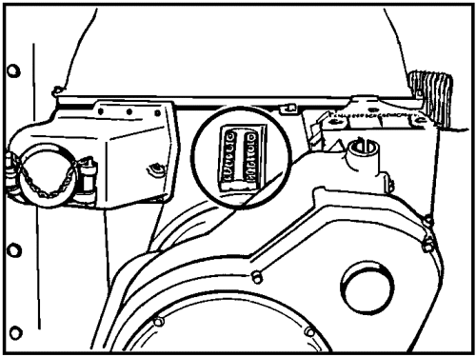

Figure 66. Location of torque key on gun mount.

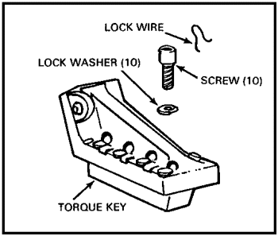

Figure 67. Torque key assembly.

a. Maintenance. There is no adjustment for the torque key; however, wear tolerances must be checked periodically. Both the keyway on top of the tube and the torque key itself must be kept clean, free of dirt and grit, and lubricated with automotive grease (GGP). Remove the torque key after firing 1,500 rounds to inspect and measure wear as follows:

(1) Remove the lock wire (Figure 68) with wire cutters.

(2) Use a 5/16-inch hex-socket head screw key to remove the 10 socket head screws and lock washers. Lift out the torque key.

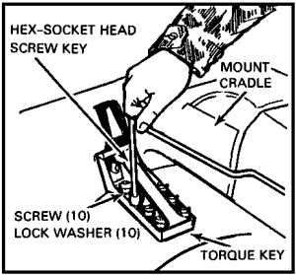

Figure 68. Torque key removal.

(3) Using a machinist's metal ruler (Figure 69), measure the torque key for wear. When the measurement across the wear surface is less than 31/32 inch (24.5 mm), replace the torque key with a new one. If the measurement is greater than 31/32 inch, lubricate and reinstall.

NOTE: The torque key wears about 0.001 inch (0.025 mm) per 100 rounds fired.

(4) To reinstall or replace the torque key, first ensure that the (new) torque key and keyway are free of nicks, dirt, or grit; then lubricate with automotive grease (GGP).

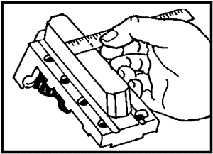

Figure 69. Measure torque key.

(5) Place the torque key in its position. It should slide into position easily.

CAUTION

DO NOT FORCE THE TORQUE KEY INTO THE KEYWAY. IF THE KEY DOES NOT SLIDE INTO PLACE, IT MAY BE NECESSARY TO ROTATE THE TUBE SLIGHTLY BY PLACING A TIMBER THROUGH THE MUZZLE BRAKE.

(6) Replace the 10 socket head screws and lock washers (Figure 70 ).

(7) Safety wire the screws with lockwire as shown.

(8) After installing or replacing the torque key, the breech operating cam should be checked for proper adjustment.

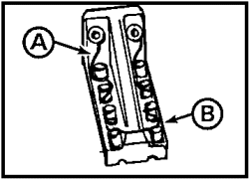

Figure 70. Torque key.

PRACTICE EXERCISES:

83. The torque key fulfills the essential function of--

a. locking the tube to the cradle.
b. limiting the length of recoil.
c. preventing the tube from twisting.
d. reducing rotational force on the breech.

84. The torque key is fitted to the top of the cannon tube through the upper gun mount and is secured by--

a. 12 hexnuts and lock washers.
b. 10 cap screws and lockwire.
c. 8 screws and fasteners.
d. 6 bolts and cotter pins.

85. Wear tolerance on the torque key must be checked after each--

a. operating cam adjustment.
b. 500 miles of driving.
c. 1,000 hours of operation.
d. 1,500 rounds of firing.

86. The torque key must be replaced when the measurement across the wear surface is less than--

a. 31/32 inch.
b. 0.001 inch.
c. 25.5 mm.
d. 0.025 mm.

//////////////////////////////////////////////////////////////////////////////////////////////////////////////////////////////////////////////////////////////////

ANSWERS:

83. c.
84. b.
85. d.
86. a.

//////////////////////////////////////////////////////////////////////////////////////////////////////////////////////////////////////////////////////////////////

18. SUMMARY. The various tests and alignments discussed in this lesson are designed to keep your weapon ready for action at all times. Actual performance of tests, alignments, and appropriate maintenance may be done by the howitzer crews, but supervision by a technically proficient individual is indispensable if the task is to be done correctly.

a. Prefire checks ensure that the major components will function reliably and that no condition exists that can damage materiel or injure personnel.

b. Fire control equipment alignment tests will verify the parallel relationship of these fire control instruments with the axis of the bore. Correct alignment is essential for accuracy of fire.

c. The loader-rammer is a manually activated, hydraulically operated tool that will reduce the amount of time needed to load and fire the howitzer. Proper handling and correct adjustment of tolerances will ensure it is ready to function as designed. If the loader-rammer fails to function, the projectile can still be loaded by hand with rammer staffs.

d. Equilibration equalizes the amount of effort required to elevate and depress the weapon tube. The preponderance of weight forward of the trunnions makes a properly adjusted equilibrator essential to the overall performance of the weapon.

e. Since the operating cam is what makes the breech mechanism function (semiautomatic), maladjustment can interfere with completing the firing mission, damage materiel, and injure personnel. Always check clearances and adjust the operating cam tolerances after inspecting or replacing the torque key.

f. The torque key is a brass device that keeps the cannon tube from turning as a result of the torque created by the projectile when the weapon is fired. Because it is subject to constant wear, it should be inspected at least annually and replaced when worn beyond tolerance.

Lesson 3
THE M109A2/A3 IN OPERATION

OBJECTIVE

After completing this lesson, you will be able to supervise placing the M109-series howitzer into operation; understand the technical aspects of the electrical system, hydraulic system, traversing mechanism, power and manual ramming, and recoil spades; and be able to recognize incorrect operation and apply corrective measures to ensure proper operation, maintenance, and adjustment of these components. Additionally, you will be able to supervise howitzer crews in preparing the weapon and vehicle for operations under unusual conditions.

REFERENCES

This lesson is based on TM 9-2350-311-10, TM 9-2350-311-20-1, TM 9-2350-311-20-2, and LO 9-2350-311-12, and other materials approved for US Army field artillery instruction; however, development and progress render the text continually subject to change. Therefore, base your examination answers on material presented in this text rather than on individual or unit experience.

19. INTRODUCTION.

a. Electrical system. The 24-volt, negatively grounded electrical system requires four 12-volt storage batteries. Direct current for charging the batteries and operating electrical units is furnished by a 100-ampere engine-driven alternator and a selenium-type rectifier. Current may also be supplied by an external source through a slave receptacle. A slip-ring assembly provides continuity of electrical circuits from hull to cab components.

b. Cab power. The CAB POWER switch controls all electrical power to the cab with the exception of that for communication and for illumination of the crew compartment. The CAB POWER switch is located on the gunner selector switch box at the gunner's station (Figure 71).

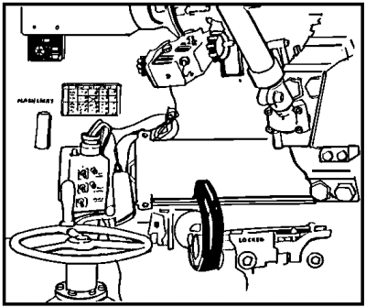

Figure 71. Gunner's station controls M109A2/A3.

Major components that are electrically activated, hydraulically operated, and switched through the CAB POWER switch include the following:

- Traversing mechanism.

- Elevation mechanism.

NOTE: These components may also be manually operated.

c. M109A2/A3. A gunner's selector switch box (Figure 72) has been installed in the M109A2/A3. The switch box has the CAB POWER switch and ELEVATION CONTROL switch and a TRAVERSE CONTROL switch that has eliminated the need for the manual power selector lever and the speed selector lever. The CAB POWER switch and the TRAVERSE CONTROL switch each has an indicator light beside the switch that lights when the switch is in the ON or POWER position. The TRAVERSE CONTROL switch is a two-position toggle switch; one side is the MANUAL position, and the other side is the POWER position.

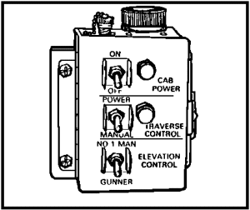

Figure 72. Gunner's selector switch box, M109A2/A3.

d. Operation. To turn on the cab power:

(1) Have the driver (or assistant) flick on the MASTER switch in the driver's compartment.

(2) Start the engine and operate it at 1,000 revolutions per minute (RPM) to keep the batteries charged.

(3) Turn on the cab power by flicking the CAB POWER toggle switch to the ON position (up). The power indicator light should come on. If the indicator fails to light up, the bulb should be checked and replaced if necessary. When the cab power is no longer needed, flick the CAB POWER toggle switch back to the OFF position (down).

e. Maintenance. Crew maintenance of the CAB POWER switch is limited to bulb replacement and normal exterior cleaning.

CAUTION

SWITCH BOXES AND OTHER ELECTRICAL COMPONENTS IN THE M109A2/A3 ARE WATERPROOF IN ORDINARY USE. HOWEVER, HIGH PRESSURE WATER USED IN CLEANING CAN PENETRATE SEALS AND CAUSE SHORT CIRCUITS, FIRE HAZARDS, AND IRREPARABLE DAMAGE. PARTICULAR CARE MUST BE TAKEN TO KEEP WATER OUT OF THE HARNESS OF THE GUNNER'S SELECTOR CONTROL BOX ON THE M109A2/A3.

PRACTICE EXERCISES:

87. Major components that are electrically activated, hydraulically operated, and switched through the CAB POWER switch include:

a. ______________________________________

b. ______________________________________

88. On the M109A2/A3 howitzers, the gunner's selector switch box controls these functions:

a. ______________________________________

b. ______________________________________

c. ______________________________________

89. It is necessary to first turn on the ________________ switch before activating the CAB POWER switch.

90. Power ON is indicated on the gunner's selector switch box when the _______ ___________ _________ _______ ____.

//////////////////////////////////////////////////////////////////////////////////////////////////////////////////////////////////////////////////////////////////

ANSWERS:

87. a. Traversing mechanism
b. Elevation mechanism
88. a. Cab power
b. Traverse control
c. Elevation control
89. MASTER
90. power indicator light comes on.

//////////////////////////////////////////////////////////////////////////////////////////////////////////////////////////////////////////////////////////////////

20. HYDRAULIC SYSTEM. The cab hydraulic system (Figure 73) provides power for the operation of the cab traversing and howitzer elevating mechanisms and the loader-rammer. Pressure within the system is supplied by a hydraulic pump powered by a 5-horsepower electric motor, which charges the accumulator. A power control handle is provided for use by the gunner in elevating and traversing the weapon. An elevation control handle is also provided for the assistant gunner; this control is operative when the gunner's elevation selector switch is depressed. In addition to the power controls, there are manual controls for elevating and traversing.

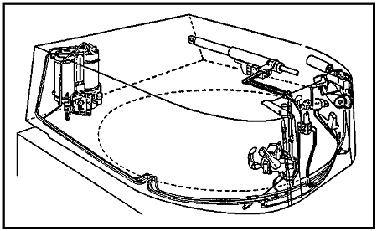

Figure 73. Hydraulic system.

a. Components and functions.

(1) Reservoir. The reservoir holds hydraulic fluid, which may be pumped into the accumulator as it is needed to pressurize the system.

(2) Power pack pump. The power pack pump, powered by a 5-horsepower electric motor, is located in the top of the reservoir. This pump pumps the oil out of the reservoir into the accumulator to pressurize the system.

(3) Accumulator. The accumulator is a metal cylinder containing hydraulic fluid and compressed nitrogen gas separated by a floating piston (Figure 74). The nitrogen gas is precharged to a pressure of 500 psi at 70°. The accumulator allows the transfer of pressure to the system to serve the power traversing mechanism, the elevating mechanism, and the loader-rammer. In operation, the hydraulic fluid is forced through a tube from the accumulator to the elevating and traversing mechanisms and loader-rammer by the compressed nitrogen gas acting against the floating piston.
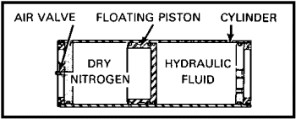
Figure 74. Main accumulator cross section.

(4) Pressure sensitivity switch. The pressure sensitivity switch is located at the base of the accumulator. It senses the pressure in the system and helps the pressure between 925 and 1,225 psi. When the pressure drops below 925 psi, the pressure sensitivity switch turns on the 5-horsepower (hp) motor to activate the pump to return the pressure to operating limits. When the pressure reaches 1,225 psi, the switch shuts the motor off.

(5) Safety relief valve. The safety relief valve opens when the pressure in the accumulator reaches between 1,600 and 3,100 psi. This action allows the hydraulic oil to flow back into the reservoir and prevents the seals in the hydraulic system from being damaged.

(6) Accumulator pressure gage. The accumulator pressure gage, located in front of the accumulator, indicates the amount of nitrogen pressure during the zero pressure check, and the available pressure for hydraulic operations.

(7) Reservoir sight gage. The reservoir sight gage is located between the reservoir and the accumulator. It visually indicates the amount of oil in the reservoir.

b. Zero pressure check. The zero pressure check is performed when troubleshooting the main accumulator and hydraulic system. The zero pressure check is not performed by the howitzer crew as a part of the daily or prefire maintenance checks. It should be performed by qualified organizational maintenance personnel (artillery mechanics). However, its check is the responsibility of the chief of section and maintenance supervisor. The zero pressure check is two checks in one. The first indicates the amount of precharged nitrogen in the main accumulator. The second indicates whether there is enough hydraulic oil in the main power pack reservoir. The need to perform a zero pressure check is indicated when the cab traversing, elevation, and rammer systems function sluggishly. For example, if the electric drive motor runs more than usual to keep pressure built up for power operation of traversing (elevation and rammer system) a zero pressure check may be necessary to detect, isolate, and correct the problem. To perform the zero pressure check, follow this step-by-step procedure:

(1) Place the weapon on level ground, if possible.

(2) Flick the MASTER switch and the CAB POWER switch (Figure 75) to the ON position to charge the system.

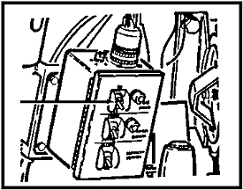

Figure 75. CAB POWER switch.

(3) Observe the pressure gage (Figure 76 ) reading. Normal operating pressure will read 925 to 1,225 psi.

(4) Now flick both the MASTER and CAB POWER switches to the OFF position.

(5) Move the cab traversing lock handle (Figure 77) to the LOCKED position, or place the tube in travel lock.

(6) On the M109A2/A3, move the TRAVERSE CONTROL switch (Figure 78 ) to the MANUAL position.

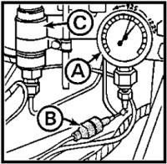

Figure 76. Area around pressure gage.

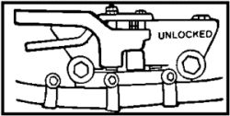

Figure 77. Traversing lock handle.

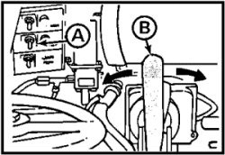

Figure 78. Traverse control switch and gunner's handle.

(7) Disconnect the circuit connector (number 645 wire) (Figure 76 ) located at the right rear of the cab near the pressure gage. If the howitzer is not equipped with such a connector, disconnect the lead at the pressure sensitive switch (Figure 76 ).

(8) Now, again flick both the MASTER and CAB POWER switches to the ON position.

(9) Move the gunner's control handle (Figure 78 ) to the left or right slowly while observing the pressure gage pointer (Figure 79).

(10) Observe the pressure gage pointer (needle) as it drops from operating pressure (925 to 1,225 psi), until it flutters and finally drops sharply to a 0 psi pressure reading. The reading at which the pointer fluttered is the amount of precharged nitrogen pressure in the main accumulator. Normal precharged nitrogen pressure in the main accumulator will be 500 psi at 70°F. This could vary ±50 psi with changing temperatures.

NOTE: If the main accumulator nitrogen pressure is below 500 psi, use manual operation only until the system can be recharged by organizational maintenance personnel.

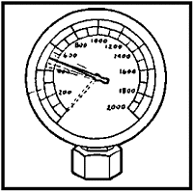

Figure 79. Pressure gage pointer.

(11) To continue the zero pressure check for the hydraulic system's oil pressure, flick both MASTER and CAB POWER switches to the OFF position.

(12) Observe the sight gage (Figure 80) on the main hydraulic reservoir. Oil appearing in the gage should be level with the mark on the scale that reads full at zero pressure check.

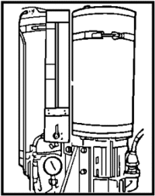

Figure 80. Sight gage.

(13) If the oil level is below the mark, replenish the reservoir oil level before continuing.

(14) To add hydraulic oil, remove the cab access plate (Figure 81 ), located on the top right rear of the cab, by removing its four bolts (Figure 81 ).

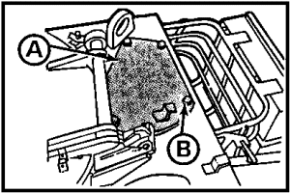

Figure 81. Access plate and bolts.

(15) Unscrew and remove the dipstick (Figure 82) from the top of the hydraulic oil reservoir, and note the reading on the dipstick.

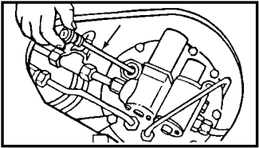

Figure 82. Dipstick.

(16) Add hydraulic oil (MIL-H-6083) to the reservoir, and check the level again with the dipstick. The oil should be level with the FULL mark on the dipstick.

(17) With the oil at its proper level, replace the dipstick in the hydraulic oil reservoir and tighten. Replace the access plate and four bolts.

(18) Reconnect the circuit connector (Figure 76 and the lead (Figure 76 ).

(19) Flick both the MASTER and CAB POWER switches to the ON position.

NOTE: The main hydraulic system should now charge.

(20) Observe the pressure gage pointer. It will move from 0 and should stop between 1,175 to 1,275 psi. This completes your hydraulic system zero pressure check, and all components should now function properly.

PRACTICE EXERCISES:

91. The hydraulic system is pressurized by a pump, driven by--

a. a 3-horsepower electric motor.
b. a 5-horsepower electric motor.
c. a 11.25-horsepower hydraulic motor.
d. the vehicle main engine.

92. The main accumulator contains hydraulic fluid and compressed--

a. hydrogen.
b. oxygen.
c. nitrogen.
d. butane.

93. The zero pressure check is performed to determine if there is enough hydraulic oil in the main power pack reservoir and to verify--

a. nitrogen gas pressure in the main accumulator.
b. hydraulic oil level in the secondary accumulator.
c. electrical systems overload capacity.
d. operation of the hydraulic systems pressure gage.

94. Normal hydraulic operating pressure is indicated by a reading on the pressure gage of--

a. 500 to 550 psi.
b. 700 to 850 psi.
c. 825 to 925 psi.
d. 925 to 1,225 psi.

95. When required, hydraulic oil is added to the reservoir by replenishing--

a. through the cab access plate on top of the cab.
b. the secondary reservoir directly.
c. the equilibrator cylinder.
d. a filler neck near the pressure gage.

//////////////////////////////////////////////////////////////////////////////////////////////////////////////////////////////////////////////////////////////////

ANSWERS:

91. b.
92. c.
93. a.
94. d.
95. a.

//////////////////////////////////////////////////////////////////////////////////////////////////////////////////////////////////////////////////////////////////

21. CAB TRAVERSING MECHANISM. The traversing mechanism (Figures 83 and 85), located at the left front of the cab, is used to pass power from either the manual traversing drive or the hydraulic traversing drive to the cab ring gear to control the horizontal (azimuth) movement of the weapon.

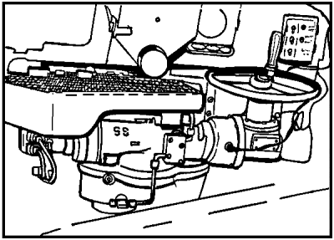

Figure 83. Traversing mechanism.

The power elevation and traversing control handle (Figure 84) directs pressurized oil to drive the traversing motor. During manual traversing, power is passed from the hand traversing drive through the no-back device, the clutch, and the gear train to the cab ring gear. During power traversing, power is passed from the hydraulic motor through the gear train to the cab ring gear. A no-back device has been included in the traversing mechanism to prevent undesired rotation when the traversing mechanism is set for manual traversing. The M109A2/A3 has a ring and race type of traverse. The ring is attached to the hull (motor carriage) and does not move in traverse but supports the weight of the race, which is attached to, and moves with the cab in traverse. Bearings between the ring and the race provide ease of movement. The traversing mechanism is either hydraulically or manually powered and is capable of 6,400 mils (360°) on-carriage traverse. An electrical traversing circuit provides

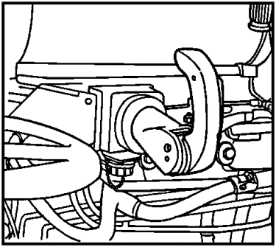

Figure 84. Gunner's control handle.

the electrical control for the hydraulically powered traversing system.

The M109A2/A3 is equipped with a positive displacement traversing motor (Figure 85) which is the same as the traversing motor used in the M60 tank.

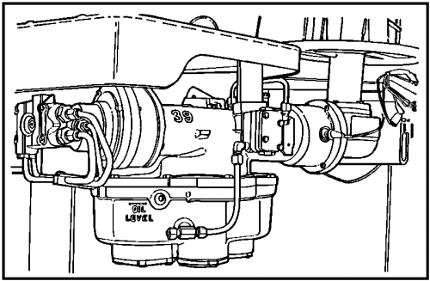

Figure 85. Traversing mechanism, M109A2/A3.

a. Components of the traversing mechanism. The maintenance supervisor (commander, section chief) is concerned with all aspects of the howitzer--its components, functions, and operation. To properly supervise the crew, he must understand the relationship of those component parts and how they function together to make the weapon operate. Additionally, he must ensure that all operations are done in a way that is safe to personnel and equipment.

- Traverse lock. This is a two-position lock (Figure 86) located to the right of the gunner's control handle. The cab traverse lock prevents damage to the traversing mechanism by keeping the cab from rotating during movement. The traverse lock may also be used to hold the cab in place when the howitzer is sitting on a cant.

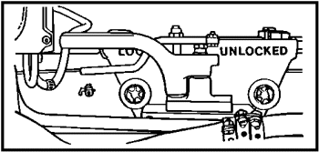

Figure 86. Cab traverse lock.

(2) Travel lock. This is a three-position lock located on the front of the howitzer hull. The travel lock prevents damage to the trunnions and elevating mechanism by keeping the tube from bouncing during movement. (Figure 87)

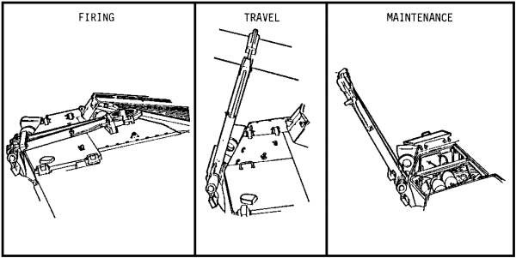

Figure 87. Tube travel lock.

NOTE: Using the tube travel lock, even when moving only a few feet, has prevented damage to the long and heavy tube of the M109A2/A3.

(3) MANUAL/POWER TRAVERSE control switch. The selection switch is located on the cab power control box. This switch allows the gunner to choose power or manual style traversing when the howitzer MASTER switch is on. (Figure 88)

(4) Hydraulic traversing motor. The traversing motor is located on the left side of the howitzer cab at the gunner's station.

(5) Manual traversing handwheel. The manual traversing handwheel is located at the top front of the traversing motor. The handwheel moves the tube 10 mils in traverse per turn of the wheel.

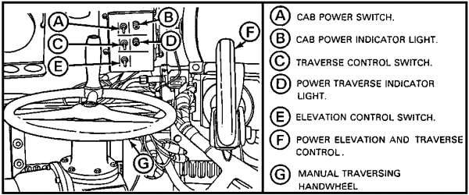

Figure 88. Gunner's controls.

b. Operation and function. The cab of the M109A2/A3 can be traversed by either manual or power traversing. This operation can be done only by using the controls at the gunner's position at the left front of the cab. Before the weapon can be traversed, several preliminary steps and checks must be performed as follows:

- Unlock the tube travel lock.

- Unlock the cab traverse lock.

- Alert the crew that you are traversing.

- Clear the area around the vehicle.

(1) Disengage and secure the tube travel lock. The tube travel lock of the M109A2/A3 (Figure 89) is mounted on the front of the hull and lies flat on the forward deck when disengaged from the tube during firing. A safety latch pin, located at the base of the travel lock, must be disengaged to permit the travel lock to move forward, allowing the transmission access doors to open.

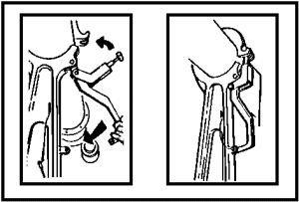

Figure 89. Tube travel lock, 155-mm M109A2/A3 howitzer.

(2) Unlock cab traverse lock. The cab traverse lock is located inside the cab to the right of the gunner's control handle (Figure 90). The lock is in the UNLOCKED position when the handle covers the word UNLOCKED (handle to the right).

Step 1. Squeeze the release lever to release the handle.

Step 2. Move the handle to the right to the UNLOCKED position, and release the lever to engage the positioning hole.

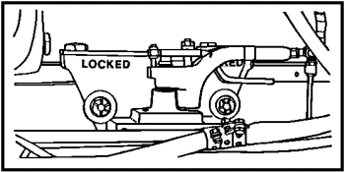
Figure 90. Cab traverse lock in UNLOCKED position.

(3) Lock cab traverse lock. Moving the handle to the left so that it covers the word LOCKED locks the cab traverse.

Step 1. Squeeze the release lever to release the handle.

Step 2. Move the handle to the LOCKED (handle to the left) position, and release the lever to engage the positioning hole. (Figure 91)

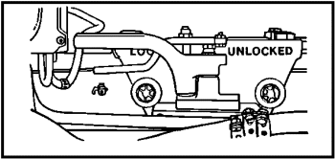

Figure 91. Traverse lock in LOCKED position.

NOTE: When difficulty is experienced in placing the release lever into the positioning hole, traverse the cab slightly left or right to align the lock teeth with the cab race ring teeth.

(4) Alert the crew. Tell your crew that you are traversing so that you do not knock people or equipment off the deck with the tube or off the cab top by rotation. Also, make sure that no equipment is hanging out of the cab windows and that spade stowage boxes are closed.

(5) Clear area around vehicle. This is to ensure that the gunner knows his limits when traversing so that he does not strike any trees, buildings, or vehicles that may be adjacent to the howitzer.

(6) Traverse the M109A2/A3. When the TRAVERSE CONTROL switch is in the POWER position, it activates a solenoid that controls the hydraulic fluid pressure to the positive displacement traversing motor. Traverse is done with a power control handle. When the TRAVERSE CONTROL switch is in the MANUAL position, it activates an electric clutch that engages the traversing handwheel linkage. The handwheel has been enlarged to give better leverage and 10 mils of traverse with each turn of the handwheel.

c. Maintenance. General maintenance of this system requires a continuing effort to keep components clean, moisture free, and properly lubricated, as appropriate. Dirt and grit of any kind can keep the weapon from performing well or even from performing at all. Spent machine gun brass allowed to fall into the turret ring mount teeth can cause the entire traversing system to malfunction. Specific checks and maintenance requirements for the traversing system include:

(1) Hydraulic lines and connections--check for signs of leakage, wear, or loose fittings.

(2) Cab race ring--excess lubricant on the race ring can cause vehicle deadline. Open the inspection door, and make sure it needs lubricant before pulling a pipe plug and temporarily replacing it with a grease fitting.

(3) Traverse mechanism--grease and dirt tend to pile up near the traverse mechanism pinion gears. Open the access plate, and clean as needed.

(4) Main accumulator pressure gage--during power traverse operations, check the main accumulator pressure gage and be sure it reads between 925 and 1,225 psi.

d. Traversing troubleshooting guide. The following guide (Table 1) may be used by maintenance personnel and supervisors to isolate, diagnose, and correct problems developed in the traversing system.

Table 1. Traversing troubleshooting guide.

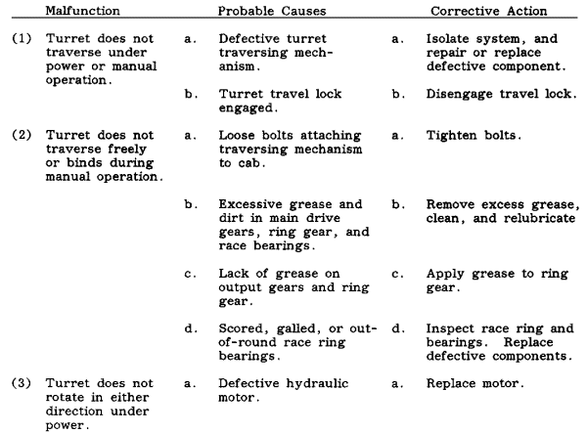

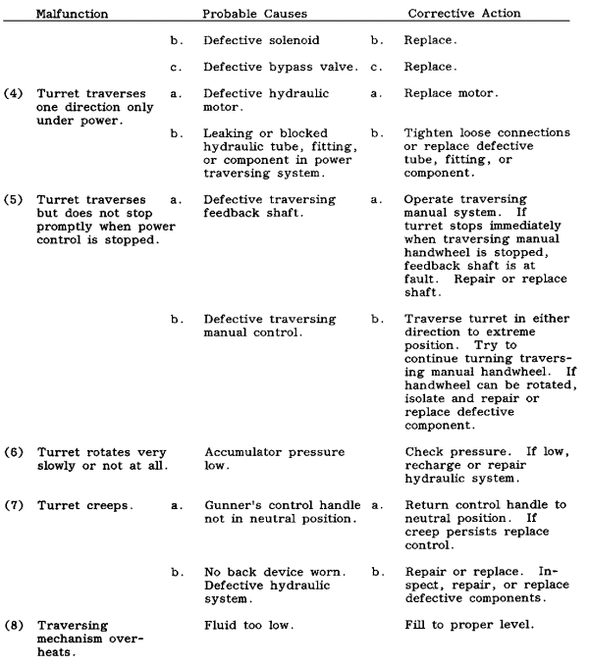

PRACTICE EXERCISES:

96. Undesired rotation of the cab is prevented by the __________________ __________________.

97. The M109A2/A3 traversing mechanism allows for ___________ mils on-carriage traverse.

98. Traversing may be done manually or it may be ___________ powered.

99. Stress is relieved on both traversing and elevating mechanisms by a combination of an exterior tube travel lock and __________ _____ ___________ _________________.

100. Before trying to traverse the weapon, the following actions must be completed.

a. _________________________________________________

b. _________________________________________________

c. _________________________________________________

d. _________________________________________________

101. T F A probable cause of difficulty (binding) in manual traversing operations could be excessive grease and dirt in the ring gear or race bearings.

102. T F When the turret fails to traverse in either direction under power, low hydraulic fluid is indicated.

103. T F A pressure check should be performed on the hydraulic system if the turret rotates slowly.

104. T F A defective electric clutch is indicated when the traversing mechanism overheats.

//////////////////////////////////////////////////////////////////////////////////////////////////////////////////////////////////////////////////////////////////

ANSWERS:

96. no-back device
97. 6,400
98. hydraulically
99. interior cab traverse lock.
100. a. unlock tube travel lock
b. unlock cab traverse lock
c. alert crew that you are traversing
d. clear the area around the vehicle
101. T
102. F
103. T
104. F

//////////////////////////////////////////////////////////////////////////////////////////////////////////////////////////////////////////////////////////////////

22. RAMMER. The rammer is a manually activated, hydraulically operated system that aids in loading the howitzer by thrusting the projectile into the chamber. The weapon-mounted rammer (Figure 93) found on the M109A2/A3, remains in alignment as the tube is elevated or depressed. Therefore, the projectile can be rammed at any angle of elevation that will permit loading the propelling charge without its sliding out of the chamber, and the rammer assembly is not blocked by the floor. The weapon-mounted rammer is supported in the stowed position to the lower left of the tube on the rammer shaft and needs only to be rotated about the rammer shaft into position behind the breech. The rammer cylinder on the weapon-mounted rammer is swung clear of the tray while the projectile is manually placed on the tray ahead of the cylinder. Swing the cylinder back onto the tray, and lock it in place with the latch. The number 1 man presses the rammer control valve (Figure 93), the rammer extends, and the projectile is rammed into the chamber. As soon as the rammer retracts, it is folded into the stowed position.

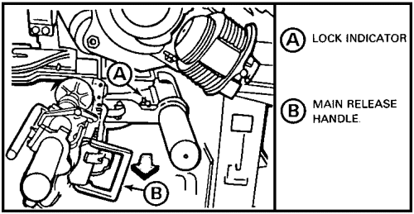

Figure 93. Weapon-mounted rammer.

a. Components. The principal components of the rammer are:

(1) Cylinder. The cylinder, when hydraulically activated, extends a telescoping ram, which slides the projectile into the chamber. At the completion of the ramming stroke, the ram is returned automatically.

(2) Tray assembly. The tray assembly, a concave length of sheet metal, supports the projectile and guides the projectile into the chamber.

(3) Blocking valve. The blocking valve is a junction box below the tube that blocks the hydraulic line to the rammer. This prevents operation of the rammer unless it is locked into the ram position and the blocking valve plunger is pressed in.

(4) Rammer control valve. The rammer control valve is located on the cab ceiling. The number one cannoneer must press (push) the valve handle in to ram the projectile, and release the handle to return the rammer. This makes ramming a projectile a positive crew member action which prevents "double ramming" or damage to the rammer by accidental ramming without a projectile.

b. Operation of the weapon-mounted rammer. The principal parts of the weapon-mounted rammer assembly are the:

- Rammer shaft and cover.

- Rammer cylinder, with cylinder handle, and latch.

- Locking indicator.

- Stowed position bracket.

The complete rammer assembly is mounted on the cradle below the breech by means of the rammer shaft (Figure 94).

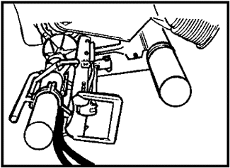

Figure 94. Weapon-mounted rammer, stowed position.

The weapon-mounted rammer can be operated at any elevation at which the propelling charge will not fall out of the chamber and the rammer assembly is not blocked by the floor. The step-by-step procedure for operating the rammer follows:

(1) Preparation for loading. Open the breechblock by grasping the operating handle, depressing the plunger, and pulling back (Figure 95). Lock the breechblock on to the cam, and return the operating handle to the stowed position (Figure 96).

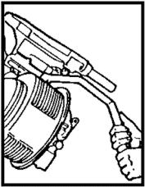

Figure 95. Operating breechblock.

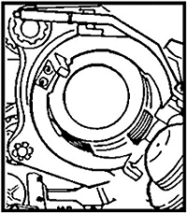

Figure 96. Store operating handle.

Grasp the main release handle (Figure 97) and cylinder handle. Pull back on the main release handle to unlock the rammer assembly. Then pull the assembly rearward until it stops. Lift the assembly up and to the right until it stops. Push the assembly forward until it stops and locks (Figure 98). Check the lock indicator (indicator in black area).

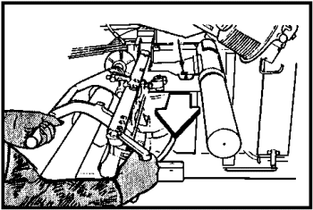

Figure 97. Main release handle.

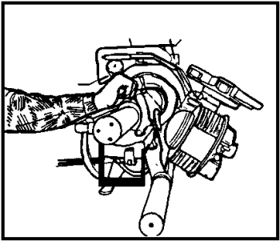

Figure 98. Rammer assembly to locked position.

Push on the cylinder latch to unlatch the cylinder. Roll the cylinder over to the left to clear the tray chute for loading the projectile (Figure 99).

CAUTION

DO NOT DISTURB MAIN RELEASE HANDLE.

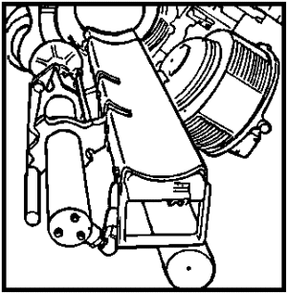

Figure 99. Rammer tray positioned for loading.

(2) Loading. After the projectile has been properly positioned on the tray chute, the cylinder handle is used to rotate the rammer back into position on the tray chute (Figure 100).

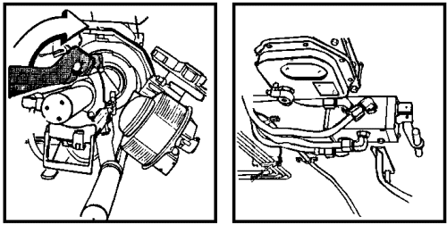

Figure 100. Preramming position.

(3) Stowing. When the rammer is to be returned to the stowed position, a hard pull on the main release handle will unlatch the tray chute and permit the rammer to be pulled to the rear of the rammer shaft. Then, by means of the cylinder handle, the rammer is lowered to the side and pushed forward onto the stowed position bracket until the locking indicator pointer shows that the assembly is in the stowed and locked position.

(4) Insert the propelling charge into the chamber until the base of the charge is 3 inches inside the rear of the chamber (Figure 101).
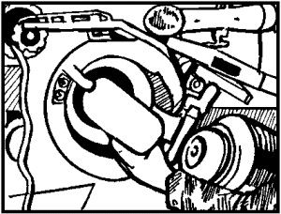

Figure 101. Inserting the propelling charge.

CAUTION

DO NOT INSERT THE PROPELLING CHARGE IN THE CHAMBER UNTIL A FEW SECONDS BEFORE FIRING. TEMPERATURE VARIATIONS WILL AFFECT PERFORMANCE CHARACTERISTICS AND CAUSE DEVIATIONS IN BALLISTICS.

(5) The breechblock is now closed by lifting up on the cradle cam handle (Figure 102).
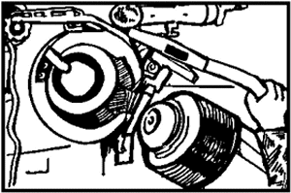

Figure 102. Activating the breech mechanism.

STAND CLEAR OF THE BREECH MECHANISM WHEN LIFTING THE CRADLE CAM HANDLE. THE BREECH MECHANISM IS ACTUATED BY A HEAVY TORQUE SPRING. WHEN THE BREECHBLOCK IS RELEASED, IT CLOSES WITH A GREAT AMOUNT OF FORCE AND SPEED.

(6) Witness marks provide a means to quickly verify (visually) correct alignment (complete closing) of the breechblock. If the witness marks do not align, release the operating handle from the secured position by depressing the plunger and pulling the handle slightly to the rear. Manually engage the clutch pin by pushing in on it. Hold the clutch pin in, and push forward on the operating handle to rotate the breechblock to the fully closed position (Figure 103). Now return the operating handle to the latched position.

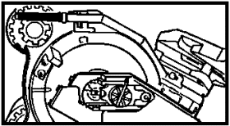

Figure 103. Breech fully closed.

(7) The primer can now be inserted into the primer chamber (Figure 104), which was uncovered by the camming of the firing mechanism to the right when the breechblock was opened.

NOTE: The only primer authorized for use in the M109A2/A3 howitzers is the M82 (brass) primer. These primers are packed one per waterproof bag. Do not open this moisture protective bag until ready to use the primer.

Seat the flanged head of the primer firmly against the extractor (Figure 105). Do not force the primer. If the chamber is dirty, remove the primer and clean the primer chamber and obturator spindle vent hole (Figure 104).

(8) Attach a firing lanyard to the eyelet of the firing mechanism lever (Figure 106). Now slide the firing mechanism to the left until it is locked in the firing position. This is done by placing the palm of the hand against the firing mechanism case and pushing it to the left.

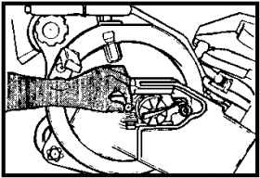

Figure 104. Inserting primer into firing mechanism.

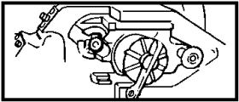

Figure 105. Primer seated against extractor.

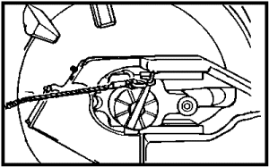

Figure 106. Firing mechanism closed, lanyard attached.

CAUTION

CHECK TO ENSURE THE FIRING POSITION OF THE FIRING MECHANISM BLOCK ASSEMBLY IS AT FULL LEFT TO AVOID MUSHROOMING OF FIRING PIN AT THE STRIKER END. A MUSHROOMED PIN MAY CAUSE FAILURE OF THE FIRING PIN TO RETRACT OR ENGAGE THE PRIMER.

(9) The weapon is now ready to fire. The firing mechanism is designed to be activated from eight positions with a straight rearward pull, or in rotation either left or right. Grasp the firing lanyard, and with a firm continuous pull, activate the firing mechanism to fire the weapon.

STAND CLEAR OF THE PATH OF RECOIL.

PRACTICE EXERCISES:

105. After a projectile has been rammed, the next step in the loading operation is to--

a. insert the propelling charge.
b. prime the firing mechanism.
c. close the breechblock.
d. return the rammer to the stowed position.

106. Correct alignment of the breechblock can be verified visually by--

a. the position of the operating handle.
b. alignment of the witness marks.
c. depressing the clutch pin.
d. seating the firing mechanism.

107. The firing mechanism is designed to be activated from eight positions with a straight rearward pull or--

a. electrically from a remote device.
b. from two positions with a continuous pull.
c. in rotation either left or right.
d. with a percussion hammer spring device.

108. The rammer assembly is made up of the following principal parts:

a. ___________________________________
b. ___________________________________
c. ___________________________________
d. ___________________________________

109. The weapon-mounted rammer is located on the __________________ below the _____________________.

110. The rammer assembly is locked in the stowed position by a ____________, which is disengaged when the __________ __________ _____________ is pulled rearward.

111. The chute is fully forward and locked in ramming position when the pointer on the __________ __________ points to the ________________ band.

112. The rammer cylinder is held in place by a ___________________ on the _____________ ________________.

113. A hard pull on the ________ _________ __________ will unlatch the tray chute so that it can be pulled to the rear of the rammer shaft.

114. The rammer is lowered to the side and placed in the stowed position by grasping the ________________________.

//////////////////////////////////////////////////////////////////////////////////////////////////////////////////////////////////////////////////////////////////

ANSWERS:

105. d.
106. b.
107. c.
108. a. rammer shaft and cover
b. rammer cylinder with cylinder handle and latch
c. locking indicator
d. stowed position bracket
109. cradle, breech.
110. latch, main release handle
111. locking indicator, black
112. latch, cylinder handle.
113. main release handle
114. cylinder handle.

//////////////////////////////////////////////////////////////////////////////////////////////////////////////////////////////////////////////////////////////////

c. Manual ramming. Manual ramming, when it becomes necessary, may be done by using the rammer staff and loading rammer that is a part of the section equipment. Loading and ramming procedures are described in the following five steps:

(1) Number 2 and number 3 cannoneers assemble five rammer staff sections (Figure 107 ) with a loading rammer on the end.

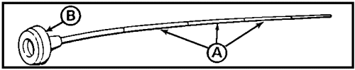

Figure 107. Rammer staff and loading rammer.

NOTE: Adjust the number of rammer staffs as necessary when the ammunition vehicle is behind the howitzer.

(2) The assistant gunner elevates the tube to about 265 mils of elevation to permit manual ramming through the rear door of the hull.

(3) The number 1 cannoneer places a round on the loading tray and pushes the projectile (Figure 108 ) forward into the chamber until the rotating band of the projectile is just forward of the loading tray .

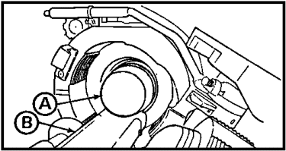

Figure 108. Loading tray.

(4) Number 2 and number 3 cannoneers now place the rammer staff and loading rammer (Figure 109) through the rear hull door and position it against the base of the projectile.

(5) Actual ramming must be uniform and hard to seat the projectile properly against the forcing cone. The number 2 and number 3 cannoneers position their hands and bodies as shown in Figure 110. On the command RAM, together they push the projectile as hard as possible to seat it in the tube.

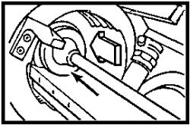

Figure 109. Rammer staff and loading rammer.

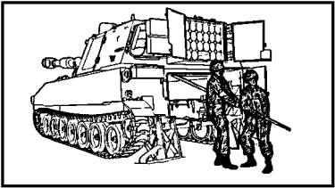

Figure 110. Number 2 and number 3 cannoneers.

d. Rammer maintenance. After the weapon has been fired it must be cleaned, and the after-operations maintenance checks and services must be performed according to TM 9-2350-217-10N. Specific rammer maintenance is limited to thorough cleaning and application of light lubricating oil to unpainted surfaces as follows:

(1) Place the rammer at a convenient elevation for maintenance.

(2) The rammer and all rammer components are wiped with a cleaning rag.

(3) Remove any rust from the rammer head and tray with crocus cloth.

(4) Lubricate the rammer head and tray with a few drops of oil (PL-S).

(5) Lubricate the grease fittings with a grease gun.

PRACTICE EXERCISES:

115. T F The alternate ramming method is possible only with the rammer cylinder in ramming position.

116. T F Manual ramming is conducted on the command of READY from the gunner.

117. T F Manual ramming is done with the tube at about 366 mils in elevation.

118. T F The number 2 and number 3 cannoneers may perform manual ramming with the section rammer staff with 3 sections.

119. T F The projectile must be rammed as hard as possible to achieve uniform ballistics.

120. T F The first step in performing after-operation maintenance on the rammer is to place the rammer in a convenient position.

121. T F Only unpainted surfaces need to be lubricated.

//////////////////////////////////////////////////////////////////////////////////////////////////////////////////////////////////////////////////////////////////

ANSWERS:

115. F
116. F
117. F
118. T
119. T
120. T
121. F

//////////////////////////////////////////////////////////////////////////////////////////////////////////////////////////////////////////////////////////////////

23. EMPLACE AND RECOVER THE RECOIL SPADES. The purpose of the recoil spades is to stabilize the vehicle during firing and to minimize displacement (backward motion) of the weapon during recoil. Spades help transmit much of the shock of firing to the ground. The M109A2/A3 is equipped with two case metal recoil spades located at the rear of the vehicle and operated manually. Recoil spades must be properly emplaced before the weapon is fired or extremely inaccurate fire and extensive damage to spade and suspension system may result.

CAUTION

NEVER TRY TO TURN THE VEHICLE WHILE IT IS ON THE SPADES. THIS CAN TWIST AND DAMAGE YOUR SPADES. IF IT IS NECESSARY TO REPOSITION THE HOWITZER, DRIVE THE VEHICLE STRAIGHT AHEAD ABOUT 10 FEET AND THEN BACK IT STRAIGHT INTO THE FIRING POINT AND ONTO THE SPADES.

a. Emplacing the spades. The left and the right recoil spades are in mirror-image configuration; therefore, only the emplacement of one spade will be described here. The crew member(s) to perform specific tasks are prescribed in appropriate field manuals or designated by unit SOP. To emplace the spade, follow these steps:

(1) Release the spade pedal latch (Figure 111).

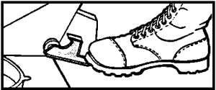

Figure 111. Spade pedal latch.

(2) Pull the strut (Figure 112 ) loose from the spade.

(3) Ensure strut spring and cable are present.

(4) Remove the spade safety pin .

(5) Release the spade locking latch .

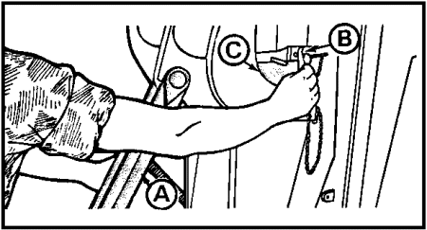

Figure 112. Spade strut, safety pins, and locking latch.

NOTE: To do these tasks on the right spade, the rear hull door (Figure 113 ) must be closed.

(6) The spade is now lowered to the ground.

(7) At this time the chief of section instructs the driver to back the howitzer up on the spades .

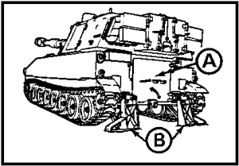

Figure 113. Howitzer on spades.

(8) Of particular importance during this operation is the fit of the spade strut (Figure 114 ) in the strut socket . Check the strut to ensure that it is positioned properly in the strut socket.

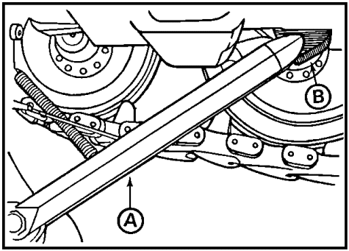

Figure 114. Spade strut.

(9) To properly emplace the spades, slowly move the vehicle backward; do not back the vehicle farther than necessary to emplace the spades firmly in the ground. The spades must not be permitted to jack up the vehicle. Once the howitzer is in position with the spades properly placed, the driver is instructed to lock the brakes and follow the prescribed shut-down procedure.

b. Recovering the spades. To recover the spades, follow the emplacement procedure in reverse except to lock down the spade pedals before moving the howitzer.

(1) The vehicle driver, when directed to do so, starts the engine and backs up just enough to relieve tension on the spade latch.

(2) When the left and right release pedals are activated the vehicle is moved forward to extract the spades from the ground.

(3) The spades must now be lifted manually (use two crew members) into position and secured with the spade locking latch and the spade safety pin.

CHECK TO ENSURE LOCKING LATCHES ARE FULLY ENLARGED.

c. Maintenance and adjustments. Normal maintenance of the spades and their components includes removal of accumulated dirt and mud and periodic repainting of surfaces. It is a good idea to also remove burrs in the metal that may have been caused by rocks in the ground and to inspect the spades for large cracks. Replace broken spades and weld cracks, if possible. Lubricate pivot points, pins, and latches to prevent rust on these exposed surfaces. If it becomes necessary to adjust the spades, follow this procedure:

(1) Back the vehicle over a log or other object at least 18 inches high that will permit the spade to be lowered without touching the ground.

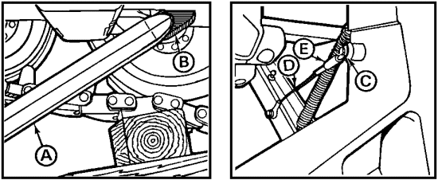

Figure 115. Spade adjustment.

(2) Check the travel of the spade strut (Figure 115 ) and its position relative to the socket on the hull. The strut should fit cleanly in the socket. If the strut is off center, remove the cable retaining screw and the cable . Loosen the jam nut , and shorten or lengthen the travel.

NOTE: Spade adjustment should be verified in a firing position as soon as practicable.

(3) Reconnect the cable , and raise and lower the spade several times to verify adjustment. Tighten the jam nut .

NOTE: When replacing the entire cable assembly, do not try to adjust the new cable to the length of the old cable.

d. Inspection. Inspections are conducted to detect and correct operational malfunctions before they occur and to prevent injury to personnel. With the spades properly adjusted and maintained, the maintenance supervisor concentrates on these areas:

(1) Latches --Check operation of spade latches in stowed position. Ensure they make positive contact to securely hold the spades in the stowed position.

(2) Burrs --Ensure burrs are removed (filed down) from corners and the spade face.

(3) Components --Make certain all spade components are present and functional.

(4) Weld joints --Closely inspect all weld joints for breaks and cracks. Ensure cracks and breaks are repaired promptly.

PRACTICE EXERCISES:

122. Proper emplacement of recoil spades before firing the weapon is essential for accurate fire and to--

a. provide balance for the added weight of the large tube extending forward of the trunnions.
b. prevent damage to spades and the suspension system from the recoiling energy.
c. counteract the tendency of the howitzer to tip backward at extremely high elevations.
d. help stabilize the weapon platform when firing at large deflection changes.

123. When backing up the vehicle during the spade emplacement operation, ensure that the spade strut fits properly into the strut socket and that the vehicle is backed up--

a. until the rear is jacked up well off the ground.
b. far enough to permit the locking latch to engage.
c. slowly, until the spades are firmly seated in the ground.
d. rapidly, to ensure the spades dig themselves fully into the ground.

124. On the M109A2/A3 howitzer, the spades are recovered--

a. automatically.
b. hydraulically.
c. simultaneously.
d. manually.

125. Adjustments to the spade assembly are made basically to ensure--

a. proper fit of the strut in the strut socket.
b. correct length of the strut cable assembly.
c. proper tension of the strut retaining spring.
d. tightness of the jam nut against the retaining screw.

126. In addition to burrs, cracks, and weld joints, recoil spades should be inspected for--

a. presence and function of all components.
b. positive contact and secure hold of latches.
c. overall cleanliness and adequate lubrication of spade components.
d. all the areas mentioned above.

//////////////////////////////////////////////////////////////////////////////////////////////////////////////////////////////////////////////////////////////////

ANSWERS:

122. b.
123. c.
124. d.
125. a.
126. d.

//////////////////////////////////////////////////////////////////////////////////////////////////////////////////////////////////////////////////////////////////

24. PREPARING TO OPERATE UNDER UNUSUAL CONDITIONS. Special care in operating, cleaning, and lubricating must be observed where extremes of temperature, humidity, and terrain conditions are present or anticipated. In addition to normal preventive maintenance services, a variety of special requirements arise when operating under unusual conditions. The supervisor must know what special requirements to initiate under a particularly unusual condition, place special emphasis on doing them, and ensure that the equipment remains operational and combat ready. He must also consider the human factor. In fact, when soldiers are cold, wet, or hot and suffering personal discomfort due to weather or other environmental factors, they may tend to neglect their equipment or operate it in an unsafe or improper manner. Under these conditions, even normal or routine operations and maintenance require more effort and should therefore be supervised more closely, to guard against the human tendency to put off work until things get better.

a. General conditions. The following are a few general considerations to keep your equipment operational under unusual conditions:

(1) Vehicles.

- Select drivers with the utmost care, and provide them with special training.

- Ensure automotive maintenance services, both routine and special, are done on schedule. Emphasize cleaning and lubrication as a critical necessity.

(2) Primary armament.

- When not in use, keep the howitzer covered.

- Clean and lightly lubricate the breech mechanism. Do not apply any lubricant to the firing pin.

- When cleaning the tube and breech, do not dilute or add antifreeze to rifle bore cleaner.

- In a cold climate, store cleaning solutions in a warm place, if available.

- Do not allow ice, snow, or water to mix with lubricants or allow dust, sand, or grit to contaminate them.

- Do not use unspecified lubricants.

(3) Secondary armament. The procedures for maintaining secondary armament are basically the same as those for operation under usual conditions. The only difference is that lubricant, automatic weapons (LAW) should be used to clean and lubricate machine guns to keep them functioning properly in cold climates.

(4) Sighting and fire control instruments. These instruments must be kept dry. They should not be moved suddenly from cold to warm temperatures or vice versa. Condensation induced by this action may cause clouding of optics and rusting of internal parts.

(5) Cold weather.

- In temperatures below freezing, keep the howitzer moving parts free of moisture.

- The time to change to lighter lubricants is indicated when operation of moving parts becomes sluggish.

- During such adverse conditions, lubricants should be changed more frequently to prevent damage to equipment.

(6) Hot, humid, or salty conditions.

- Do not park the vehicle in the sun for long periods of time, if possible.

- Oil evaporates in hot weather. Lubricate weapons more frequently.

- Clean and lubricate the howitzer bore and unpainted surfaces as often as necessary to prevent accumulation of moisture, salt, or sand.

- Apply a light film of the lubricant PL-M on the weapon and mount when not in use and keep covers in place, including optics.

(7) Dusty or sandy conditions.

- Always park the vehicle under available shelter or keep it covered with tarpaulins.

- Keep all armament lubricated and covered when not in use.

- Before firing machine guns, remove the lubrication from the bolt assembly, receiver, trigger, feed tray, cover assembly, barrel, and other moving parts.

- To avoid excessive wear, do not allow vehicle drivers to spin the tracks of howitzers when operating in dusty/sandy areas.

b. Operation in extreme cold.

(1) Winterization kit. The winterization kit is installed by organizational maintenance personnel. It is used in extreme cold (0° to -65°F) to prevent the coolant from freezing after the vehicle has been shut down. Specific directions for operation are as follows:

- Both coolant level and fuel supply must be full.

NOTE: Heater will operate with MASTER SWITCH either ON or OFF.

- Depress the press-to-test light (Figure 116 ) to check for electrical current.

- Be sure the engine coolant is at normal operating temperature (you may have to start the engine and bring the coolant temperature up).

- Remove the heater exhaust outlet plug (Figure 117) located on the hull by the engine exhaust.

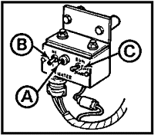

Figure 116. Heater control.

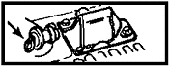

Figure 117. Exhaust outlet plug.

- Secure tarpaulins over the air intake and exhaust grilles. Tarpaulins will help keep out the cold and retain heat from the winterization kit.

- To start the coolant heater, place the HI-LO switch (Figure 116 ) to HI.

- Hold the START-RUN-OFF switch (Figure 116 ) at START.

- The indicator lamp will light, indicating the heater is operating. Immediately move the START-RUN-OFF switch to the RUN position without hesitating in the OFF position.

- Set the HI-LO switch for the desired rate of heat. If set at HI, the heater will automatically go on to low heat when the coolant temperature reaches 190°F. If the coolant temperature falls below 120°F, the heat control will return to high. The LOW position is suitable when the heater must burn over an extended period of time.

NOTE: After the heater starts, it will keep working as long as you have fuel, electric current, air, and a flow of engine coolant. The heater will automatically stop if the coolant temperature reaches 245°F. If it has to be restarted, repeat this starting procedure.

- To shut down the coolant heater, place the RUN-OFF-START switch to OFF. The heater will go to the purge cycle. Fuel will shut off and burning will stop when the remaining fuel in the heater is exhausted. The blower will run at low speed until the heater is cool, and then the heater will completely shut down.

(2) Cold weather starting. Cold weather starting procedures are to be used at 0°F and below. However, these procedures also apply when the vehicle fails to start at or below 32°F.

NOTE: If the winterization kit (coolant heater) has been in use, shut off the heater before trying to start the engine. Remove the tarpaulins, roll them into tube form, and secure them with webbing assemblies. Then install the exhaust outlet plug.

- Charge batteries (especially after 24 hours of winterization kit operation).

- Press down on the service brake pedal, pull out and down on the BRAKE LOCK handle; then release the handle to set the brake.

- Shift into neutral.

- Flick on the MASTER SWITCH (Figure 118 ). The indicator lamp will light.

- Turn the FUEL PRIME switch on for 45 seconds and release.

- Turn the FLAME HEATER MASTER switch to ON. The indicator lamp will light.

- Hold the FLAME HEATER switch in the ON position for 5 seconds.

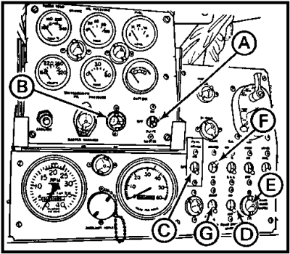

Figure 118. Indicator panel.

- Hold the starter switch in the ON position, and cycle the FLAME HEATER switch on and off at half-second intervals until the engine reaches 400 RPM; then depress the accelerator halfway and release the starter switch.

- If the engine does not start after 30 seconds or an indication of starting ceases for a period over 10 seconds, stop the starting procedure and notify organizational maintenance.

- With brakes still locked, set the throttle to run the engine at 1,200 RPM and shift the transmission to the fourth gear position. Continue to cycle the FLAME HEATER switch until the engine coolant temperature gage indicates 120°F to 140°F. Then shift into neutral and idle the engine. (If the transmission temperature approaches 300°F during warm-up, immediately shift to neutral until the temperature approaches the normal range.)

- During warm-up, refer to the indicator panel checkout procedure.

- Shift the transmission to the first gear position, and the drive vehicle slowly 100 yards, being careful not to stall the engine. This will warm lubricants sufficiently for normal operation.

(3) Engine air filters. Engine air filtering systems can influence the fuel consumption and efficient operation of your engine. Filters must be cleaned at specified intervals under normal conditions, but with increased frequency under unusual conditions, especially in dusty, sandy areas or in cold weather. For example, air filters on the M109A2/A3 should be cleaned when the indicator shows red. But this is the established minimum, under ideal or normal conditions! Much greater frequency of inspection and cleaning is necessary when conditions deteriorate. A loss of engine power and dense, black exhaust smoke can be signs of dirty air cleaners. Additionally, the air filter locking handles must be positioned properly for operation in cold or warm weather as follows (Figure 119):

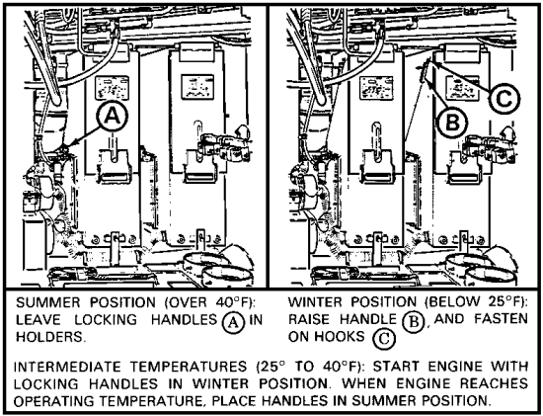

Figure 119. Air filter locking handles.

CAUTION

IF THE HANDLES ARE DOWN IN THE WINTER, THE ENGINE RUNS TOO COLD AND THE DIESEL FUEL CAN FREEZE. IF THE HANDLES ARE UP IN THE SUMMER, THE ENGINE WILL OVERHEAT AND THE VALVES MIGHT BURN.

(4) Cold weather operation of the howitzer cannon. Extreme cold weather (-20° to -65°F) reduces extension of the recoil. The maximum length needed for proper buffing action is not achieved. The buffer fluid must be brought to operating temperature by firing several rounds while operating the breech manually. Observe the following step-by-step procedure:

Step 1. Prepare the weapon for firing before opening the breech. Loosen the jam nut (Figure 120 ) on the cam tension adjustor screw .

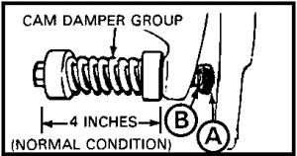

Figure 120. Cam tension adjustor screw.

Step 2. Manually open the breech, load the projectile and charge, and close the breech.

Step 3. Before inserting the primer, raise the breech operating cam (Figure 121 ) until it clears the roller by 1/16 to 1/8 inch. Turn the jam nut (Figure 120 ) counterclockwise (toward breech) until the cam is held 1/16 to 1/8 inch from the roller.

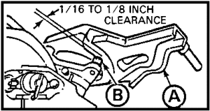

Figure 121. Breech operating cam.

CAUTION

DO NOT RAISE THE CAM BY TURNING THE JAM NUT; YOU WILL DAMAGE THE NUT.

Step 4. Insert the primer, and continue the standard firing procedures.

Step 5. After the weapon returns to battery, lift the cam, turn the jam nut (Figure 121 ) clockwise (forward) five to seven turns and lower the cam onto the roller to permit the cam and roller to hold the breech open to reload the weapon.

Step 6. Repeat steps 2 through 5 for each round fired until the buffer fluid is warmed to operating temperature in accordance with the chart in the operator's manual.

PRACTICE EXERCISES:

Match the special requirement in column A to the unusual condition in column B. More than one may apply. Question 1, answer a. has been given as an example.

Column A Column B

a. 127. Use lighter lubricants a. Cold weather

________ 128. Clean and lubricate machine b. Hot, humid, salty
guns with LAW.

________ 129. Place engine air filter c. Amphibious
locking handles in holders.

________ 130. Operate breech manually for
the first 4 to 8 rounds.

________ 131. Oil evaporates; lubricate
weapons more frequently.

132. Even normal and routine care and maintenance may be neglected when soldiers are ______, ______, _____ __________ __________ ________.

133. ________ _____ ______ ________ ____________ should not be moved suddenly from warm to cold temperature, or vice versa.

134. The winterization kit should be installed when anticipating operation in temperatures of _________ to ________.

135. In very cold weather, the semiautomatic breechblock will not function because _______ ______ ______ _____ _____ _______ ___ _________.

//////////////////////////////////////////////////////////////////////////////////////////////////////////////////////////////////////////////////////////////////

ANSWERS:

127. a.
128. a.
129. b.
130. a.
131. b.
132. hot, cold, or suffering personal discomforts
133. Sighting and fire control instruments
134. 0°F -65°F
135. extreme cold weather slows down extension of recoil.

//////////////////////////////////////////////////////////////////////////////////////////////////////////////////////////////////////////////////////////////////

25. SUMMARY. Proper and safe operation of the M109A2/A3 howitzer requires a thorough understanding of the function of each component and how it relates to the total weapon system. Serviceability, and therefore combat readiness, requires proper care and conscientious maintenance according to a scheduled routine or as particular conditions demand. Since the maintenance supervisor must be able to direct the efforts of howitzer crews and organizational maintenance personnel, recognize improper handling, detect potential equipment failure, and ensure the equipment functions according to its design capabilities, the supervisor must endeavor to achieve proficiency in all aspects of operation and function of the weapon and vehicle. While a great deal of attention to detail in both maintenance and operation is necessary under normal conditions, it becomes positively critical when operating under unusual and adverse conditions of terrain and weather.

Lesson 4
AFTER-OPERATION MAINTENANCE

OBJECTIVE

After completing this lesson, you will be able to direct and supervise weapon crews in performing after-operation maintenance on their howitzers. This will include disassembly/assembly of the breech mechanism; proper cleaning and lubrication of the chamber evacuator and muzzle break of the M109A2/A3-series howitzer at proper intervals; and use of the correct solvents, lubricants, and tools. Additionally, you will know lubrication schedules, intervals, and inspection points required to keep the weapon in operating condition.

REFERENCES

This lesson is based on TM 9-2350-311-10, TM 9-2350-311-20-1, TM 9-2350-311-20-2, and LO 9-2350-311-12, and other materials approved for US Army field artillery instruction; however, development and progress render the text continually subject to change. Therefore, base your examination answers on material presented in this text rather than on individual or unit experience.

26. INTRODUCTION. One of the major assemblies of an artillery cannon is the barrel and breech assembly. Artillerymen must understand the functioning and required maintenance of the barrel and breech to keep their weapon firing.

a. Disassembly of breech mechanism.

ONLY REMOVE THE BREECHBLOCK OPERATOR RACK SPRINGS WHEN THE BREECHBLOCK IS IN THE CLOSED POSITION. THE SPRINGS ARE UNDER HEAVY PRESSURE. UNDER NO CIRCUMSTANCES MUST REMOVAL OF THE SPRINGS BE ATTEMPTED WITH THE BREECHBLOCK OPEN.
NOTE: Before disassembling the breech mechanism, remove the direct fire telescope.

- With the firing mechanism block (Figure 122 ) in center position, push the firing mechanism into the block and rotate clockwise to remove.
- Depress detent. Slide the rack plate (Figure 123) rearward until the rack plate disengages from the plunger.

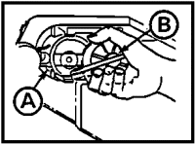
Figure 122. Firing mechanism.
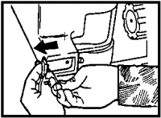
Figure 123. Rack plate.

- Is the breech block closed? (See the above warning). Drive the rack plate (Figure 124 ) rearward. Stop the plate and the rack springs will pop out. Catch the plate and springs with a clean rag .

- Release the preload on the closing spring using the spanner wrench (Figure 125 ). Apply clockwise pressure on the adjuster , and depress the adjuster plunger . Rotate the adjuster slowly counterclockwise until all torque has been relieved.

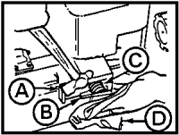

Figure 124. Rack plate and springs.

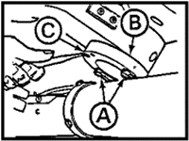

Figure 125. Adjuster.

NOTE: You may have a different type of adjuster with lugs for an adjustable wrench rather than holes for a spanner wrench.

- Loosen the jam nut (Figure 126 ), and remove the cam damper . The cannon should be elevated slightly, and the cam should be raised and secured with a strap to the cab roof.

- Open the breech (Figure 127 ) observing the following caution.

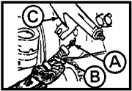

Figure 126. Cam.

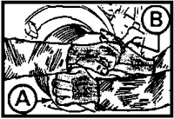

Figure 127. Breechblock.

CAUTION

SINCE ALL SPRING TENSION HAS BEEN RELEASED, BE EXTRA CAREFUL WHEN OPENING THE BREECHBLOCK . USE THE OPERATING HANDLE , AND SUPPORT THE BREECHBLOCK AS IT IS BEING OPENED. OTHERWISE, THE CARRIER WILL SLAM OPEN AND MAY BE DAMAGED. RETURN THE OPERATING HANDLE TO LOCKED POSITION.

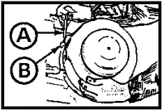

Figure 128. Lock position.

- Using the drive punch (Figure 128 ), depress the detent plunger and rotate the breechblock to the lock position.

- Remove the two screws and plunger group (Figure 129 ). Slide the firing mechanism block to the disassemble position (all the way to the right).

- Move the extractor away from the obturator nut (Figure 129 ) and the support firing mechanism block (Figure 130 ) and housing . Unscrew the obturator nut with the spanner . Remove the firing mechanism housing, block, and spring .

- Remove the firing pin retainer, firing pin, and spring from the block (Figure 131).

NOTE: The firing pin retainer is under pressure and will spring out if not restrained during disassembly.

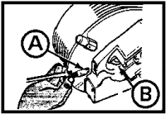

Figure 129. Plunger group.

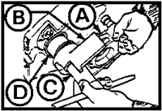

Figure 130. Firing mechanism block and housing.

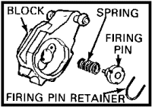

Figure 131. Block.

CAUTION

THE FOLLOWER GROUP HAS A SAFETY INTERLOCK WHICH KEEPS THE BLOCK FROM MOVING TO THE FIRING POSITION UNTIL THE BREECHBLOCK IS FULLY CLOSED. THE FOLLOWER MUST BE IN GOOD WORKING CONDITION AND PROPERLY ASSEMBLED IN THE FIRING MECHANISM TO MAKE SURE THE SAFETY WORKS. CHECK THAT THE WHITE LINES ON THE BREECHBLOCK AND BREECH RING LINE UP BEFORE FIRING.

- Pull the obturator group (Figure 132) out from the breechblock
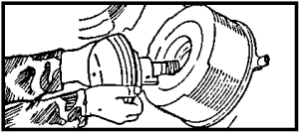

Figure 132. Obturator group.

CAUTION

DO NOT APPLY OIL OR CLEANING SOLVENT TO PAD.

- Disassemble obturator group to clean and inspect (Figure 133).

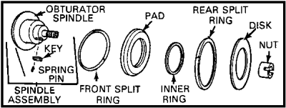

Figure 133. Disassembled obturator group.

IT TAKES TWO MEN TO REMOVE A BREECHBLOCK.

- Insert the cleaning staff (Figure 134 ) through the breechblock and carrier . Slide the breechblock off onto the staff.

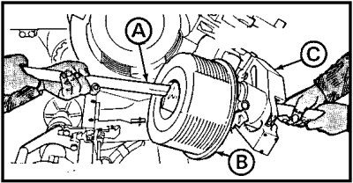

Figure 134. Slide breechblock off.

b. Assembly of breech mechanism.

NOTE: The cannon should be elevated slightly, and the cam should be raised and secured with a strap to the cab roof.

- Hold the carrier (Figure 135 ), and rotate the operating crank (Figure 135) to move the breechblock operating gear and operating rack timing marks to the inspection hole (Figure 136 ) under the carrier.

- With the carrier (Figure 135 ) in the fully open position, install the breechblock . Use the cleaning staff , and wrap the staff with rags to protect the carrier and breechblock.

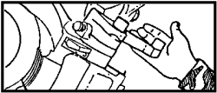

Figure 135. Operating crank.

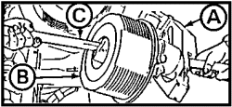

Figure 136. Carrier and breechblock.

- With the carrier in the fully open position, align the closing lug (Figure 137 ) with the detent plunger . With the operating rack and operating gear timing marks aligned in the center of the inspection hole, slide the breech block completely on. Now, recheck the alignment marks.

- Assemble the obturator group. Be sure the rings, disk, and pad are assembled in proper order on the obturator spindle. The splits in the front and rear split rings should be 180° apart as shown (Figure 138).

- Install the obturator group in the breechblock (Figure 139).

- Install the firing pin, spring, and retainer (Figure 140).
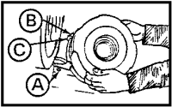

Figure 137. Marks aligned.

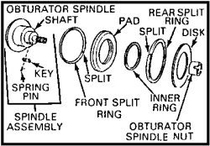

Figure 138. Obturator group.

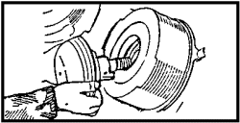

Figure 139. Obturator group being installed.

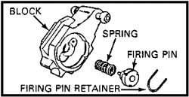

Figure 140. Firing pin, spring, and retainer.

- Replace the obturator spring (Figure 141 ). Install the firing mechanism block and housing , and secure the obturator nut Figure 142 .

- Install the plunger (Figure 142 ) and two screws . Be sure plunger tip seats in narrow slot of the obturator nut.

- Rotate the breechblock to the unlock position (Figure 143).

- Open the operating handle to engage the clutch pin (Figure 144 ), and close the breechblock . Return the operating handle to stop. If the witness marks are not aligned, the breechblock is out of time. Then slide the firing block to the center position.

- Release the strap holding the cam to the roof and lower the cam.

- Install the cam damper (Figure 145 ). Adjust the distance between the spring cap ends to 4 inches for correct cam tension. Tighten the jam nut against the mount.
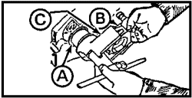

Figure 141. Obturator spring, block, and housing.

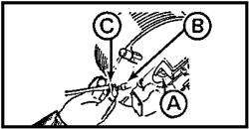

Figure 142. Plunger.

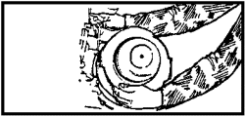

Figure 143. Unlock position.

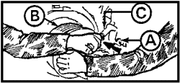

Figure 144. Operating handle.

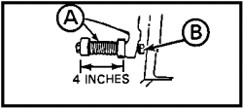

Figure 145. Cam damper.

- Apply preload tension on the breech mechanism closing springs. Use the spanner wrench (Figure 146 ) installed in the holes of adjuster . The three notches in the adjuster provide the three graduations of adjustment. Do not apply more preload tension than is needed to close the breechblock securely. Use of the final (third) notch reduces the life of the leaf springs and should be used only if necessary.

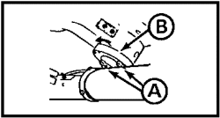

Figure 146. Adjuster.

NOTE: You may have a different type of adjustor with lugs for an adjustable wrench rather than holes for a spanner wrench. You may have an adjuster with only two graduations.

NOTE: The following task requires two people.

- Slide the rack plate (Figure 147 ) until the rear hole of the rack plate engages the plunger.

- Apply pressure to the stop plate and rack springs with the hammer handle, and slide the rack plate over the stop plate. Use the punch to depress detent.

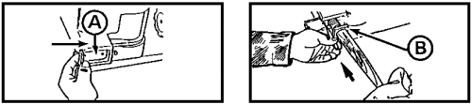

Figure 147. Stop plate.

NOTE: If the stop plate has an arrow on it, be sure it points to muzzle end.

- Assemble the M35 firing mechanism.

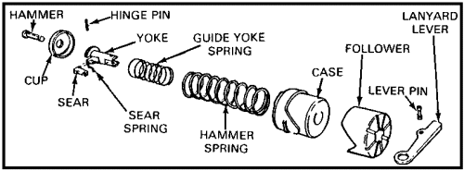

Figure 148. Firing mechanism.

- With the firing mechanism block (Figure 149 ) in the center position, insert the firing mechanism and rotate it counterclockwise.

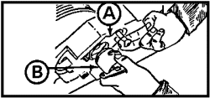

Figure 149.

PRACTICE EXERCISE:

136. T F Remove the breechblock operator springs when the breechblock is in the open position.

137. T F It takes two men to remove a breechblock.

138. T F Split rings must be replaced after disassembling the breechblock.

139. T F You may have an adjuster for the breech mechanism closing springs that requires an adjustable wrench.

//////////////////////////////////////////////////////////////////////////////////////////////////////////////////////////////////////////////////////////////////

ANSWERS:

136. F
137. T
138. F
139. T

//////////////////////////////////////////////////////////////////////////////////////////////////////////////////////////////////////////////////////////////////

c. The M109A2/A3 (M185 tube) evacuator. A cylindrical evacuator chamber (Figure 150 ) used on the M185 tube performs the function of removing propellant gases from the bore after the weapon has been fired.

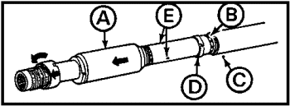

Figure 150. Evacuator chamber.

The evacuator inlet valves, located under the rear flange of the evacuator cylinder (when in place) consist of 10 countersunk holes through the tube spaced equidistant around the tube. These portholes act as valve seats for 10 ball bearings made of a special alloy metal called Rene 41. The valve balls are kept in place by a flexible split valve ring . About 18 inches forward of the inlet valves are three metering (exhaust) orifices drilled through the tube. When the propellant gases inside the tube exert pressure through the inlet valve holes onto the valve balls, the split valve ring permits the balls to raise from the holes, letting the propellant gases enter the evacuator chamber. As the projectile passes the metering orifices and the propellant gas pressure inside the tube decreases, the flexible split valve ring returns the inlet valve balls onto their valve seats to prevent gases inside the evacuator chamber from escaping through the inlet valves. Consequently, the gas pressure in the evacuator chamber is released through the metering orifices (exhaust ports) at the same time the semiautomatic breech mechanism opens. This creates a draft effect that expels gas and smoke inside the tube out through the muzzle.

d. The M109A2/A3 (M185 tube) muzzle brake. The muzzle brake is a double-baffled cylinder, internally threaded at one end to screw onto the threaded muzzle end of the tube. The double baffle construction uses the escaping propellant gases to reduce the force of the recoil by about 45 per cent. The muzzle brake 1 (Figure 151 ) is kept on the end of the tube by a key that fits through the keyway in the muzzle brake and seats in the keyway of the tube. The key is kept in place by a thrust collar that is locked in place by a collar detent . The muzzle brake on the M109A2/A3 does not have to be removed to move the evacuator cylinder forward to expose the valves and devices for cleaning.

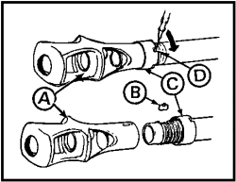

Figure 151. Muzzle brake.

e. Maintenance and inspection. The muzzle brake and evacuator cylinder should be removed and cleaned quarterly or after every 300 rounds fired. The inlet valves, metering orifices, Reene 41 balls, split ring, and tube surface should be cleaned daily when firing or at least monthly when not firing.

PRACTICE EXERCISES:

140. The chamber evacuator has ____ _______ __________ made of ____________ ______.

141. The propellant gases are kept from escaping back into the tube by the __________ __________ holding down the ______ _______ ______.

142. The muzzle brake reduces the force of ___________ by about _______.

143. As a minimum, the _________ ________ and _________ ___________ are removed quarterly for cleaning.

//////////////////////////////////////////////////////////////////////////////////////////////////////////////////////////////////////////////////////////////////

ANSWERS:

140. 10 ball bearings, Rene 41.
141. split ring, inlet valve balls
142. recoil, 45%
143. muzzle brake, chamber evacuator.

//////////////////////////////////////////////////////////////////////////////////////////////////////////////////////////////////////////////////////////////////

f. M109A2/A3 muzzle brake and evacuator maintenance. The procedure for removing and replacing the muzzle brake, chamber evacuator, and valves on your M109A2/A3 howitzer follows (see Figure 152):

THE MUZZLE BRAKE WEIGHS 350 POUNDS. EXERCISE GREAT CARE TO AVOID INJURY TO PERSONNEL OR DAMAGE TO EQUIPMENT.

NOTE: In addition to common section tools, you will need a chain hoist and an aluminum rammer staff section to perform this task.

(1) Remove the detent screw, spring, and ball. Screw the collar rearward enough to uncover the key.

(2) Remove the key from the brake and tube.

(3) Unscrew the muzzle brake until it just clears the threads on the cannon tube. Attach the hoist to the muzzle brake, and remove the muzzle brake from the tube.

(4) Screw the thrust collar forward and remove.

(5) Remove the detent screw, spring, and ball. Unscrew the evacuator chamber, slide it forward, and remove it.

(6) Slide the valve ring forward, and catch the valve balls.

NEVER REPLACE VALVE BALLS WITH STANDARD BALL BEARINGS.

(7) Reverse the procedure to install.

NOTE: You can unscrew and move the evacuator chamber forward enough to clean and service the evacuator chamber without removing the muzzle brake.

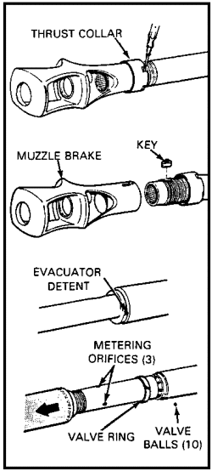

Figure 152. Muzzle brake and evacuator maintenance.

(8) With all components removed and accounted for, clean and lubricate the muzzle brake, thrust collars, and evacuator as follows:

- Clean the muzzle brake with rifle bore cleaner (RBC).
- Inspect the muzzle brake. A crack 1 inch or longer makes it unserviceable.
- Report an unserviceable muzzle brake.
- Lubricate the muzzle brake.
- Clean the muzzle brake.
- Clean the evacuator.
- Inspect the evacuator.
- Report an unserviceable evacuator.
- Lubricate the evacuator.
- Clean the metering orifices.
- Clean and dry the evacuator valve balls.
- Lubricate the evacuator valve balls.

(9) To reassemble after servicing, reverse the disassembly procedure as follows:

- Replace the valve balls and valve ring.
- Replace the evacuator; screw it on tight.
- Replace the evacuator detent screw, spring, and ball.
- Screw the thrust collar on to the tube.
- Replace the muzzle brake using a chain and hoist.
- Screw the muzzle brake tightly onto the tube.
- Replace the muzzle brake key.
- Screw the thrust collar onto the muzzle brake.
- Replace the detent screw, spring, and ball.
- Spot paint as needed.

This completes your after-operations maintenance and inspection of the howitzer muzzle brake and chamber evacuator. By remembering the sequence of assembly and disassembly, the supervisor will ensure that a relatively simple, but vitally important, task is done properly and the weapon is kept in a high state of readiness. Additionally, it is vital to emphasize safety, because of the great weight of these components, because of parts accountability, and because the valve balls cannot be replaced with common ball bearings.

PRACTICE EXERCISES:

144. The muzzle brake on the M109A2/A3 is secured in place by a thrust collar detent locking key and the ________ _____________.

145. The valve seats and metering orifices on the M109A2/A3 may be cleaned ___________ taking off the muzzle brake.

146. The valve balls are secured in the valve seats by the ____________ __________ or ________ _________.

147. There are _____________ valve balls in the evacuator assembly of the M109A1.

148. The ______ __________ on the M109A2/A3 must be inspected for _________________ which would make it unserviceable.

149. Safety must be emphasized at all times during performance of maintenance on the evacuator and muzzle brake, because the muzzle brake weighs _________ pounds.

//////////////////////////////////////////////////////////////////////////////////////////////////////////////////////////////////////////////////////////////////

ANSWERS:

144. thrust collar.
145. without
146. valve ring split ring.
147. ten
148. muzzle brake, cracks (one inch or more)
149. 350.

//////////////////////////////////////////////////////////////////////////////////////////////////////////////////////////////////////////////////////////////////

27. LUBRICATION. It is an accepted fact of physics that moving parts attached to stationary parts (wheels on axles), or moving parts within a system of moving parts (internal combustion engines), will heat up because of friction and wear and deteriorate at the points of contact. Lubricating oils and compounds like automotive grease and motor oil form a barrier between moving parts that keeps them from touching directly. This separating film is called lubrication. Friction, heat, and wear are not eliminated entirely by lubricants; parts will still wear and need to be replaced from time to time. But properly lubricated materiel will certainly outlast that which is not cared for. Lubricants, such as light oils (PL-special), will also serve to preserve nonmoving, exposed metal surfaces that would otherwise become unserviceable as a result of rust and corrosion.
Your most authoritative guide to proper and timely lubrication of the M109A2/A3 howitzer is the equipment lubrication order (LO)--LO 9-2350-303-12 and LO 9-2350-217-12N. It is important to note that your LO is a guide. Unusual conditions may require some deviations. For example, your equipment must be lubricated more often to compensate for abnormal operations and extreme conditions. High or low temperatures, prolonged periods of continuous use, and/or operation in sand, dust, or high humidity may quickly destroy the protective quality of the lubricants. Conversely, lubrication intervals may be extended during inactive periods. Finally, the maintenance supervisor should be aware that certain points on the howitzer must not be lubricated at all. For example, most control linkages are set in nylon retainers or bearings where lubricants would serve only to gather dust and grit. Accumulation of dirt will cause the linkages to wear more quickly or malfunction altogether by binding. Therefore, do not lubricate, but keep clean and dry:

- Steering control linkages.

- Brake control linkages.

- Transmission shifting control linkages.

- Accelerator and throttle controls.

- Electric motors.

a. Lubricants. A wide range of lubricants are available and must be used as prescribed, to provide the needed protection for a particular system or part of your howitzer. Most lubricants are identified by letter abbreviations for brevity, but their full nomenclature gives a clearer description of the type lubricant and its purpose. The maintenance supervisor should make an effort to recognize the specific type lubricant and its purpose by the abbreviation, as follows:

- OE-- Lubricating oil for internal combustion engines. This is normal engine oil in viscosity ratings (weight) from W-10 to W-30.

- HDO-- Heavy duty lubricating oil for internal combustion engines. A better grade of engine oil with viscosity rating from W-10 to W-30; used where heavy use is made of the equipment.

- OEA-- Light engine oil for internal combustion engines. Viscosity rating is about W-5; for use in subzero temperatures of 0°F to -65°F, such as found in arctic zones.

- OHT/OHC-- Hydraulic fluid with a petroleum base for use in all hydraulic systems of your howitzer, including the elevating/equilibrating system, traversing system, and recoil system. A preservative compound is added to protect internal components. OHT and OHC are interchangeable and can be mixed. OHT is preferred for its better preservative qualities.

- GO-- Heavy duty gear oil with a W-90 or W-80 rating. Be sure you use the correct weight for the expected temperature range of operation in your locality.

- GOS--Lightweight gear oil for use where temperatures are persistently below 0° (0°F to -65°F).

- GGP--A general-purpose grease used to lubricate bearings and other moving parts.

- GAA-- Lubricating grease of a lighter weight than GGP that is for automotive and artillery application where temperatures range below 0°.

- GMD-- Molybdenum disulfide grease; especially well suited for lubricating muzzle brake and evacuator components in subzero temperatures.

- NATO-S 1735-- Molybdenum disulfide lubricating oil for specific application to the engine mount screw of the M109A1 howitzer in all temperatures.

- GIA-- Specially formulated lubricating grease for use on aircraft and instruments. Your howitzer fan gear case is lubricated semiannually with GIA.

- CLP--Cleaner, lubricant, preservative authorized to replace RBC, PL-S, LSA and LAW.

- PL-S-- General-purpose lubricating and preserving oil; normally applied to parts not subject to great stress and pressures. Used to lubricate weapon parts, including small arms, machine guns, and exposed bearing surfaces on the cannon. Applied to "oil can" points, such as hinges and latches.

- LAW-- Used primarily for lubrication of internal and external components of the .50 caliber machine gun in subzero temperatures.

- LSA-- A semifluid lubricating oil, particularly well suited for application to the sliding area of the cannon firing mechanism (M35).

- CT-- A corrosion preventive compound, CT is applied on heavy-duty weather-exposed parts, such as your vehicle tow cable.

The chart in Figure 153 provides a guide to proper application of the correct lubricant for a specific component, under given temperature ranges.

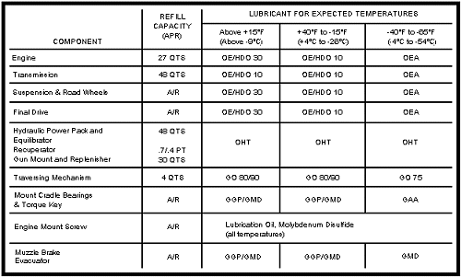

Figure 153. Lubricant selection guide.

PRACTICE EXERCISES:

150. T F Proper lubrication eliminates heat, friction, and wearing of parts in internal combustion engines.

151. T F LO 9-2350-311-12 is an official document. Deviations from it are not authorized.

152. T F As a general rule, all moving parts on the howitzer cannon, carriage, and engine require some type of lubrication.

153. T F While most oils cannot be used interchangeably or mixed with each other, OHT and OHC are interchangeable and can be mixed.

154. T F Secondary armament and cannon firing mechanisms in temperate climates are best lubricated with LSA.

155. T F Final drives, suspension, and road wheels are lubricated with GAA (grease, automotive, and artillery).

//////////////////////////////////////////////////////////////////////////////////////////////////////////////////////////////////////////////////////////////////
ANSWERS:
150. F
151. F
152. F
153. T
154. T
155. F
//////////////////////////////////////////////////////////////////////////////////////////////////////////////////////////////////////////////////////////////////

b. Cleaning compounds. The howitzer, carriage, and all other components of your howitzer require periodic cleaning for proper maintenance. The correct cleaning method and compound will not only make your cleaning job easier but will protect the parts and prolong their useful life. For example, obturator pads and preformed packings should be cleaned only with soap and water. Unauthorized cleaning agents can damage the equipment and are hazardous to personnel.

NEVER USE GASOLINE AS A CLEANING AGENT.

The following are authorized cleaning compounds:

- RBC-- RBC acts as a solvent on weapon parts exposed to powder foulings and as a preservative for short periods of time (3 days or less). It should be used on the cannon tube, breech mechanism, muzzle brake, evacuator, and evacuator valves and orifices.

- CLP--Cleaner, lubricant, preservative is authorized to replace RBC, PL-S, LSA and LAW.

NOTE: Soap and water may be used when CLP or RBC are not available, but remember to dry and lubricate the weapon immediately.

- SD-2-- This is a specially formulated dry cleaning solvent that is used to clean transmission oil screens and breathers.

c. Lubrication schedules. LO 9-2350-311-10 should be on hand and in active use during all maintenance operations. Before starting lubrication, ensure that there is no evidence of grittiness or binding in bearings or other areas to be lubricated. Grease fittings should be clean, lubricants should be clear and uncontaminated, and the proper tools should be on hand. Lubrication requirements for different components of your howitzer are scheduled by need and are coded as follows:

- D--Daily.
- W--Weekly.
- M--Monthly.
- Q--quarterly; every 3 months.
- S--semiannually; twice per year.
- A--annually; once a year.

Additionally, some services must be performed after specific events such as number of hours of operation, number of rounds fired, or number of miles traveled. This will be specified in your schedule.

(1) Daily. Figure 154 shows points that must be cleaned and lubricated each day that the howitzer is operated or the weapon is fired. The type lubricant is indicated by letter abbreviations, as explained in paragraph a.

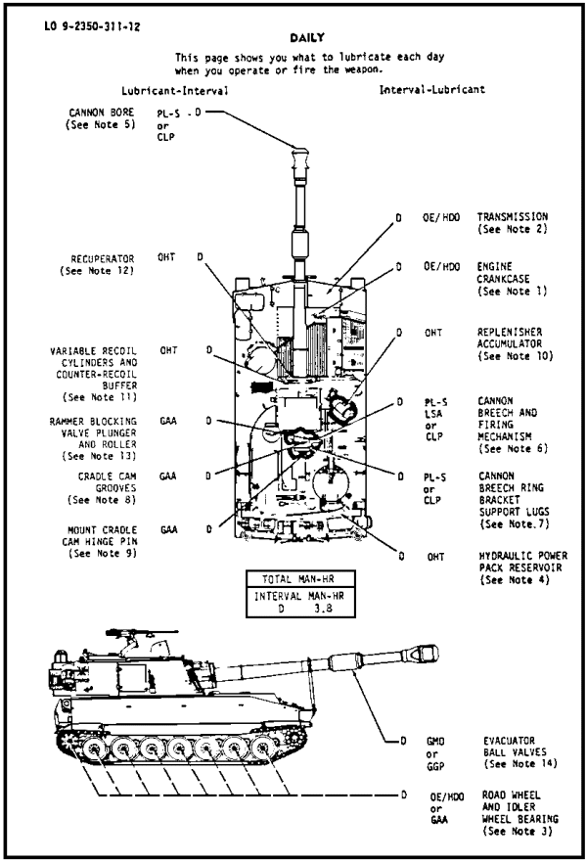

Figure 154. Daily lubrication points.

(2) Weekly. The fact that only a relatively few items require weekly lubrication does not diminish their importance. You should lubricate the following weekly:

- GAA rammer.

- PL-S elevating cylinder.

- GAA M140 alignment device dovetail mount.

(3) Monthly. Lubrication is required for a number of critical components on a monthly basis (Figure 155). For example, ignoring the evacuator for a prolonged period of time can cause it to "freeze" in place. Correcting such a problem involves a very costly removal by a cutting torch. Also, the track adjuster keeps proper tension on the track, and keeps the track from being thrown off.

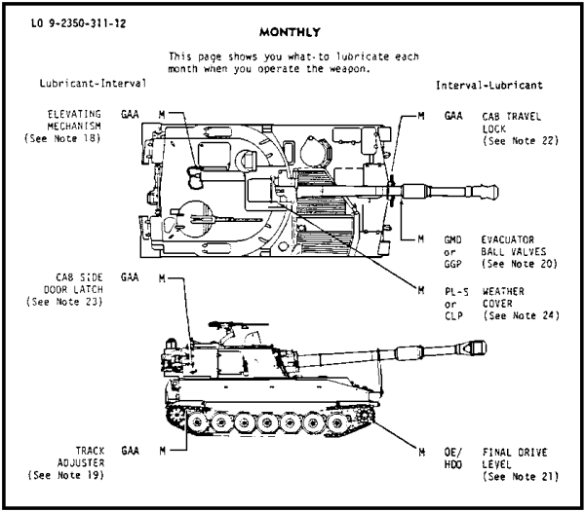

Figure 155. Monthly lubrication points.

(4) Quarterly. Quarterly lubrication points are shown in Figure 156.

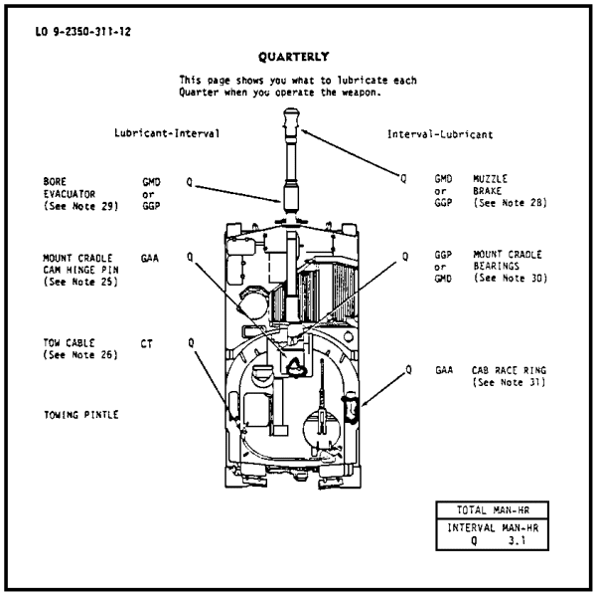

Figure 156. Quarterly lubrication points.

(5) Semiannually. About every 6 months, your howitzer requires special attention and lubrication of a number of those hard-to-reach places. Semiannual lubrication services take more time and should be scheduled so as to allow enough time to do a thorough job. The cut-away view of the M109A2 in Figure 157 shows all the points requiring lubrication semiannually.

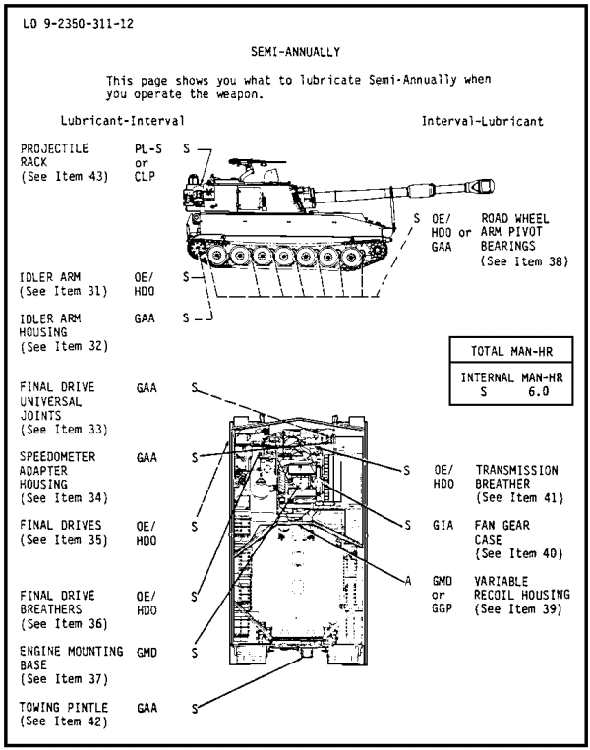

Figure 157. Semiannual lubrication points.

(6) Annually. The lubrication points requiring services once each year should also be scheduled after 75 hours of operation (cumulative) or 750 driven miles, whichever comes first. Figure 158 gives an indication of the varied types of services required and the lubricants needed to perform this service. Do not overlook the requirement to change engine oil filter elements and thoroughly clean the filter shell with SD-2 during this service.

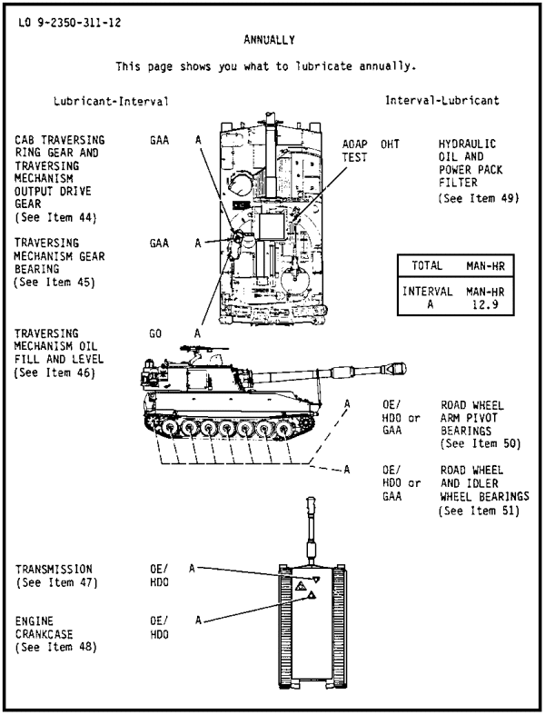

Figure 158. Annual lubrication points.

(7) Irregular. There are a number of lubrication requirements that depend on specific events. For example, the torque key and gun tube keyway (Figure 159) is lubricated only when it is removed and replaced. Additionally, there are many so-called oil can points that are lubricated with PL-S as frequently as necessary to ensure proper function. Oil can points include all hinges, latches, pins, and nonstress moving parts.

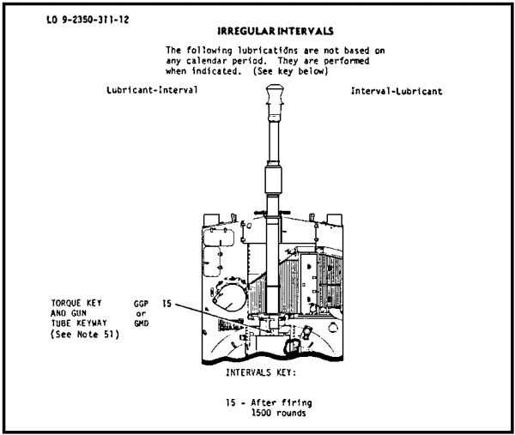

Figure 159. Irregular lubrication points.

PRACTICE EXERCISES:

156. Even though RBC acts as a preservative, it should not be left on the weapon for more than _____ _________.

157. Where RBC is not available, gun tubes and other parts exposed to powder fouling may be cleaned with _____ ____ ______.

158. Before using lubricants from previously opened containers, always check first for possible ____________________________.

159. Those services coded for daily (D) lubrication must actually be performed each day that the _________ __________ __________ or the __________ ______ ___________.

160. Rammer grease fittings are lubricated with GAA on a ______________ schedule.

161. Failure to properly care for the evacuator may result in a very costly removal by _______________ _____________.

162. Transmission oil screens and breathers are cleaned annually with cleaning agent _______________.

163. Irregularly scheduled lubrications depend on _________ ________ to become due and include lubrication of the torque key and _______ ______ ____________.

164. Hinges, latches, pins, and other nonstress moving parts are called _____ _______ points for lubrication purposes.

//////////////////////////////////////////////////////////////////////////////////////////////////////////////////////////////////////////////////////////////////

ANSWERS:

156. 3 days.
157. soap and water.
158. contamination.
159. howitzer is operated, weapon is fired
160. weekly
161. cutting torch.
162. SD-2.
163. specific events, gun tube keyway.
164. oil can

//////////////////////////////////////////////////////////////////////////////////////////////////////////////////////////////////////////////////////////////////

28. SUMMARY.

a. After-operation maintenance involves cleaning, inspecting, and lubricating all those parts of the howitzer that operate to make the M109A2/A3 howitzer a self-propelled, full-track field artillery weapon. The term daily maintenance is used to identify those services necessary after the weapon has been operated and/or fired. Since the cannon, breech mechanism, and evacuator are subject to powder fouling, these components require great care, thorough cleaning, and proper lubrication.

b. Lubrication of every other part, component, or system of the howitzer, to include the cannon, carriage, engine, and hydraulic system, is done at specified intervals with a variety of lubricants and the tools needed to do the job. While the type lubricant and the service interval is specified in your lubrication order, these apply only to normal operating conditions. Extreme conditions of temperature, humidity, or other environmental factors, and heavy use or nonuse will demand more frequent (or allow fewer) lubrications and the use of lubricants better suited to the specific condition.

c. The maintenance supervisor must be prepared to organize and sustain the type of maintenance effort that will ensure that the equipment entrusted to his care is kept in its highest possible state of combat readiness.

Lesson 5
M109A6 (Paladin) MAINTENANCE

OBJECTIVE

After completing this lesson, you will be able to identify the differences between M109A1-A5 and the M109A6 howitzers and the differences in supervising weapon crews in performing maintenance on an M109A1-A5 and the M109A6 howitzers. This will include differences in the hydraulic, electrical and automotive systems. Additionally, you will know operation of the Automatic Fire Control System (AFCS) in the maintenance mode.

REFERENCES

This lesson is based on TM 9-2350-314-10, TM 9-2350-314-20-1, and TM 9-2350-314-20-2, and other materials approved for US Army field artillery instruction; however, development and progress render the text continually subject to change. Therefore, base your examination answers on material presented in this text rather than on individual or unit experience.

INTRODUCTION

The primary mission of the field artillery is to support the maneuver forces. The M109A6 is an advancement over all cannon systems in the army's inventory. It has the ability to fight and survive in both a conventional and NBC environment. Paladin is more reliable, responds quicker, provides more flexibility, and is less vulnerable than previously fielded M109's.

1) DIFFERENCES:

The cab of the M109A6 howitzer is a complete redesign from the M109A2/A3. Early in the Howitzer Improvement Program (HIP), the U.S. Government made a decision to have a new cab designed rather than to cut and weld the existing one. This decision was based on a need to increase the ballistic protection of the crew, provide structural modifications for the state-of-the-art Paladin peculiar items, and provide support for the added stress caused by firing the M203 propelling charges. The major differences, which can be seen, are:

a. Stowage baskets.

b. LAW stowage boxes.

c. Bustle extending the entire width of cab.

d. Grenade stowage boxes.

e. External power receptacle on right rear of hull. NOT TO BE USED FOR ENGINE STARTUP.

f. Different BII (tool) stowage.

g. Right side escape hatch missing.

h. Commander’s cupola is higher.

i. A bigger travel lock.

j. A completely different cab structure with a roof slope.

k. M93 Chronograph Antenna with Mount and Terminator

l. Gun mount ballistics shield.

m. M140 alignment device bracket.

n. A large access door on left front side of cab (hydraulic compartment).

o. A box shaped compartment on the top where the Microclimate Conditioning System (MSC) is housed.

p. Radio antennas.

- PLGR Antenna.

LOCATION AND DESCRIPTION OF MAJOR COMPONENTS.

1 CANNON M284--155MM -Provides main armament for howitzer.

2 GUN TUBE TRAVEL LOCK -Provides support for gun tube during travel.

3 REPLENISHER -Allows for change in quantity of oil required by the recoil cylinders and for expansion and contraction of hydraulic fluid due to temperature changes.

4 CAB LIFTING BRACKETS -Two front lifting brackets and two rear lifting eyes provide connecting points for lifting cab.

5 BALLISTIC SHIELD -Provides protection for variable recoil and recuperator from small arms fire and shrapnel.

6 MACHINE GUN .50 CAL -Provides for air and troop defense. Refer to TM 9--1005--213--10 for description.

7 M140/M140A1 MOUNTING BRACKET -Provides mounting for the M140/M140A1 alignment device during boresighting of the M117A2 Pantel.

8 BALLISTIC COVER -Protects panoramic telescope (Pantel) against shock during firing and against inclement weather.

9 ANTENNAS -Two antennas receive and transmit radio signals.

10 CAB SIDE DOOR -Provides emergency exit.

11 HYDRAULIC COMPARTMENT ACCESS COVER -Permits access to hydraulic compartment.

12 EXTERNAL FIRE EXTINGUISHER T--HANDLE -Actuates engine compartment fire extinguisher from outside the howitzer.

13 ROADWHEELS -Seven sets of roadwheels on each side provide support and guides for the track.

14 HYDRAULIC COMPARTMENT ACCESS DOOR -Permits access to hydraulic compartment.

15 BATTERY ACCESS DOORS -Two doors provide access to batteries.

16 DRIVE SPROCKETS -Drive sprockets, two each side, transfer power from the transmission and final drive to track.

17 TRACK ASSEMBLY -Two track assemblies provide mobility for the vehicle.

18 TRANSMISSION ACCESS DOORS -Two doors provide access to front of powerpack.

19 FRONT TOWING EYES -Two front towing eyes provide connection points for towing howitzer.

20 FRONT LIFTING EYES -Two lifting eyes provide connection points for lifting howitzer.

21 HEADLIGHTS -Two headlights provide light for night driving and blackout conditions.

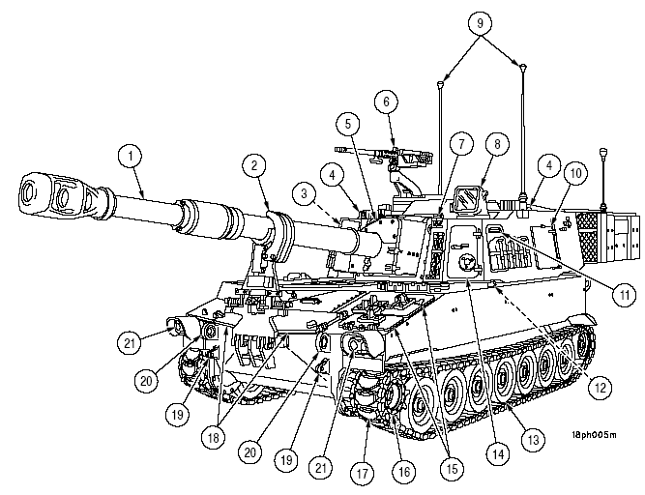

22 STOWAGE BASKETS -Two baskets provide stowage for miscellaneous items.

23 PLGR ANTENNA -The Precision Lightweight GPS (Global Positioning System) Receiver (PLGR) antenna is used to support the Satellite Signals Navigation Set (AN/PSN--11)

24 COMMANDER’S CUPOLA -Provides access to machine gun. Rotates manually 6400 mils.

25 ENGINE EXHAUST OUTLET -Provides outlet for engine exhaust.

26 COMMUNICATIONS TERMINALS -Provide connecting points for wire line communications.

27 REAR LIFTING EYES -Two rear lifting eyes provide connection points for lifting howitzer.

28 EXTERNAL POWER RECEPTACLE -NATO type power receptacle provides circuitry to receive power from an outside source.

29 TAILLIGHT/STOPLIGHT -Two taillight units provide rear brake and taillights for night driving under normal and blackout (infrared) conditions.

30 IDLER WHEELS -Idler wheels, two each side, maintain track tension.

31 EXTERNAL INTERCOM BOX -Provides communications capabilities outside of howitzer.

32 CREW COMPARTMENT DOOR -Provides access to and from crew compartment.

33 TOWING PINTLE -Provides connecting point for towing howitzer.

34 REAR TOWING EYES -Two rear towing eyes provide connection points for howitzer towing.

35 GRENADE BOXES -Two boxes provide stowage for grenades.

36 SPADES -Two spades provide stability when firing off of loose, sandy, or muddy soils. Also used when mated with ARV.

37 ROCKET LAUNCHER BOX -Provides stowage for three AT4 rocket launchers.

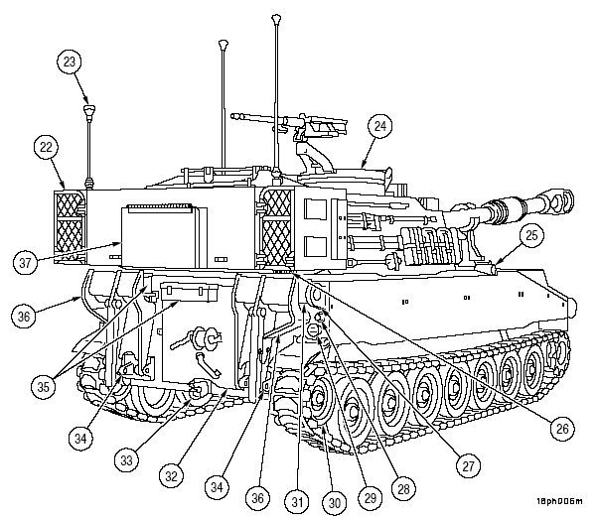
38 BILGE PUMP DISCHARGE -Outlet for fluids when bilge pump is operated.

39 RADIATOR FAN ACCESS COVER -Permits access to radiator fans.

40 COOLING AIR EXHAUST GRILLE -Discharge location for engine cooling air.

41 RADIATOR CAP ACCESS COVER -Provides access to engine radiator cap.

42 PERSONNEL HEATER EXHAUST -Outlet for personnel heater exhaust.

43 FUEL FILL ACCESS DOOR -Permits access for filling engine fuel tanks.

44 WEATHER COVER -Protects cannon rotor shield.

45 MICROCLIMATE CONDITIONING SYSTEM -Provides a decontaminated, conditioned air supply for crewmen operating under NBC conditions.

46 GUNNER’S ESCAPE HATCH -Provides access to and from crew compartment.

47 VENTILATION INTAKE/EXHAUST DUCT GRILLE -Permits outside air to lead particulate filter system and exhausts smoke from crew compartment.

48 DRIVER’S HATCH -Provides access to and from driver’s compartment.

49 ENGINE AIR INTAKE GRILLE -Permits ventilation and access to engine.

50 ENGINE OIL LEVEL COVER -Provides access for checking engine oil level.

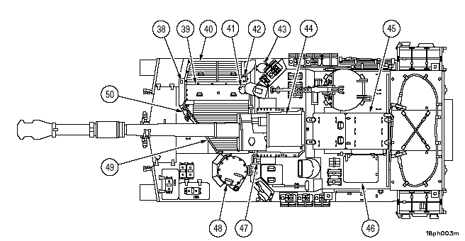

PRACTICE EXERCISES

165 T F The hydraulic power pack has been upgraded and left in the same location.

166 T F The driver’s compartment has added protection.

167 T F The travel lock was left the same.

//////////////////////////////////////////////////////////////////////////////////////////////////////////////////////////////////////////////////////////////////
165 F
166 T
167 F
//////////////////////////////////////////////////////////////////////////////////////////////////////////////////////////////////////////////////////////////////

2) MICROCLIMATE CONDITIONING SYSTEM (MCS)

1. Microclimate Conditioning System.

a. NBC FILTER

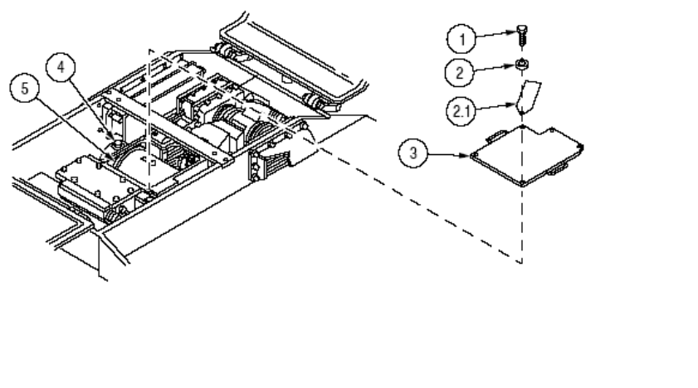
(1) REMOVAL
(a) Open MCS access doors.
(b) Remove filter access cover (3).
(c) Set filter support (4) to UNLOCK.
(d) Lift NBC filter (5) from filter cavity and place in a plastic bag.
(e) Wipe filter cavity with M290 wipes, and dispose of wipes with unserviceable filter.

WARNING
MCS FILTER CHANGE WILL BE DONE IN MOPP IV WHEN IN AN ACTUAL OR SIMULATED NBC ENVIRONMENT.

(2) Installation: Ensure students perform the following steps:
(a) Install filter (5) and align both ends of the filter with the arrow pointing away from the locking bar.
(b) Set the filter lock (4) to LOCKED.
(c) Install filter access cover (3).

OPERATIONS OF EQUIPMENT

2. The MCS control panel is located on the left cab wall at the gunner's station. The panel controls operation of the MCS. Its controls and indicators are:
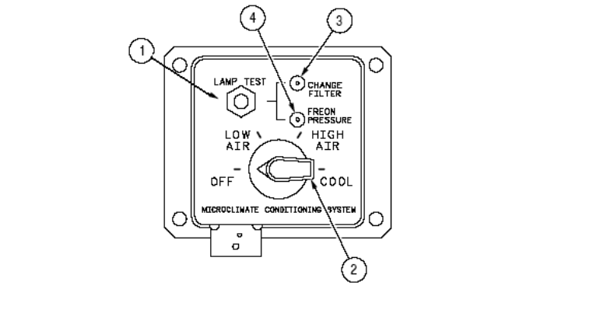
(1) Lamp test switch (1) - Tests the panel lights when the master switch is on and the lamp test switch is pressed.

(2) Change Filter Light (3)- Indicates when the system filter needs to be changed.

WARNING
During operation, if the change filter light is on, the operator should immediately disconnect from the MCS and turn off the MCS.

(3) Freon Pressure Light (4)- Indicates when the system freon pressure is not within the proper operating range.

(4) Mode Select (2) - Selects OFF, LOW/HI AIR, and COOL operations. In the COOL mode the air flow temperature is 55 degrees F depending on the ambient temp.

B. M3 Heaters. Five M3 heaters, four in the cab, and one in the driver's compartment, have been installed in the howitzer to permit warming of filtered air delivered to each NBC station. The heaters allow individual temperature adjustment of air delivered to each station for personal comfort and prevent frost bite when operating the MCS in temperatures less than 40 degrees F. The M3 heaters have one switch and one light. They are:

1. Power/Temperature Switch - Provides power to the heater and controls temperature adjustment. When the switch is fully counterclockwise, the heater is OFF. To adjust the temperature rotate the switch clockwise until desired temperature is reached.

2. Power Light - Light is lit when the heater POWER and
vehicle MASTER switches are ON. The M3 heaters will provide warm air in the low setting only.

WARNING
Allow M3 heaters to warm air for 15 minutes before connecting to MCS. This prevents possible frostbite of the lungs.

C. Umbilical Hoses. Hoses are connected to each M3 heater to
deliver airflow to the crew man's M25A1/M42 protective mask and cooling vest. When not in use the hoses are stowed securely to the cab and hull by Velcro stowage straps. Drivers extension hose must be disconnected if traversing beyond traverse limit stops. Components installed on each flex hose are:

1. Diverter Valve - Directs air flow to both the M25/M42 mask and vest or diverts it just to the mask by rotating the selector valve. To direct airflow to the mask, rotate selector bleed port open. To direct airflow to mask and vest, rotate bleed port closed. When operating in LOW AIR, the diverter valve delivers airflow sufficiently to the mask only. When not in use, the protective cover is installed on the outlet port to the vest.

2. Quick-Disconnect - Quick-disconnects are installed on each hose. The quick-disconnects connect to each crewman’s M42 protective mask. When not in use they are connected to the stowage orifices. By removing the quick-disconnect from the mask with the diverter bleed port closed, the orifice bleeds off minimal air when filtered air is desired to the vest only.
3. Vest - The light weight ventilated vest is worn under the MOPP suit to improve mission capability by providing air flow to the body when in MOPP 4.

4. M25 Protective mask - Can be used separately or in conjunction with the MCS as a ventilated face piece protective mask. The mask carries the M10A1 NBC filter to filter chemical agents when not connected to the diverter valve quick-disconnect.

PRACTICE EXERCISES

168 T F Masks should be attached to the system before turning on the M3 heaters.

169 T F The MCS has been designed to be able to change the filter from inside the howitzer.

//////////////////////////////////////////////////////////////////////////////////
168 F
169 F
/////////////////////////////////////////////////////////////////////////////////

3) REPLENISHER SYSTEM

CAUTION
Do not bleed system pressure by loosening hydraulic fittings. Loosening fittings to bleed pressure will cause damage to adapter seal and fitting.
NOTE
Pressure may increase during normal firing due to heat expansion. Safe-to-fire range is 17---50 psi.

Check replenisher system pressure at replenisher gage manifold (18) on cab ceiling. Pressure should be
between 17 and 24 psi at 70 degrees. If reading is low, replenish system with OHT hydraulic fluid as follows: Place tube at zero elevation. Remove cap (19). Fill replenisher using M3 pump at valve (20) until gage
(18) reads between 17 and 24 psi. If pressure is above 24 psi, bleed pressure by loosening bleed
port plugs (21 and 22). Install cap (19). At 7 psi and below, on inside gage, go to bottle for filling. Between 8 to 16 psi fill at gage manifold

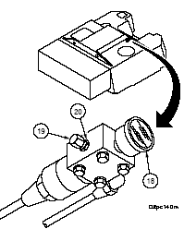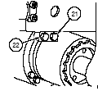

4) Zero Pressure Check

a. Park vehicle on level ground, if possible.
b. Place gun tube in stowed position (para 2--8.20).
c. Move cab traversing lock handle to locked position (para 2--8.21).
d. Turn MASTER power ON. Start engine and idle at 1000 at 1100 rpm.
e. Place hydraulic control box HYDRAULIC POWER ON/OFF switch to ON position. Run hydraulic system approximately 3 minutes.
f. Pull valve (1) open and release.
g. Read hydraulic system pressure gage (2)
h. Place hydraulic control box HYDRAULIC POWER ON/OFF switch to OFF position.
i. Move COS control handle to left or right stop, release control handle.
j. Pull valve (1) open and release.
k. Confirm that pressure on hydraulic pressure gage (2) drops from approximately 1925 psi to 900 psi + 50 psi.
l. Move COS control handle left or right to stop, hold for approximately 5 seconds.
m. Pull valve (1) open and release.
n. Needle will move to 0 psi.
o. If hydraulic presssure is low, use manual operation only. Notify unit maintenance.

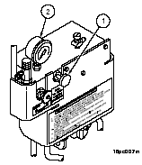

PRACTICE EXERCISES

170 The replenisher pressure gage should read between ______ and _____ PSI before firing.

171 The engine should be run at approximately ________ RPM when running hydraulic system.

//////////////////////////////////////////////////////////////////////////////////////////////////////////////////////////////////////////////////////////////////
170 17, 24
171 1000
//////////////////////////////////////////////////////////////////////////////////////////////////////////////////////////////////////////////////////////////////

5) Travel Lock System
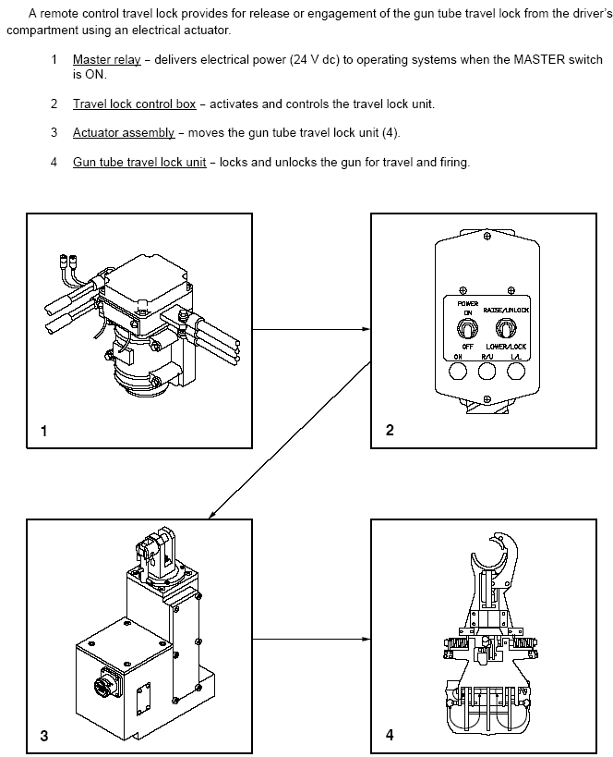

Check travel lock (1) to ensure that jaw (2) is fully clamped and properly positioned on gun
tube (3). Check electrical connections at travel lock control box (4) and travel lock actuator (5).
Tighten connectors if necessary. Check travel lock for proper operation:
CAUTION
During icing conditions, ensure that travel lock is not frozen in position before attempting to move it.

Check operation in power mode. If travel lock does not operate in power mode, check operation in manual mode

Releasing Gun Tube (Manual).
WARNING
Do not let go of crowbar until travel lock is on deck.
a. Remove retaining clip (1) from actuator release pin (2).
b. Remove upper actuator release pin (2) to disengage actuator (3).
c. Insert crowbar into lever (4).
d. Pull down on crowbar until jaw (5) is unlocked and fully retracted.
e. Elevate gun tube to clear travel lock (6)
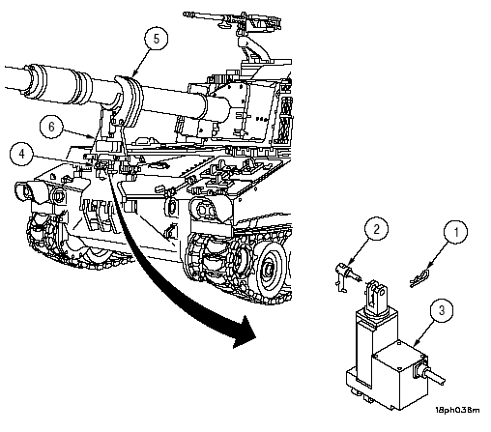

Gun Tube Travel Lock Maintenance Position.
- Release gun tube

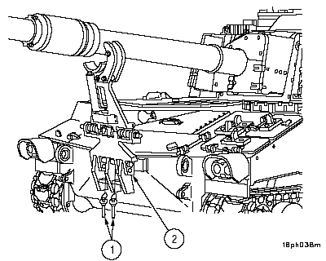

CAUTION
To prevent damage to hull, do not allow travel lock to slam against hull after quick--release pins are removed.

b. Remove two quick--release pins (1) from hull mounting bracket (2).
c. Move travel lock forward to rest against hull to achieve maintenance position.
d. After maintenance is completed, move travel lock inward to align mounting holes and install two
quick--release pins (1) in hull mounting bracket (2).
e. Stow gun tube in travel position

PRACTICE EXERCISES

172 The travel lock is controlled by
a) Chief of Section
b) Gunner
c) Driver

173 T F The travel lock is a part of the hydraulic system.

174 T F If the travel lock is not functioning the howitzer is non-operational.

//////////////////////////////////////////////////////////////////////////////////////////////////////////////////////////////////////////////////////////////////
172 c
173 F
174 F
//////////////////////////////////////////////////////////////////////////////////////////////////////////////////////////////////////////////////////////////////

6) AFCS Maintenance Mode

Maintenance mode can be entered from Power Up or Normal Operations mode. If you enter Maintenance Mode from Power Up, there are more PDIU System tests available, but the howitzer is removed from the POC Fire Control Net so no digital fire missions will be received. Notify the POC that this vehicle is entering the AFCS Maintenance Mode and will be off the Fire Net. If you enter Maintenance Mode from Normal Operations there are fewer PDIU System tests available, but the howitzer is still on the POC Fire Net and can receive and process digital fire missions.
a. The BIT is a self-test of the AFCS. This test occurs when the vehicle MASTER power is ON and the AFCS POWER switch is placed to ON. By placing the AFCS POWER switch and PCU circuit breakers to ON, the DU will display each of the seven subsystems. An OK condition indicates a subsystem is 100% functional.
NOTE:
If DCU contains an incorrect configuration, the AFCS will not allow the operator to select normal operations until a correct DCU software configuration is downloaded.
b. When configuration verification checking indicates that the executed software configuration is not the same as the acquired software configuration, a short error message ''INVALID SOFTWARE CONFIGURATION'', ''ACK'' will appear on the soft key label line of the DU.
When the message is acknowledged, the AFCS will proceed to the ''SELECT OPERATION MODE'' menu.
c. A DEGRADED condition indicates a subsystem is not 100% functional. When a degraded condition exists, it will be in field 7 by one or a combination of these letters with the following meaning:
N - Navigation, A - GPS Aiding, C - Communication Processing, W - Weapon Controller.
d. Another DEGRADED condition is ''OUT''. When ''OUT'' is displayed, the subsystem is not functional.
e. These two conditions, OUT and DGRD, will be tested to determine where the fault exists and the extent of the fault. After a fault has been detected, press the illuminated soft key beneath the word ACK. After pressing the ACK key, the screen will display the three operational modes: TRAINING, NORMAL OPERATIONS, MAINTENANCE.
f. To select the MAINTENANCE MODE, highlight the word maintenance and press the illuminated soft key beneath the word SELECT to enter the maintenance mode master menu.
g. The AFCS also provides the capability for the AFCS operator to transition from Normal Operational Mode functions to Maintenance Mode functions and back to Normal Operational Mode without having to perform a power down sequence, system restart, or Normal Operational Mode initialization procedures. This capability shall only be available when the AFCS has successfully completed a Normal Operational Mode initialization.
Selection of the Maintenance Mode from the AFCS Mode Selection display shall not allow the AFCS operator to transition to Normal Operational Mode without first performing either a power down sequence or a system restart. When Maintenance Mode functions are selected from the AFCS Operational Mode, the prognostic/diagnostic interface unit (PDIU) shall be directed to limit intrusive testing to only those tests which will not impact the ability of the AFCS to quickly respond to fire mission requests. When Maintenance Mode is entered from the AFCS Mode Selection display, the PDIU shall be allowed to perform its full range of intrusive tests.

If a fire mission is received while the AFCS is in a Maintenance Mode function which was activated from the Operational Mode, the operator shall be prompted to either accept or reject the mission. Operator acceptance of the mission shall automatically terminate all Maintenance Mode function activity and transition to Normal Operational Mode fire mission processing. Operator rejection of the mission shall cause an operator abort of the fire mission and shall cause the AFCS to remain in the currently active Maintenance Mode function.

- To display the AFCS STATUS menu, select MAINTENANCE from the SETUP AND INFORMATION menu. Press SELECT key. This will cause the MAINTENANCE MODE SELECT menu to be displayed.
NOTE:
If MAINTENANCE is selected from NORMAL OPERATIONAL MODE, the MAINTENANCE screen will display ''SELECT'' and ''CANCEL'' options above soft keys 1 and 4 in field 16.
b. Select AFCS STATUS from the MAINTENANCE MODE SELECT menu. Press SELECT key. This will cause the AFCS STATUS menu to be displayed.
(1) AFCS STATUS

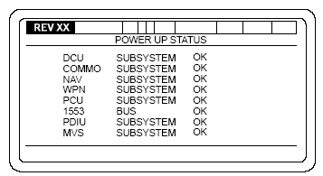or 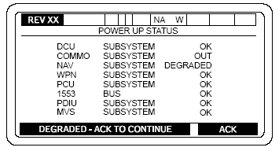
c. The AFCS STATUS menu will display the various subsystem faults. Using this fault list (showing Degraded Mode of each subsystem), you will be able to determine if Degraded Mode is acceptable depending on mission requirements.
(1) The DCU SUBSYSTEM STATUS will display:
CPU BRD BIT -- I/O BRD DU SERIAL --
BIT HARDWARE -- I/O BRD SERIAL --
INVALID HDWR -- I/O BRD DISCRETE --
1553B BRD BIT -- UNDET 1553B CONF --
NVM R/W -- TR SW STATUS REC --
DU BIT -- GUN SW STATUS REC --
-- = (OK, FAIL)
(2) The COMMO SUBSYSTEM STATUS will display:
BIT RECEIVED --
I/O BRD SERIAL --
TCIM COMMO --
TCIM BRD BIT --
TCIM LOAD --
NVM R/W --
-- = (OK, FAIL)
(3) The NAV SUBSYSTEM STATUS will display:
BIT RECEIVED -- NAV IF BIT --
DRU CONNECT -- GPS COMMO --
DRU INTERTIAL -- GPS BIT --
DRU BIT -- GPS ANTENNA --
I/O BRD SDLC BIT -- VMS BIT --
(4) The WPN SUBSYSTEM STATUS will display:
BIT RECEIVED -- AZ VOLT --
NVM R/W -- AZ CURRENT --
SERVO BRD BIT -- EL VOLT --
WPN BIT -- EL CURRENT --
TUBE TEMP BIT -- AZ TACH --
ADC BIT -- EL TACH --
BCS --
-- = (OK,FAIL)
(5) The PCU SUBSYSTEM STATUS will display:
BIT RECEIVED --
PCU BIT --
-- = (OK, FAIL)
(6) The 1553 BUS STATUS will display:
BIT HARDWARE --
1553 BOARD BIT --
DCU TO PDIU CONNECT --
DCU TO PDIU BUS --
DCU TO MVS CONNECT --
DCU TO MVS BUS --
-- = (OK, FAIL)
(7) The PDIU SUBSYSTEM STATUS will display:
BIT RECEIVED --
PDIU BIT --
DCU TO PDIU CONNECT --
-- = (OK, FAIL)
(8) The MVS SUBSYSTEM STATUS will display:
BIT RECEIVED --
MVS BIT --
DCU TO MVS CONNECT --
-- = (OK, FAIL)

a. To start the PDIU SYSTEM TEST, from the maintenance mode select menu, move the cursor with the arrow keys until the PDIU SYSTEM TEST is boxed and press select.
b. The screen will display a prompt, ''ARE YOU SURE,'' YES OR NO. Press ''YES''. The screen will display the following message: INITIALIZING PDIU SYSTEM TEST PLEASE WAIT...
c. The PDIU SYSTEM TEST MENU will be displayed. This menu will allow you to select the desired functions:
A DIAGNOSTIC TEST
B PREVIOUS FAULT SUMMARY
C RECONFIGURATION ADVICE
D MAINTENANCE MODE SELECT MENU
The previous Fault Summary and Reconfiguration Advice functions are not always available. These options will not be displayed if their functions cannot be performed.
(1) DIAGNOSTIC TEST
( a) To perform DIAGNOSTIC TEST, press the ''A'' soft key.
( b) This allows you to select which part of the system you would like to test based upon the problem you are troubleshooting. The Gun Positioning System will not be available until the hydraulics segment has been successfully tested (the PDIU should not be reset). To test the entire system, all four segments should be tested in the order they appear on the screen. If any of the segment tests fail, the fault should be corrected, the AFCS should be reset and the testing should begin again with the first test. Continuing testing without resetting the system can result in false failures.
( c) To perform any of the segment tests, select ''YES'' when that segment appears behind ''CHOOSE OPTION''.
( d) When you have completed the required actions, press GO soft key and testing will continue.
During the next few screens, you will be given the CANCEL soft key option. CANCEL is there in case you selected the DIAGNOSTIC TEST function (from the menu) by mistake or in case you changed your mind. When you press CANCEL, the system will display the PDIU SYSTEM TEST MENU again. Throughout diagnostic testing, you will be given instructions. When you press GO, you are telling the system that you have done the task it asked for. It is important that you complete the task before pressing GO because many of the decisions that the system makes are based on the actions that you made.
( e) If the result is not correct, then you are asked if you performed the action correctly. If you answer ''YES'', a fault will be detected by the PDIU. If you answer ''NO'', you will be given another chance to perform the action correctly. Then, if the action is not performed correctly, a fault will be detected by the PDIU.
( f) When END MAINT is displayed, you have the option of stopping the test at that point. If you select END MAINT, testing will immediately stop and you will see the Fault Summary display with all of the test results up to where you stopped. This feature is provided to allow you to return to normal operations with minimum of delay if necessary. When you press END MAINT, the system can only report the results of the test up to where you stopped. There may be further faults not detected.
( g) During diagnostic testing, you will also be asked to answer questions. Questions will always be asked so that a YES or NO answer is possible by pressing the YES or NO soft key.
( h) Several times during diagnostic testing, you will see the messages that start with the words ''TEST IN PROGRESS''. This is intended to let you know that the system has recognized your last response and is busy with a long test operation.
( i) If you are troubleshooting a hydraulics or weapon positioning problem or performing a full system checkout, you should press the YES soft key. This will begin a new sequence of instructions and questions. Usually, the test sequence will run to completion and display the Fault Summary screen. However, some faults can be isolated further. This special menu screen will list the problem areas.
( j) Each of the problem areas that requires extra testing will be displayed with an asterisk (*). You can choose to continue testing this problem area by pressing YES. If you press NO, the next problem area will appear. If you decide not to do any of the testing, press END MAINT and the system will immediately display the Fault Summary.
( k) If you press the YES soft key for one of the areas, testing will continue with instructions and questions until the fault has been isolated as far as possible by the PDIU. When the extra testing is complete, you will see FAULTY SUPPLY FILTER displayed on the screen.
( l) Press GO and the Fault Summary screens will list the definition of the Fault Priority Codes assigned to each fault message.
(1) P1 = faults require immediate attention. You have lost or may lose a major system function that may affect your mission capabilities.
(2) P2 = faults that do not immediately affect your mission readiness but should be corrected as soon as possible.
(3) P3 = faults can be deferred until a scheduled maintenance period.
(m) If no faults are found, '' NO FAULTS FOUND '' will be displayed.
NOTE
All of the information in the Fault Summary screens should be reported to unit maintenance. Copy the list of problems and possible faults before pressing GO. If you forget or don't have time to copy all the information now, it can be redisplayed by selecting the Previous Fault Summary option in the PDIU SYSTEM TEST MENU screen the next time it is displayed, even if power has been removed.
( n) The Fault Summary list can take up to 3 screens. When you have finished, press GO to continue. After corrective actions have been accomplished, the test should be reran to ensure no additional faults are detected.
( o) If Reconfiguration Advice is available for the detected faults, press YES to get further information on what backup modes of operation are available for subsystems that are not operational.
( p) After you have read the screen press GO to continue. After all Reconfiguration Advice messages have been read, you will be given two screens of instructions that will return the vehicle to a given state. Testing is complete, press the final GO, the screen will display the PDIU SYSTEM TEST MENU again.
(2) PREVIOUS FAULT SUMMARY
( a) To view the PREVIOUS FAULT SUMMARY, press the B soft key.
( b) This will list all the problems found during the LAST diagnostic test performed. If no faults were detected, NO FAULTS FOUND will be displayed.
( c) If the last DIAGNOSTIC TEST was aborted before completion, PREVIOUS TEST ABORTED ALL FAULTS MAY NOT HAVE BEEN DETECTED will be displayed.
( d) When all screens in the Previous Fault Summary have been viewed, press GO and the PDIU SYSTEM TEST MENU will automatically be displayed again.
(3) RECONFIGURATION ADVICE
( a) To view Background Monitoring Mode RECONFIGURATION ADVICE press the C soft key.
( b) This screen will display warning messages for each message sent to the DCU during normal operations. If you press NEXT, the next warning message and it's advisory information will be displayed. If you press DELETE, the warning message and it's advisory information will be deleted and the next warning message will appear.
( c) After all messages have been viewed, ALL MESSAGES READ PRESS NEXT TO REPEAT LIST will be displayed.
( d) If you press CANCEL you will exit from the RECONFIGURATION ADVICE and the PDIU SYSTEM TEST MENU will be displayed.
( e) To exit from the PDIU SYSTEM TEST, press the D soft key. This will terminate PDIU SYSTEM TEST and the MAINTENANCE MODE SELECT MENU screen will appear. The PDIU will automatically enter into its Background Monitoring Mode.
( f) An option will not be displayed if its function cannot be performed.
( g) DIAGNOSTIC TEST and MAINTENANCE MODE SELECT MENU options will always be available. DIAGNOSTIC TEST is the way to perform all diagnostic testing. MAINTENANCE MODE SELECT MENU is the way to end PDIU system testing and return to AFCS operations.

Select WEAPON CONTROL TEST from MAINTENANCE MODE SELECT MENU.
This test checks the elevation and azimuth tachometers which control the speed of
the gun tube and cab movement during automatic positioning; LOAD, LAY, and
STOW.
a. This test will be used when directed by troubleshooting procedures, or when the tachometers appear to malfunction. Notify unit maintenance of any malfunctions.
This test SHOULD NOT be performed in accordance with the standard vehicle setup condition. Vehicle setup conditions for (THIS) test are:
(1) Park vehicle with transmission in neutral, engine running.
(2) Set parking brakes.
(3) Remove gun tube from travel lock and place travel lock in lower/unlock position.
(4) Unlock cab traverse lock.
(5) Set DCU POWER switch to ON.
(6) Place hydraulic control box POWER switch to ON.
(7) Set GUN SERVO switch to ON.
b. The first menu to be displayed will be the WEAPON CONTROL INSTRUCTIONS menu and may contain two pages of instructions. The second display will be the WEAPON CONTROL TEST BEGIN menu followed by several WEAPON CONTROL TEST menus.
c. Elevating gun tube will cause numbers to appear/change (as CHIEF OF SECTION control handles are elevated) in EL TACH box. If numbers do not change/move, your TACH is not working. Press CONTINUE to move to the next step.
d. Depressing gun tube will cause numbers to appear/change (as CHIEF OF SECTION control handles are elevated) in EL TACH box. If numbers do not change/move, your TACH is not working. Press CONTINUE to move to the next step.
e. Traversing gun tube to the right will cause numbers to appear/change (as CHIEF OF SECTION control handles are elevated) in AZ TACH box. If numbers do not change/move, your TACH is not working. Press CONTINUE to move to the next step.
f. Traversing gun tube to the left will cause numbers to appear/change (as CHIEF OF SECTION control handles are elevated) in AZ TACH box. If numbers do not change/move, your TACH is not working. Press CONTINUE to move to the next step.
g. Report any malfunctions to unit maintenance.

Select VMS TEST from the MAINTENANCE MODE SELECT MENU.
a. This test is designed to check Vehicle Positioning System. This test is used whenever directed by troubleshooting procedures, or when NAV DEGRADED is displayed on the DU and you get ZUPT requests after about every 4 minutes of travel.
b. This test is run automatically.
c. Depressing soft key under CANCEL will end test and take you back to MAINTENANCE MODE SELECT MENU.
d. If test results indicate a fault, determine if this degraded mode is acceptable. If not notify unit maintenance.
e. Test results can show the following:
RESULT -- VMS GOOD
RESULT -- VMS BAD
RESULT -- CAB SIDE MODEM BAD
RESULT -- CHASSIS SIDE VMS MODEM BAD
f. When test is ended, depress soft key under ACK. This will take you back to MAINTENANCE MODE SELECT MENU.

Select AUDIO ALERT TEST from MAINTENANCE MODE SELECT MENU.
Press SELECT KEY. AUDIO ALERT TEST is displayed.
a. Depressing soft key under CANCEL will take you back to MAINTENANCE MODE SELECT MENU.
b. Depressing soft key under CONTINUE will start your AUDIO ALERT TEST.
c. When your AUDIO ALERT TEST is complete, you may depress soft key under CONTINUE to repeat test.
d. When test is complete, depress soft key under CANCEL to return to MAINTENANCE MODE SELECT MENU.
e. If there is fault with your intercom/AFCS, notify unit maintenance.

Select DISPLAY TEST from MAINTENANCE MODE SELECT MENU. Press
SELECT key.
a. Your display (EL PANEL) will become highlighted for 2 seconds. After 2 seconds, your EL PANEL will return to normal. You may reselect DISPLAY TEST if required.
b. If there are some spots on your EL PANEL that did not light up, determine if this degraded mode is acceptable. If this is not acceptable, notify unit maintenance.

Press SELECT key.KEY AND SWITCH TEST.
a. Depress each key in turn (including arrow keys, soft keys, LOAD, LAY, and STOW keys) and place both switches shown to ON/OFF for testing. As each key is depressed, it will be highlighted.
b. As each switch/toggle is moved, it will move up or down on your EL PANEL.
c. If fault is indicated with your keypad, switches, soft keys, arrow keys, LOAD, LAY, or STOW keys, notify unit maintenance.

BORESIGHT ANGLE ENTRY

NOTE
This selection will be used by unit maintenance personnel to input correction to NAV
SUBSYSTEM boresight. Entry of improper data into boresight angle entry menu can
cause gun to be laid incorrectly. This could result in injury or death to personnel down
range. If you accidently enter this mode, you must exit immediately by pressing the
CANCEL key.

EFC ENTRY

a. Place cursor on EFC and press soft key under SELECT prompt, the EQUIVALENT FULL CHARGE menu will be displayed.
b. On this screen the intermediate round count is the number of rounds since the last time that the COS verified from his DA 4513 and press the UP DATE EFC soft function key.
c. This display allows the operator to view the following features of a propellent charge combination:
EFC Factors
Cumulative EFC
Intermediate Rounds
Cumulatives Rounds
In addition, the Total Rounds and the Cumulative EFC for all propellent charge combination is displayed.
d. To update the EFC for a propellant charge combination, place cursor in RNDS column and move to the line which the propellant charge combination is on, press soft key under SELECT prompt.
e. An update EFC rounds menu will be displayed with EFC data for the selected combination.
f. Type number of rounds fired and press ENT key.
g. The EFC menu will be displayed with number of rounds entered from previous step in the RNDS column. When the soft key under UPDATE EFC prompt is pressed, the TOTAL RNDS column will be updated with the addition, and RNDS column will become zero.
h. Press soft key under CANCEL prompt, the MAINTENANCE MODE SELECT MENU will be displayed.

Move cursor to SOFTWARE VERSION on the MAINTENANCE MODE SELECT
MENU. Press soft key label SELECT.

Displays: Operating system version
BIOS Information (Vendor & Version)
Elapsed Time Meter (in hours)
This allows the operator to view system related parameters.

PRACTICE EXERCISES

175 T F The maintenance portion of the AFCS can be accessed from the startup screen or the normal mode menu.

176 T F Boresight angle entry should be updated every time Fire Control Alignment tests are done.

177 T F The VMS test checks the status of the vehicle’s positioning system.

//////////////////////////////////////////////////////////////////////////////////////////////////////////////////////////////////////////////////////////////////
175 T
176 F
177 T
//////////////////////////////////////////////////////////////////////////////////////////////////////////////////////////////////////////////////////////////////

- ENGINE

The power pack in the PALADIN Howitzer incorporates the new Low Heat Rejection (LHR) engine. The LHR engine is less dependent on the cooling system. This means that more of the engine's heat is rejected through the exhaust and less through the cooling system. This is accomplished by insulating the exhaust ports and exhaust manifolds. The new LHR engine also incorporates a new higher efficient turbocharger. The above changes provide a cooler running and more efficient engine. Engine horsepower increase is also a by-product of these changes. The LHR engine develops 440 horsepower at 2300 rpm.

The LHR engine also includes a new cold weather starting system. This system utilizes glow plugs instead of an air box heater. The cold weather starting system includes glow plugs (one for each cylinder), a glow plug controller, glow plug switch, glow plug wait/pilot lamp, and associated wiring. Each will be discussed.

1. Glow Plugs: The eight glow plugs are grouped in three different relays in sets of 3, 3, and 2. Any one failure of a glow plug will not degrade the cold weather starting system. The LHR engine has been successfully started with ease at -25 degrees F using as few as four glow plugs. In addition, the glow plugs have proven to be quite durable. Therefore, a failed start due to glow plug failure alone is unlikely.

The glow plug system is used to aid in cold weather starting.
1) GLOW PLUGS switch and WAIT light -- GLOW PLUG switch activates controller and WAIT light.
2) Controller and glow plugs -- The controller powers glow plugs and WAIT light. When activated, the
WAIT light comes on for 35 seconds while glow plugs reach sufficient temperature. The WAIT light
then flashes to indicate that the engine can be started. After the engine is started, the WAIT light and
glow plugs stay on for an additional 60 seconds.
3) Engine -- Contains controller and eight glow plugs.
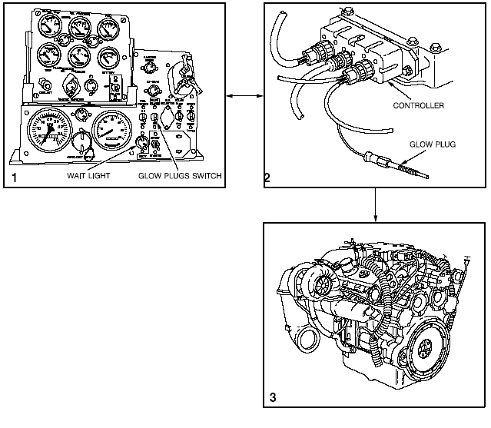

2. Glow Plug Controller: The glow plug controller powers the glow plugs and lights await/pilot lamp on the driver's instrument panel. The controller contains a microprocessor and three relays. The microprocessor closes the three relays, which in turn provide power to the glow plugs. However the microprocessor will not power the glow plugs under the following conditions:

a. The engine is warm; the controller is above 50 degrees F.
b. Battery voltage is low.
c. Battery (or supply) voltage is excessive.
d. Failed microprocessor.
e. All relays are stuck open.

3. Starting Engine
NOTE
A functional check of the glow plug system must be
performed whenever operation in ambient
temperatures below 50F is anticipated and after any
maintenance on the glow plug system is performed.

Push GLOW PLUG switch (11) to ON position. Glow plug WAIT lamp (12) will light.
(1) At temperatures above 50 F, the WAIT lamp (12) will flash on for 1 second and turn off
when the GLOW PLUG switch (11) is turned on.
(2) At temperatures below 50 F, the WAIT lamp (12) will turn on for 35 seconds and then flash
on/off for another minute and turn off.
If the glow plug WAIT lamp (12) does not turn on as indicated in Step 2, notify unit maintenance.

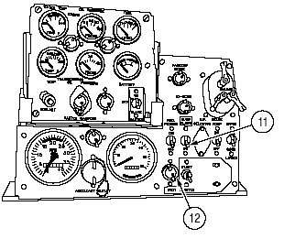
NOTE
A manual override for glow plug equipped engines is
used in emergencies only, as determined by the chief
of section. Manual override is affected by holding on
continually the spring--loaded GLOW PLUG switch.
Do not hold manual override switch on for more than
2 minutes.

PRACTICE EXERCISES

178 T F The vehicle starter safety automatically engages if the ambient air temperature is below 50 F.

179 T F The LHR engine is designed to deliver more heat to the crew compartment during cold weather.

//////////////////////////////////////////////////////////////////////////////////////////////////////////////////////////////////////////////////////////////////
178 F
179 F
//////////////////////////////////////////////////////////////////////////////////////////////////////////////////////////////////////////////////////////////////

